**Login Page.**

Once you are on the website and you have not logged in yet, the page will show the “Login Page”, where you must enter a valid username and password.

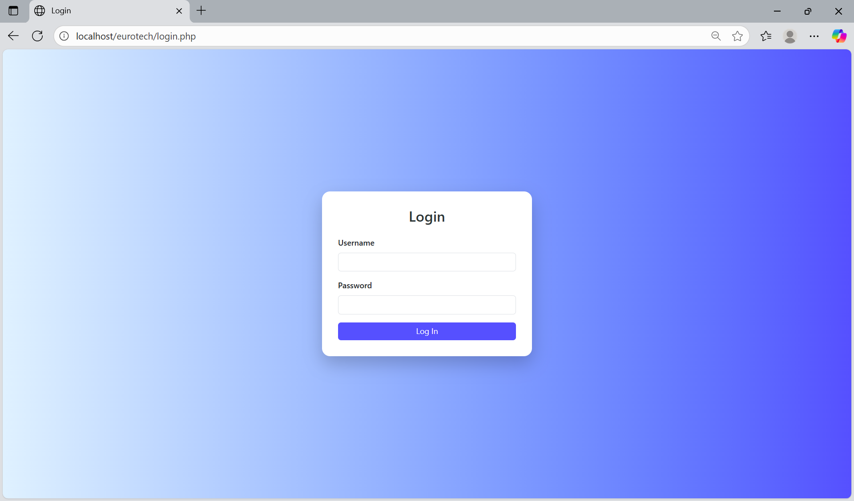

**Home Page.**

If you log in with a valid user, you will be sent to the “Home Page”, that shows you a welcome message and the purpose of the web site. Depending on your user’s role, it will show different options in the navigation bar that is at the top of the page.

If you log in with a user that have the role “Administrator”, you will have permissions to navigate into the pages “Customers”, “Customers PN”, “Customers PPAP Number”, “PPAP’s”, “BluSeal”, “Cables”, “Tapes”, “Tubes”, ”Products”, “Users” and “Vendors” with the options that are at the top of the page.

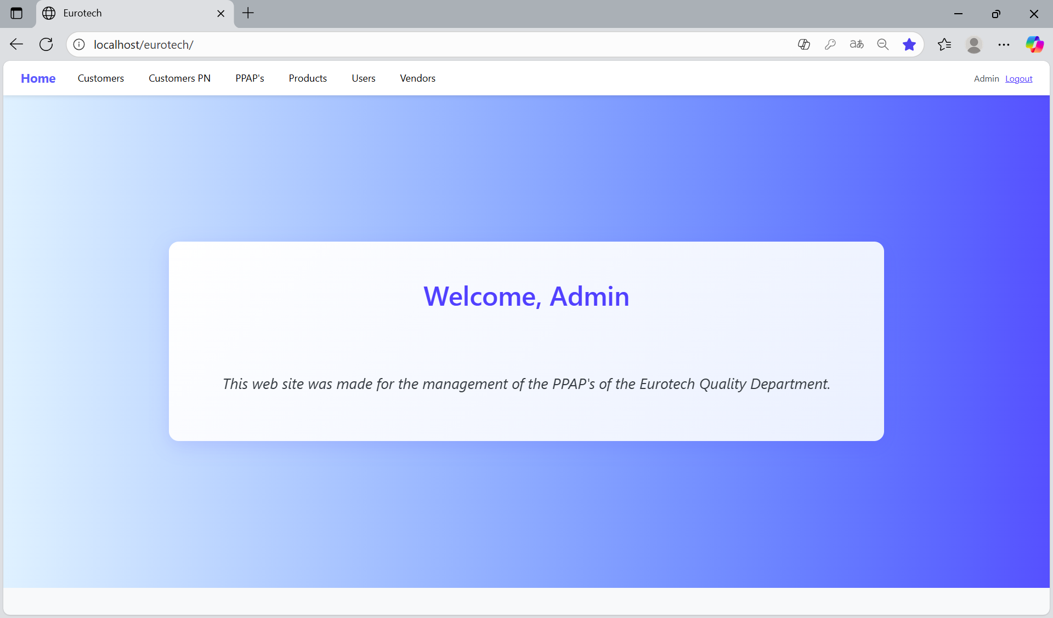

If you log in with a user that have the role “User”, you will only have permissions to navigate into the pages “PPAP’s”, “BluSeal”, “Cables”, “Tapes” and “Tubes” with the options that are at the top of the page.

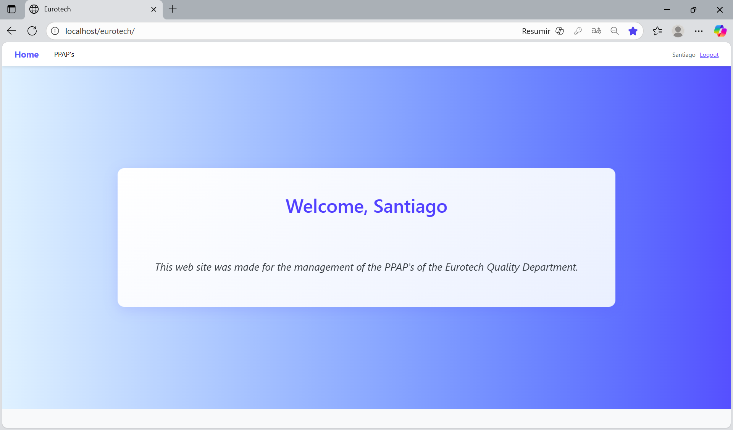

**Users with the role “Administrator”.**

***- Customers Page.***

On the navigation bar, you can navigate to the “Customers Page”.

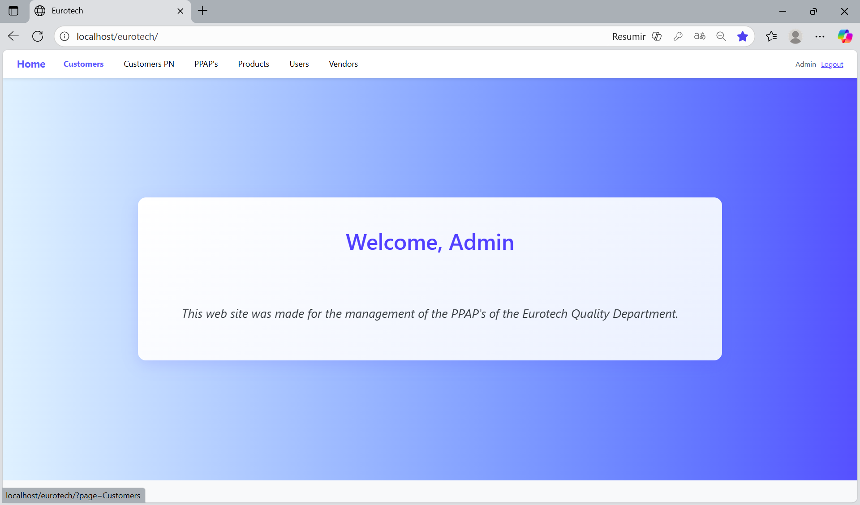

In this page you can manage the registers of all the customers.

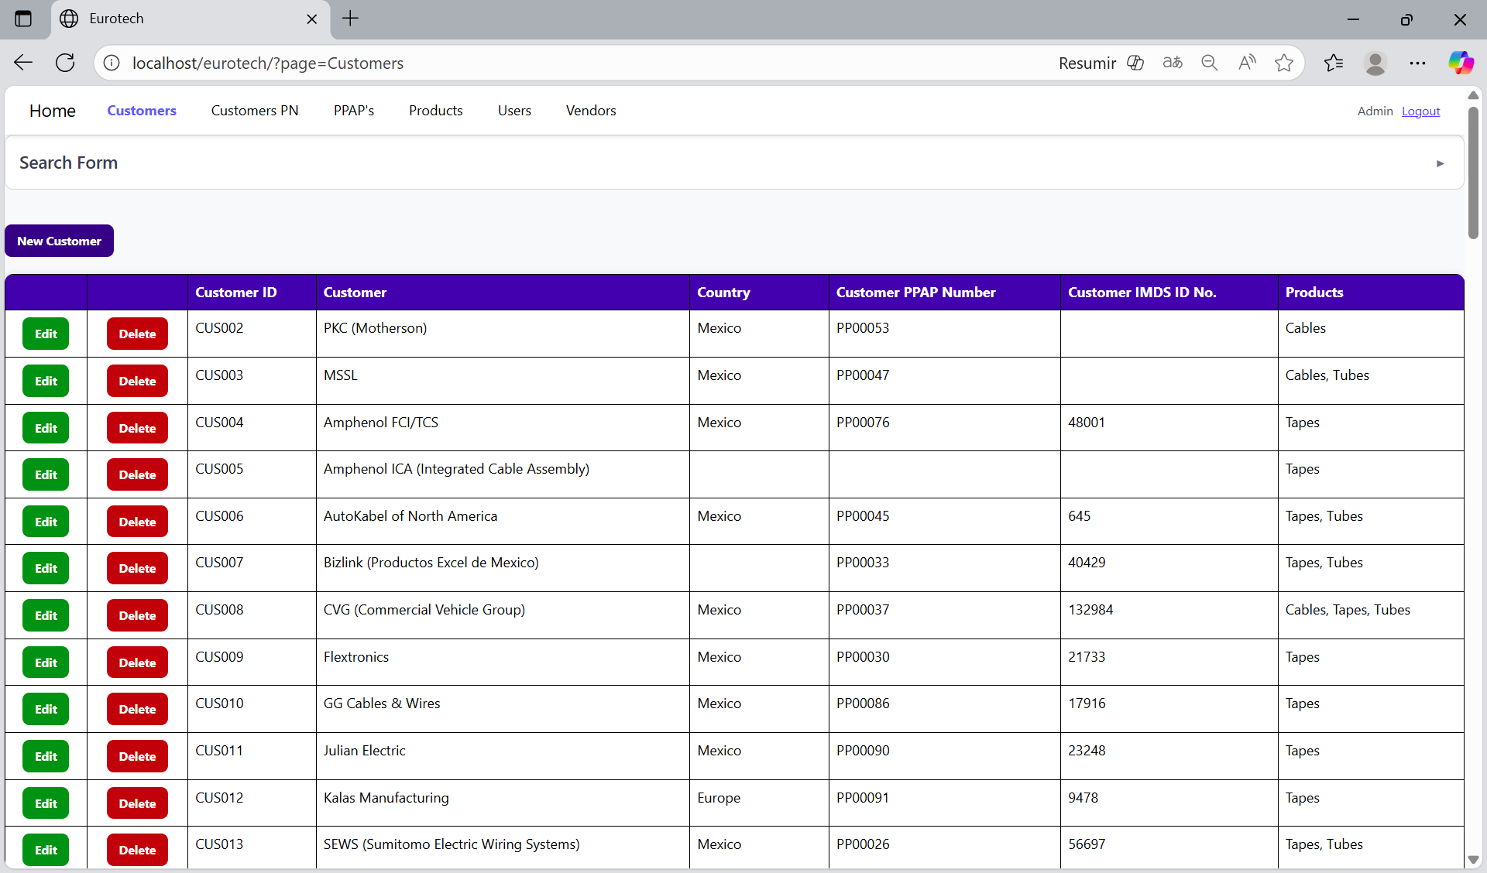

*Search Form.*

At the top of the page, it will be a dropdown “Search Form” that has all the fields of the table for querying registers.

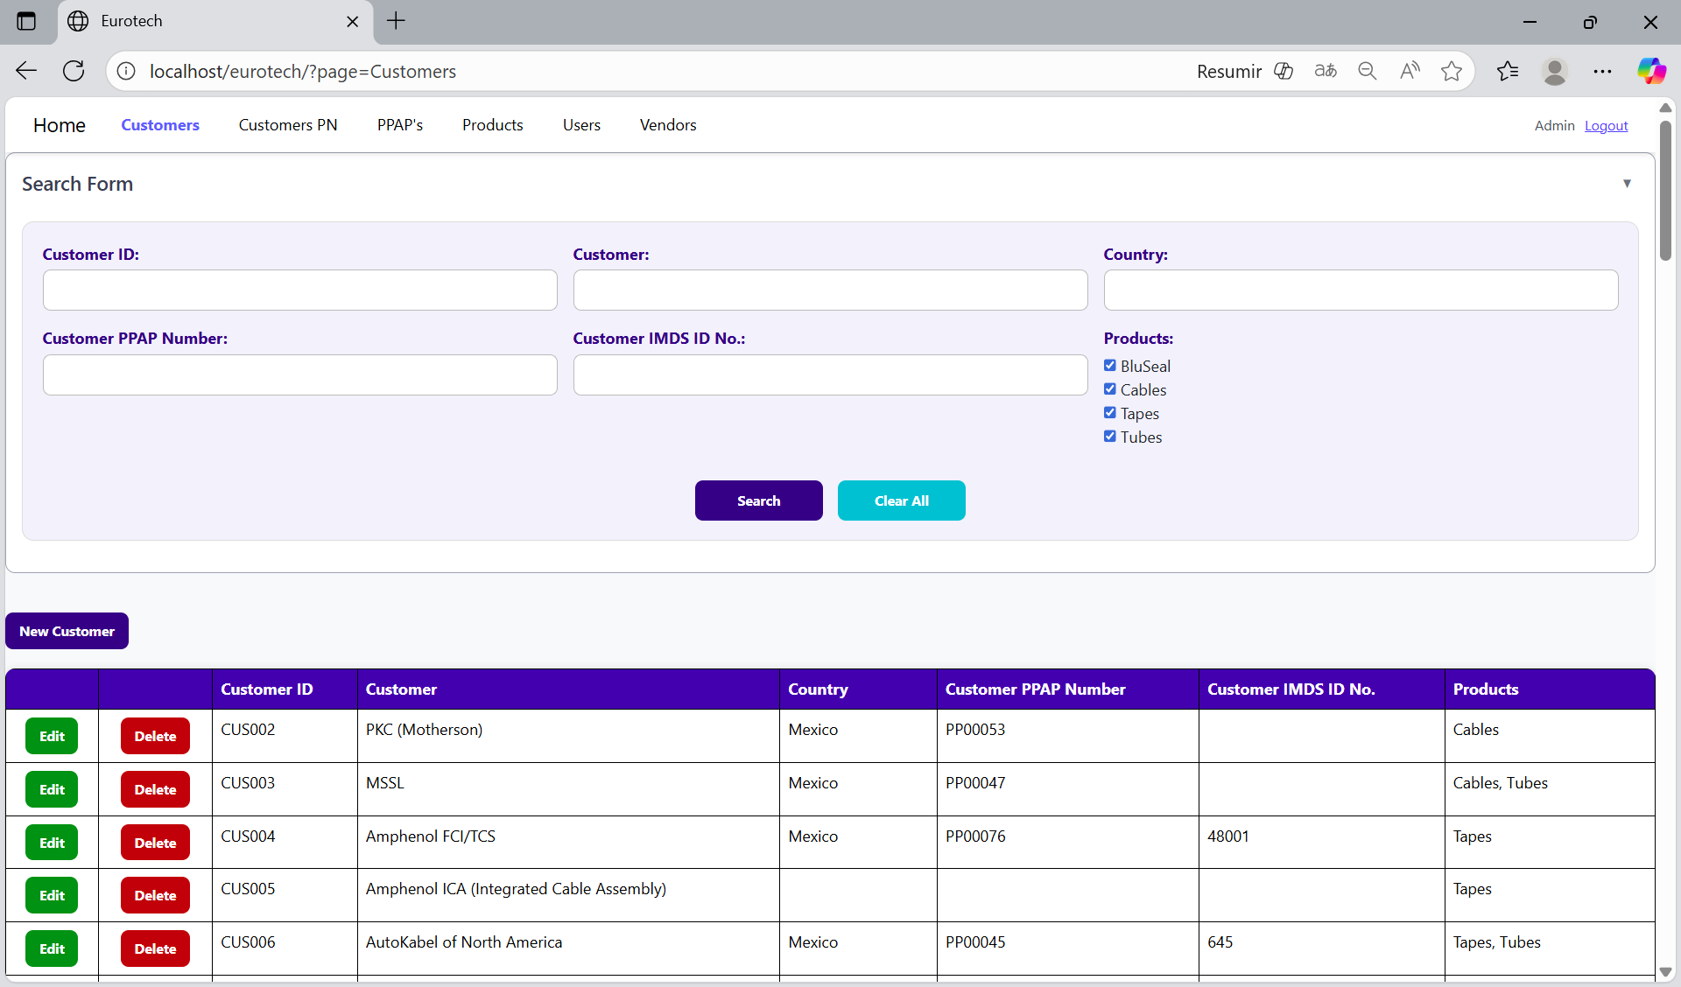

You can search by “Customer ID”, using the “Customer ID” field and clicking the “Search” button.

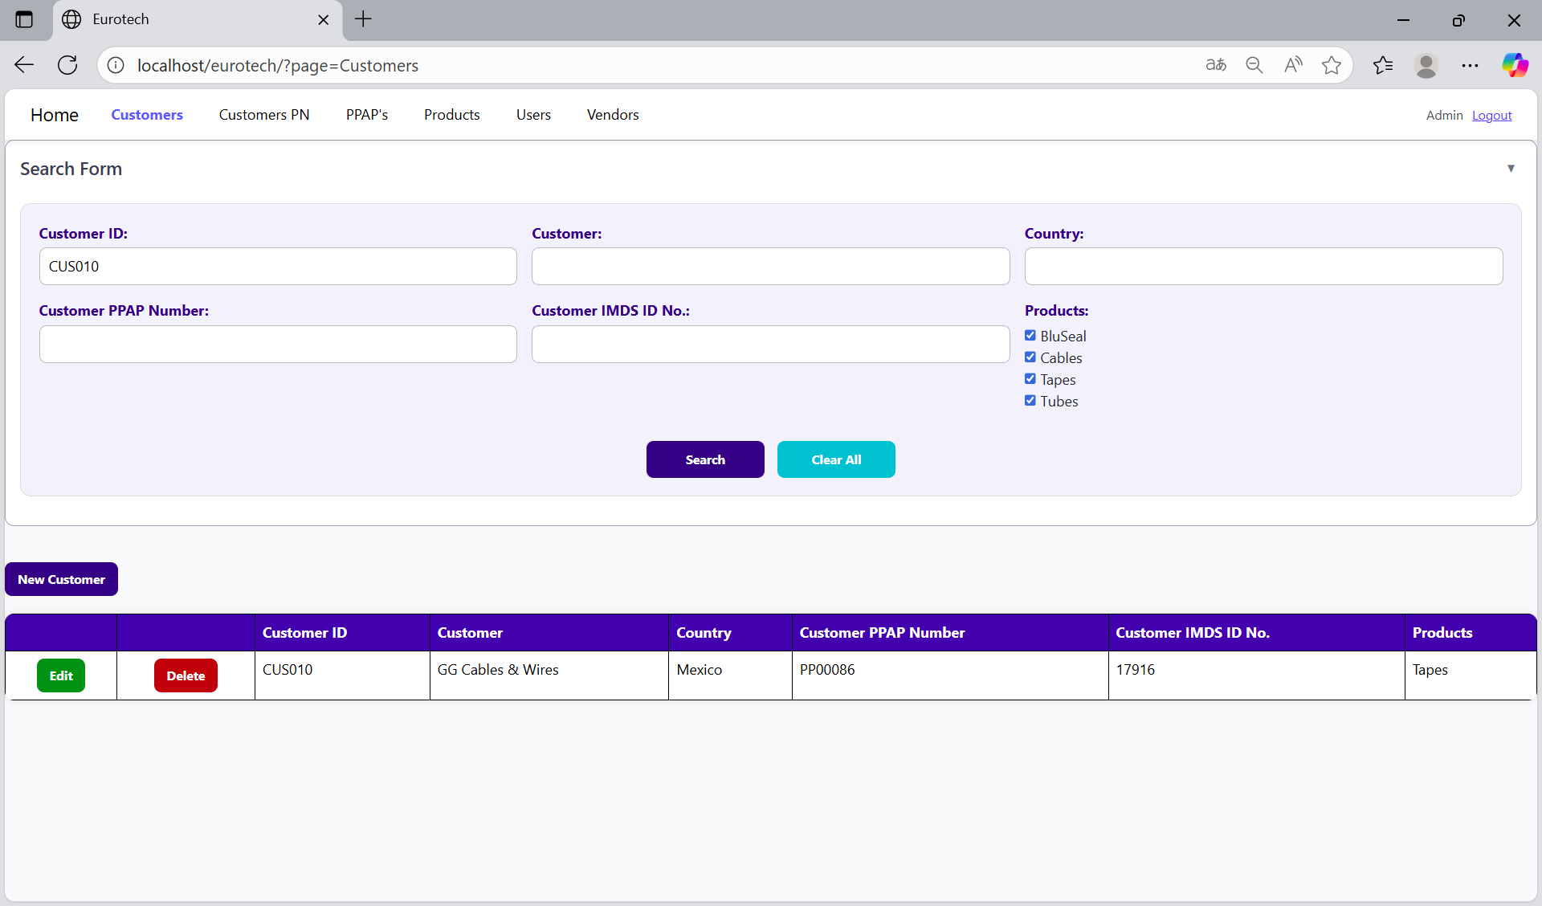

You can search by “Customer”, using the “Customer” field and clicking the “Search” button.

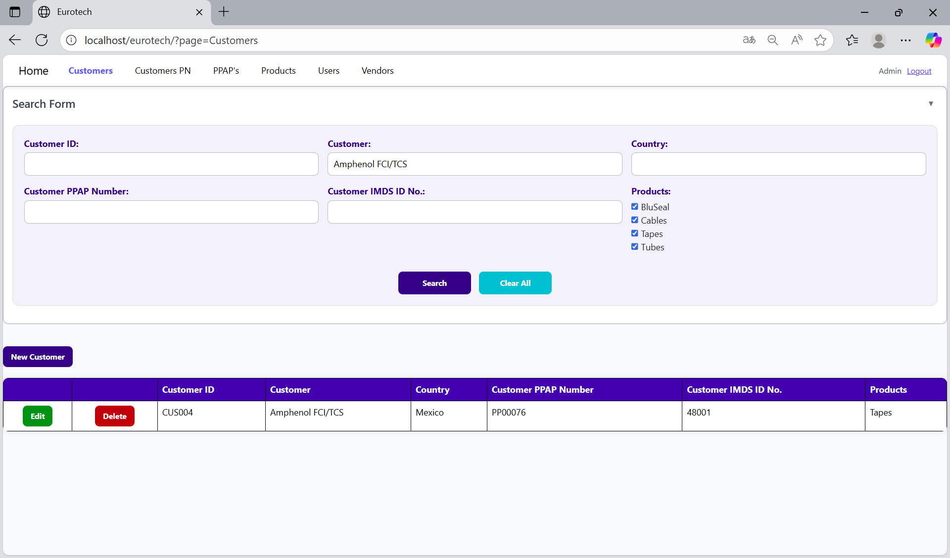

You can search by “Country”, using the “Country” field and clicking the “Search” button.

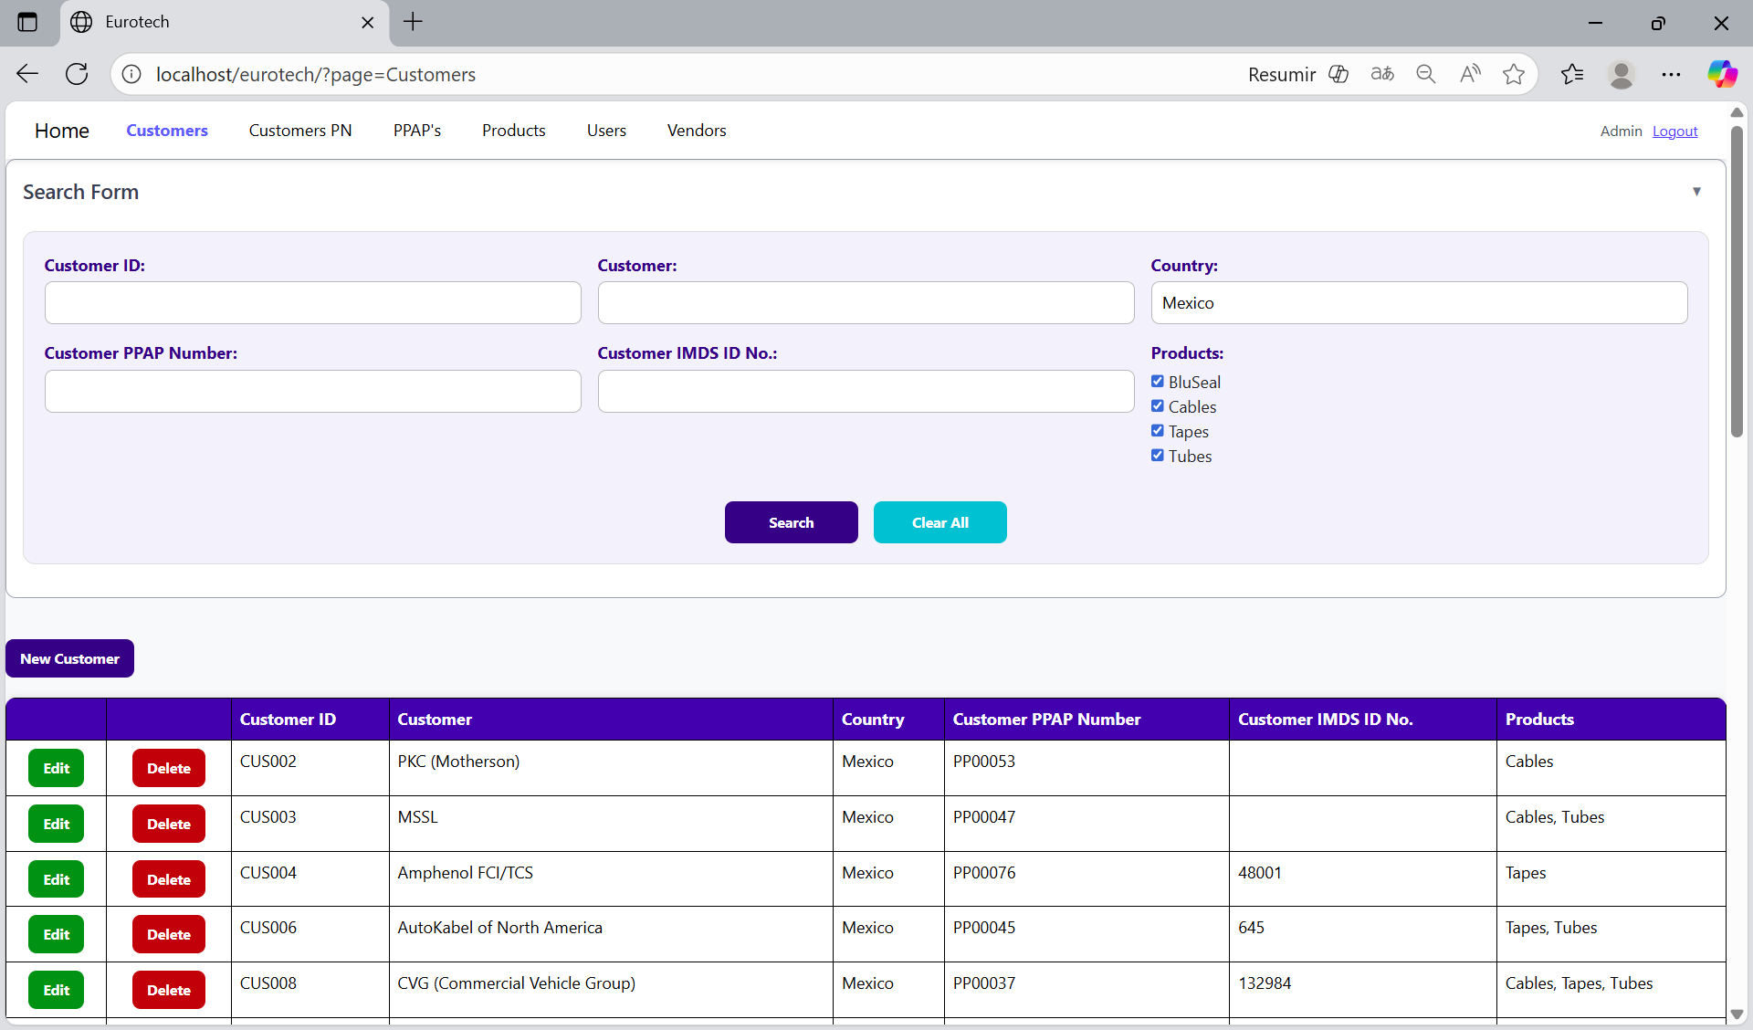

You can search by “Customer PPAP Number”, using the “Customer PPAP Number” field and clicking the “Search” button.

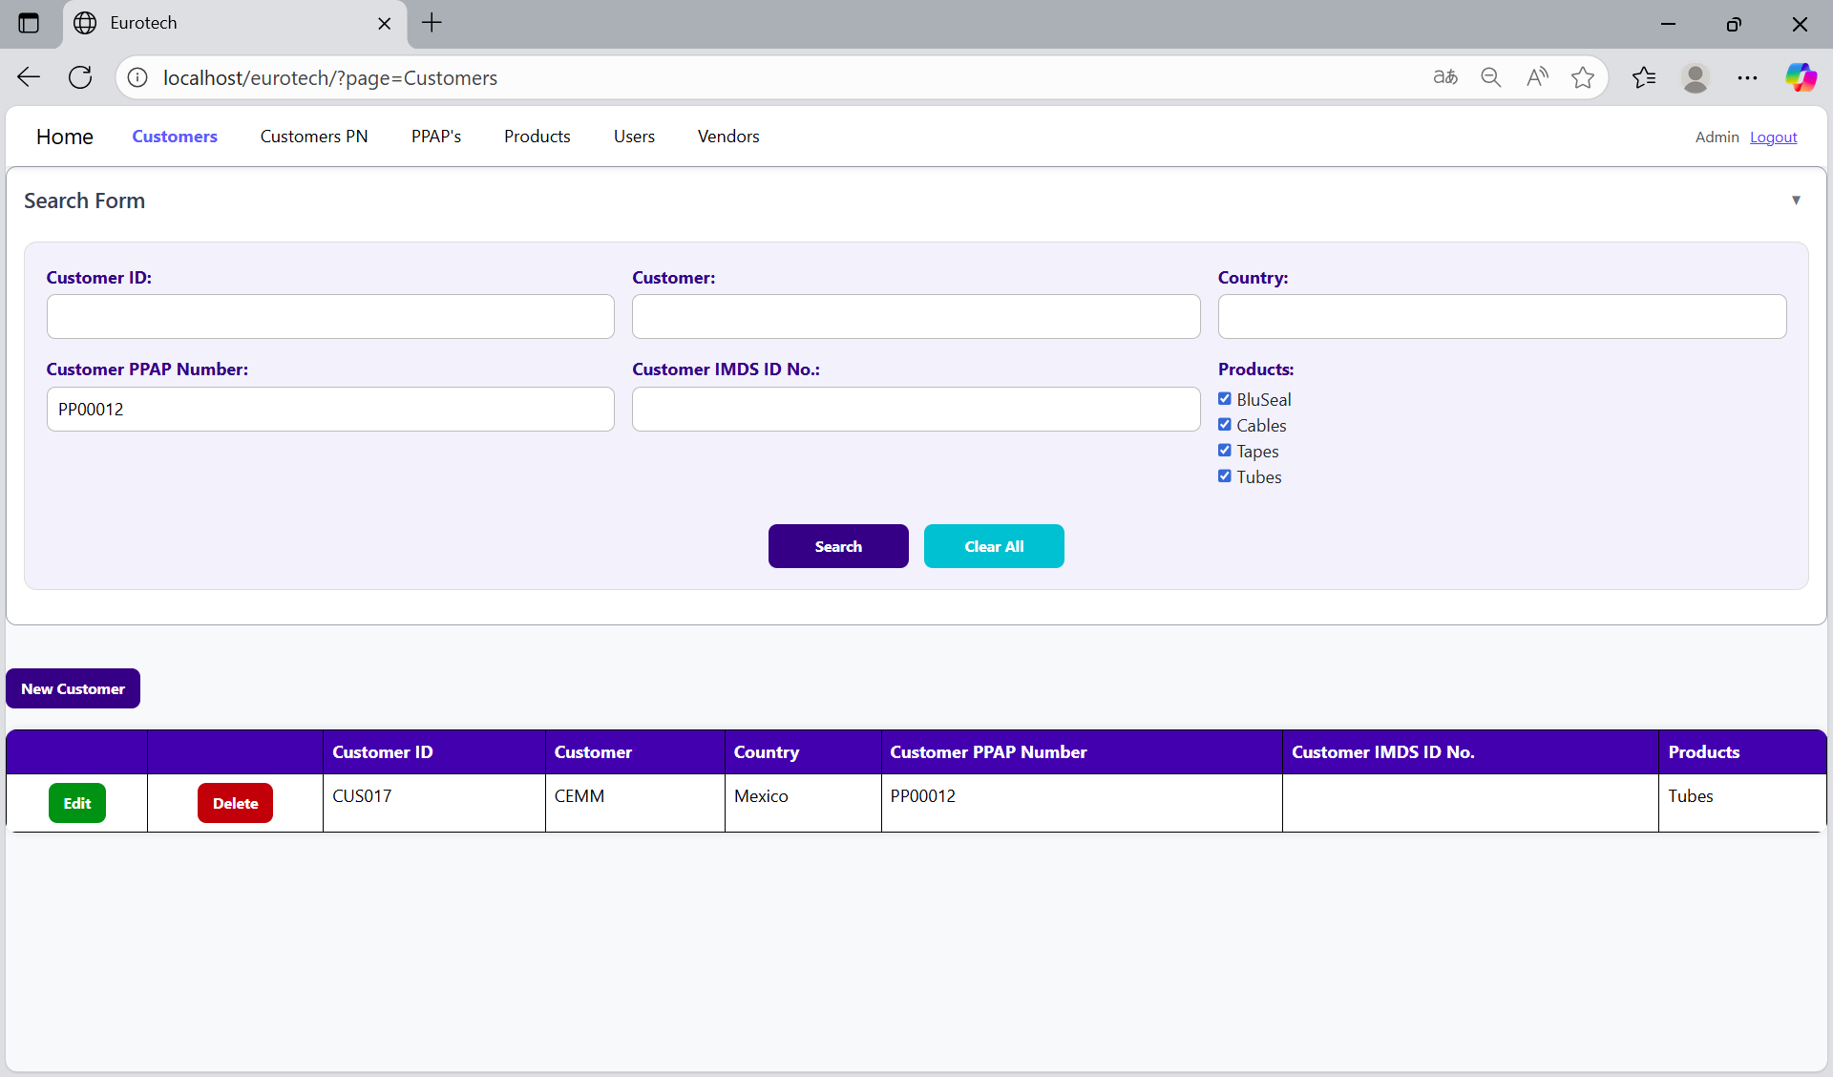

You can search by “Customer IMDS ID No.”, using the “Customer IMDS ID No.” field and clicking the “Search” button.

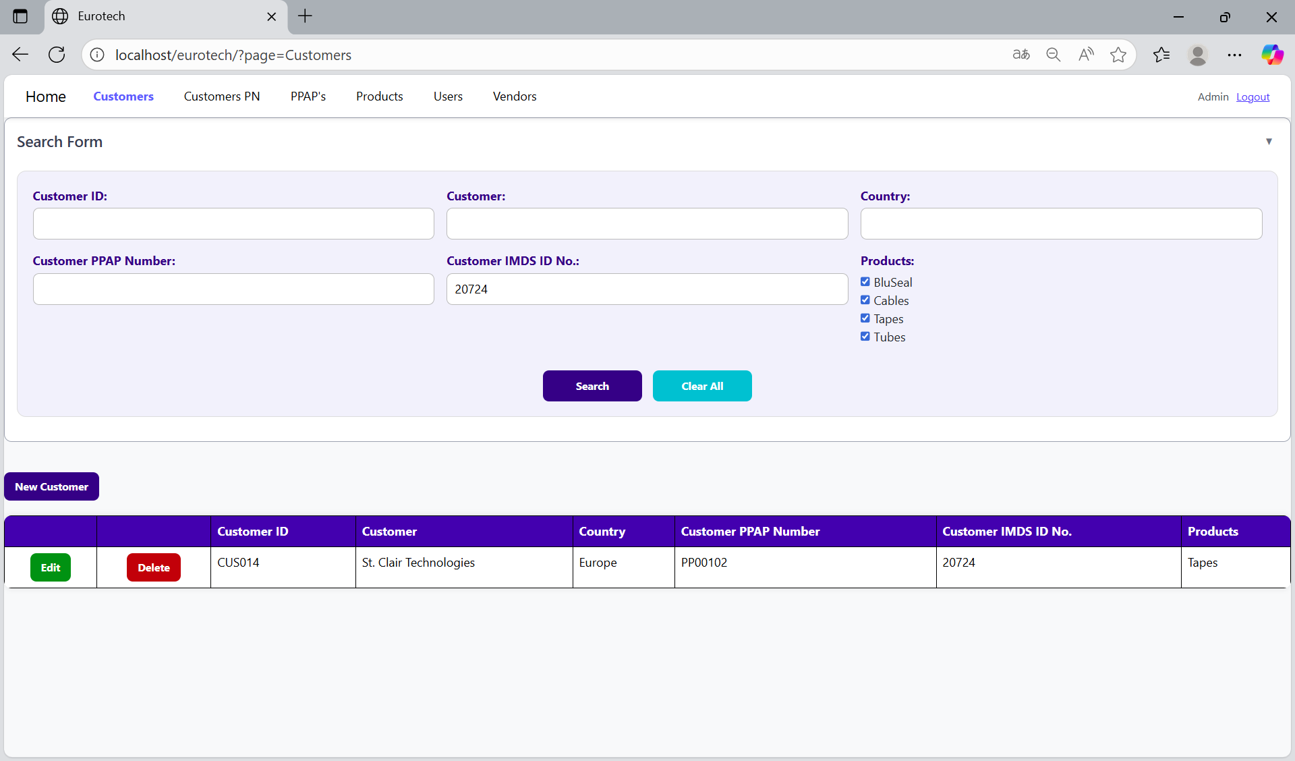

You can search by “Products” (this means the products of the PPAPs that will be realize for the customers), using the “Products” field and clicking the “Search” button.

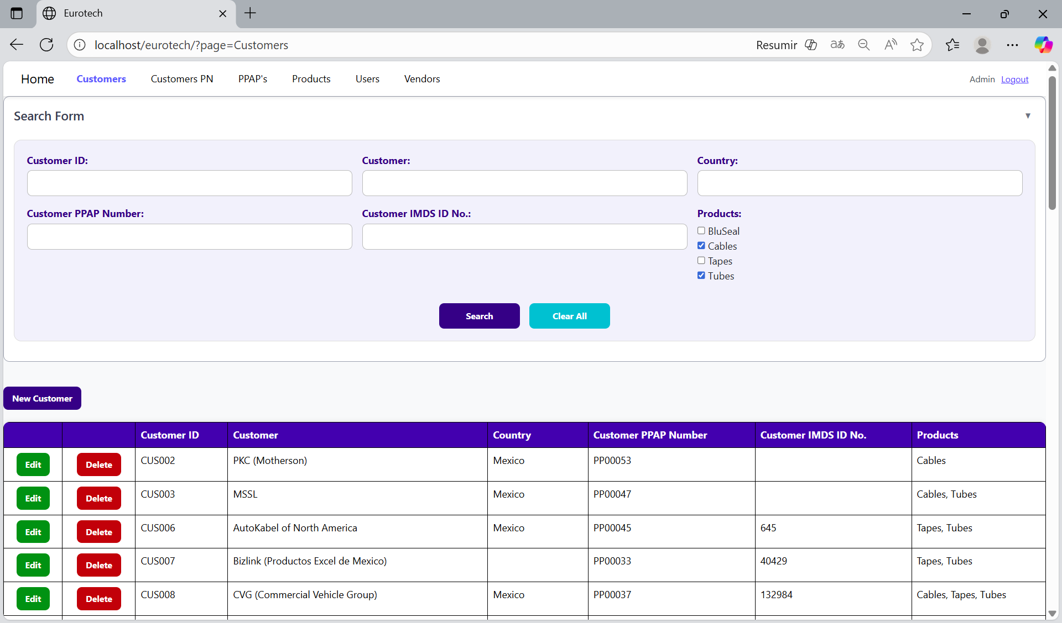

And with the “Clear All” button, you can clean the querying and see all the registers of the customers.

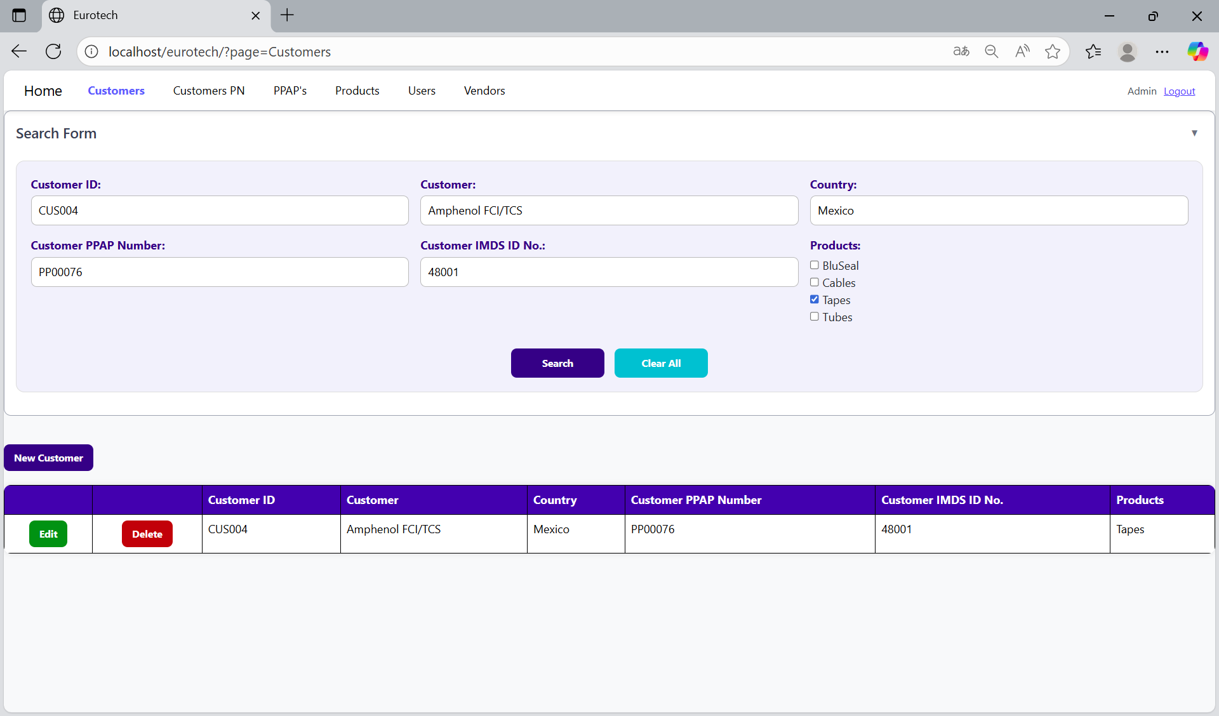

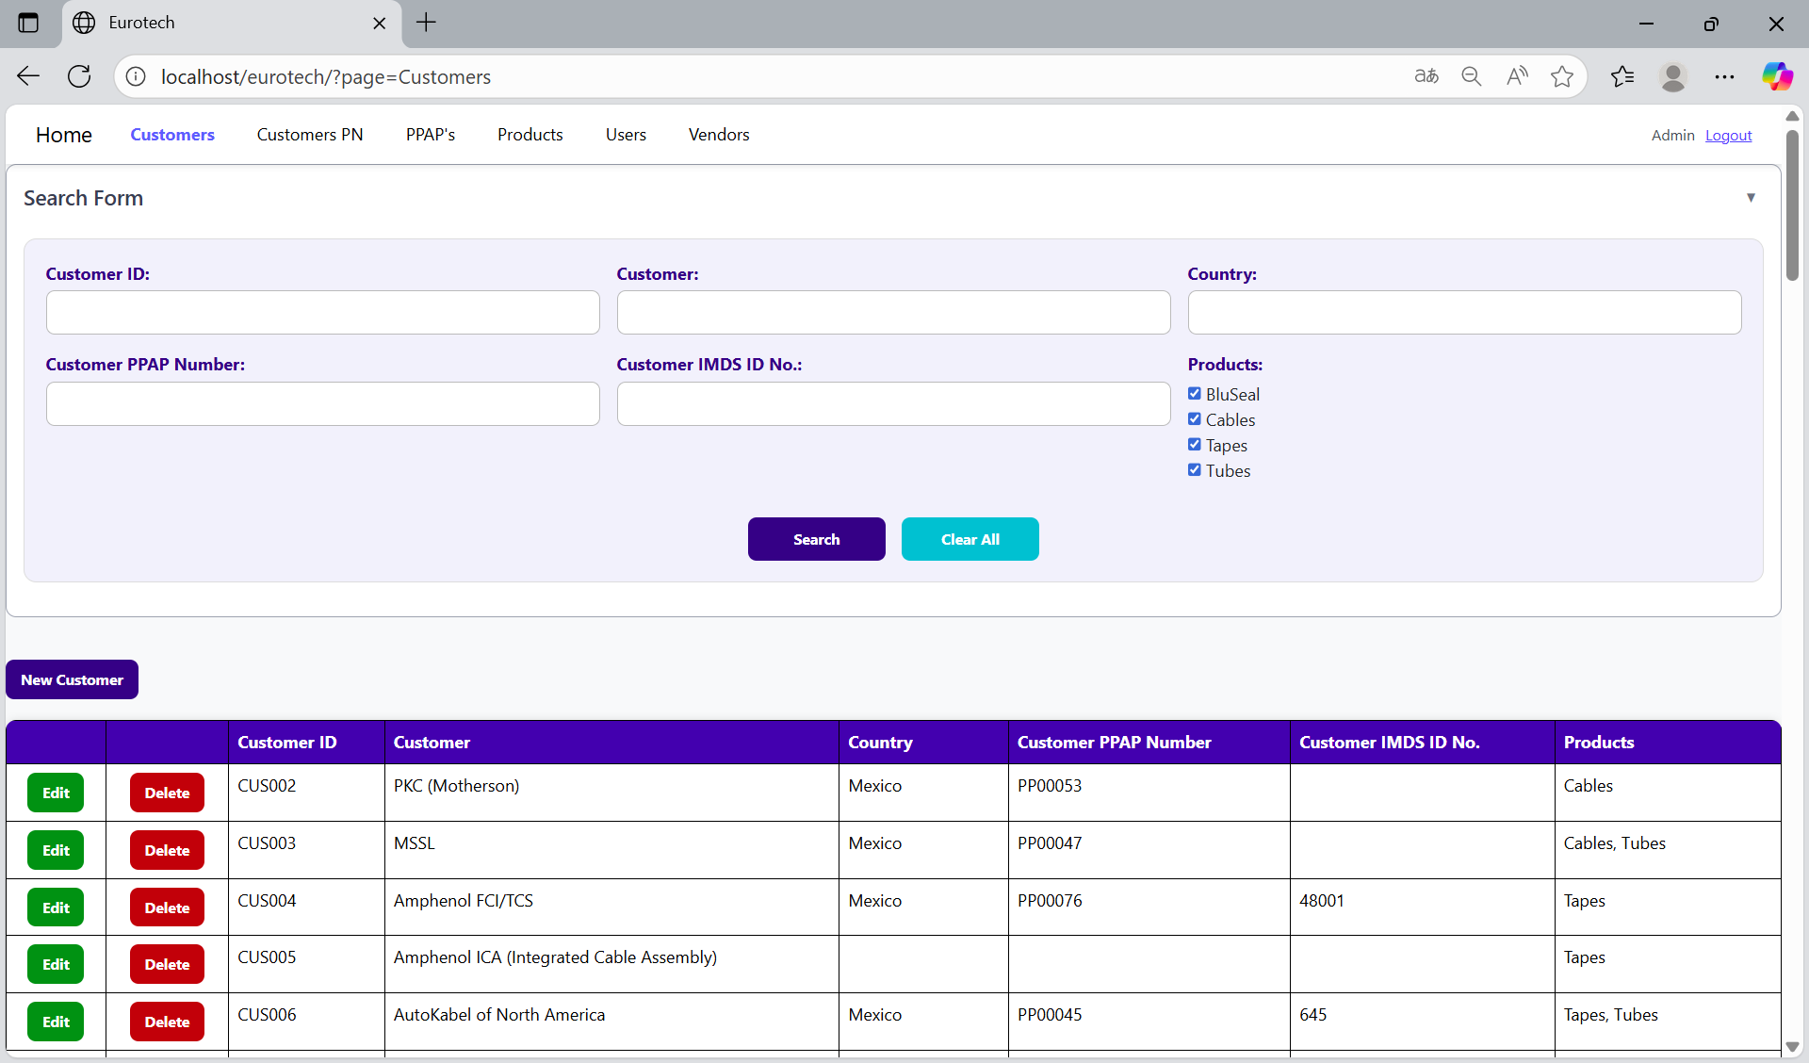

*New Customer.*

Below the “Search Form”, it is the “New Customer” button. If this button is clicked, it will display a register form to create a new customer.

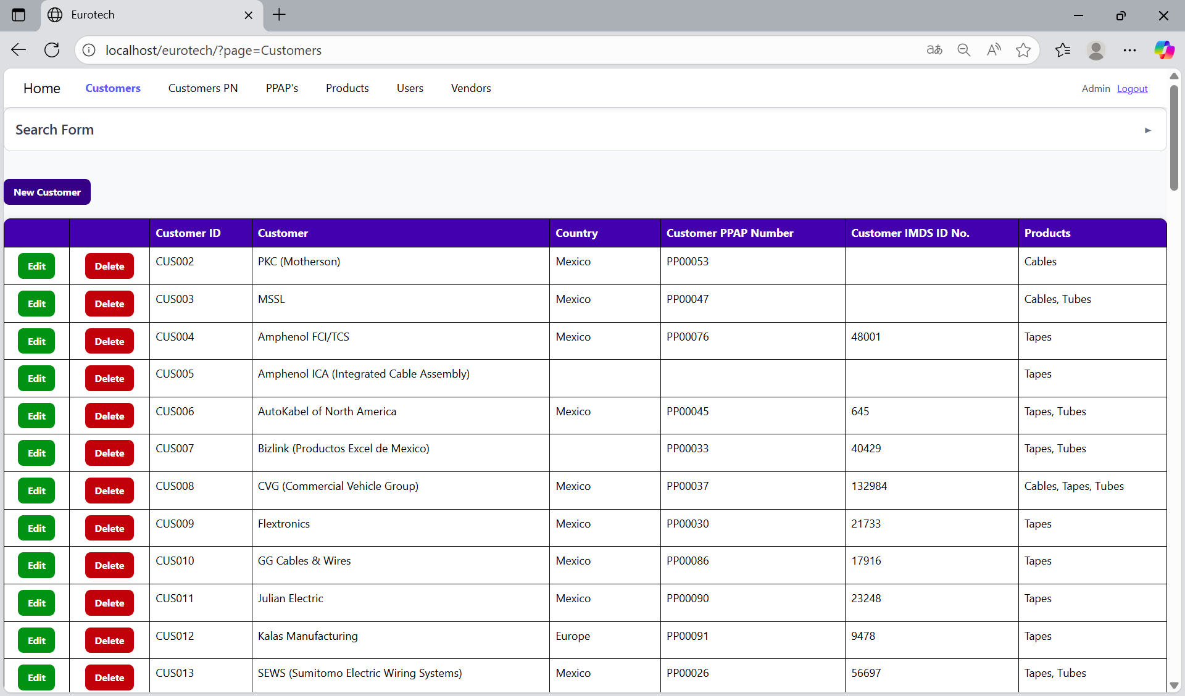

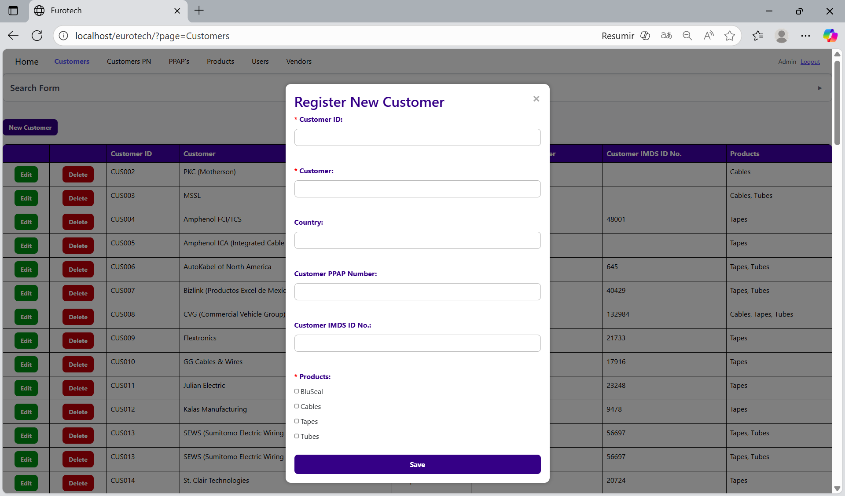

The register form has the “Customer ID”, “Customer” and “Products” fields as mandatories, and the “Country”, “Customer PPAP Number”, “Customer IMDS ID No.” fields that aren’t mandatories. You can’t duplicate registers that already exist in the database.

If you want to save the register of a new customer, you must click the “Save” button.

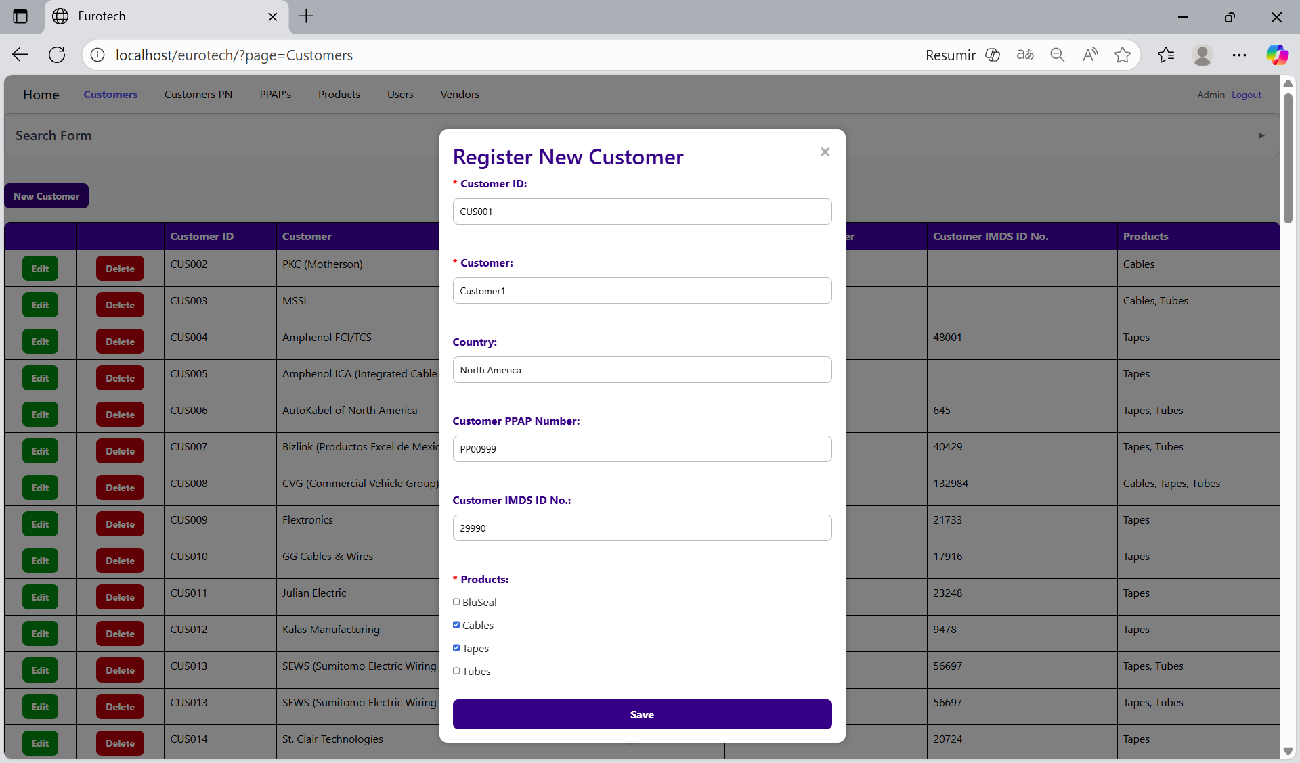

*Edit Customer.*

In each register from the table, it will be an “Edit” button. If this button is clicked, it will display an update form to edit the information of the selected customer.

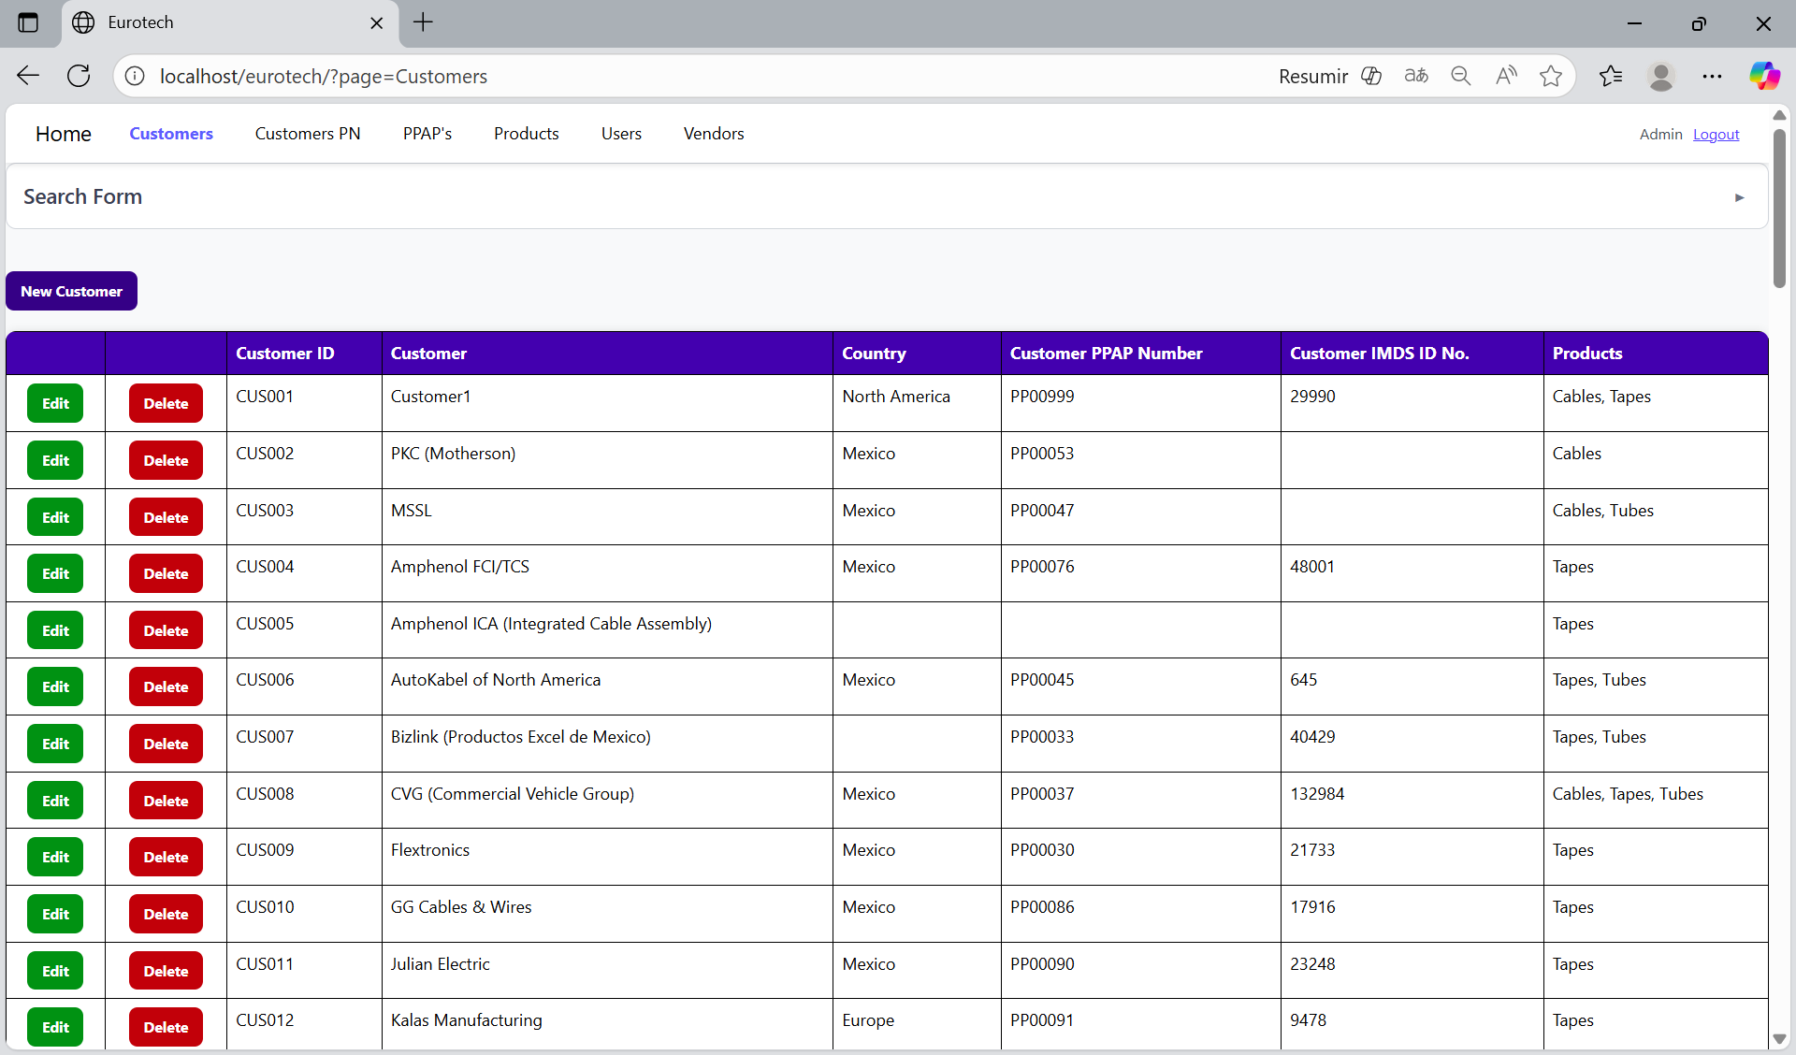

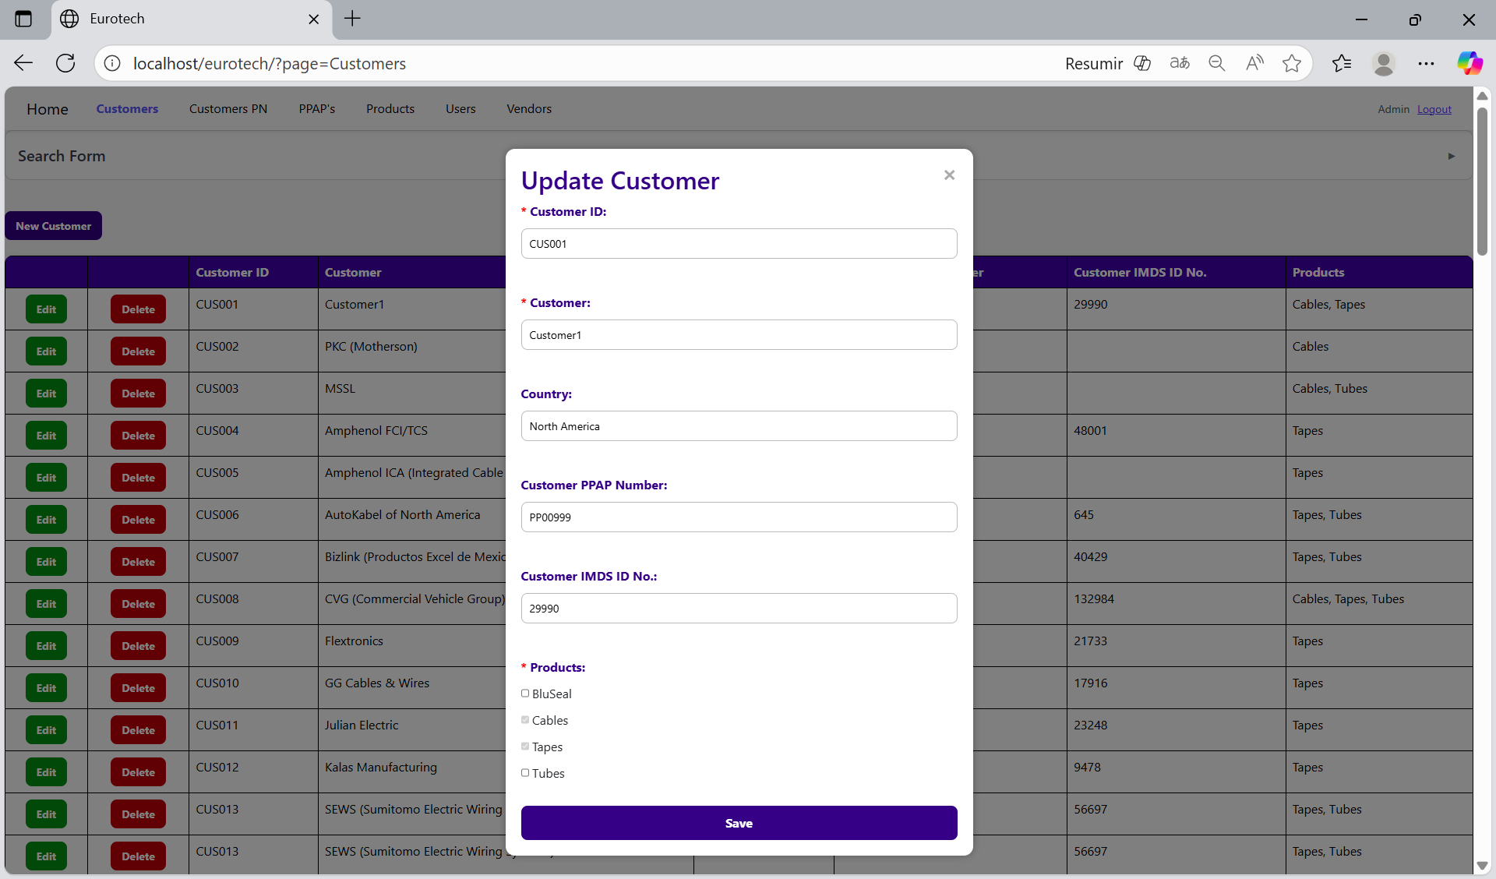

To save the changes, you must click the “Save” button.

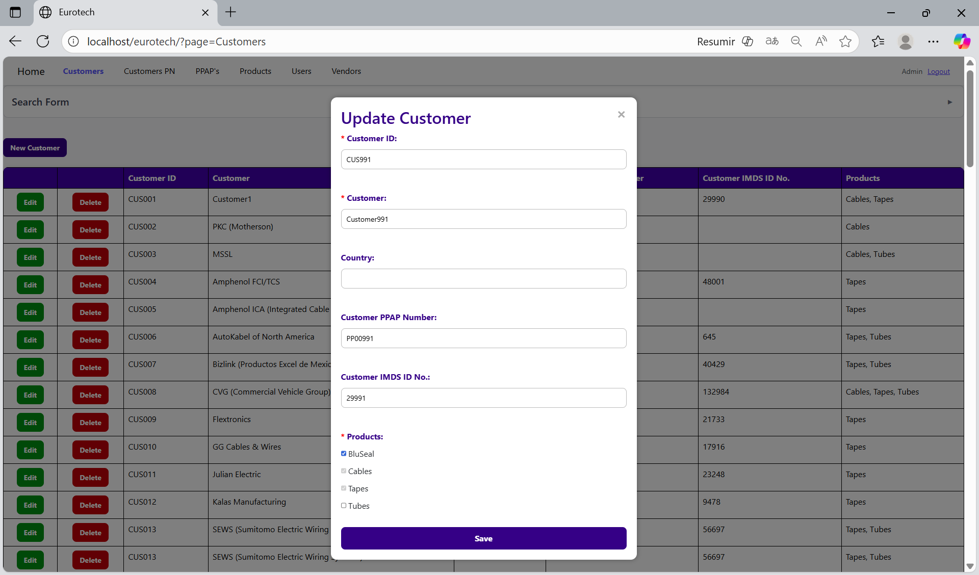

*Delete Customer.*

In each register from the table, it will be a “Delete” button. If this button is clicked, it will display the information of the selected customer with a message to confirm the delete action.

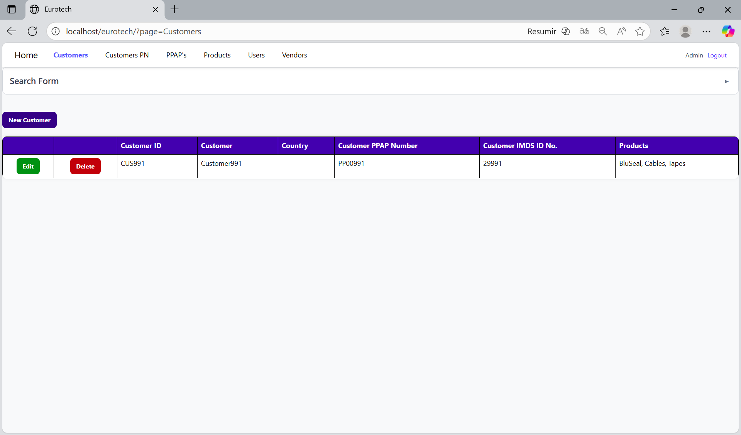

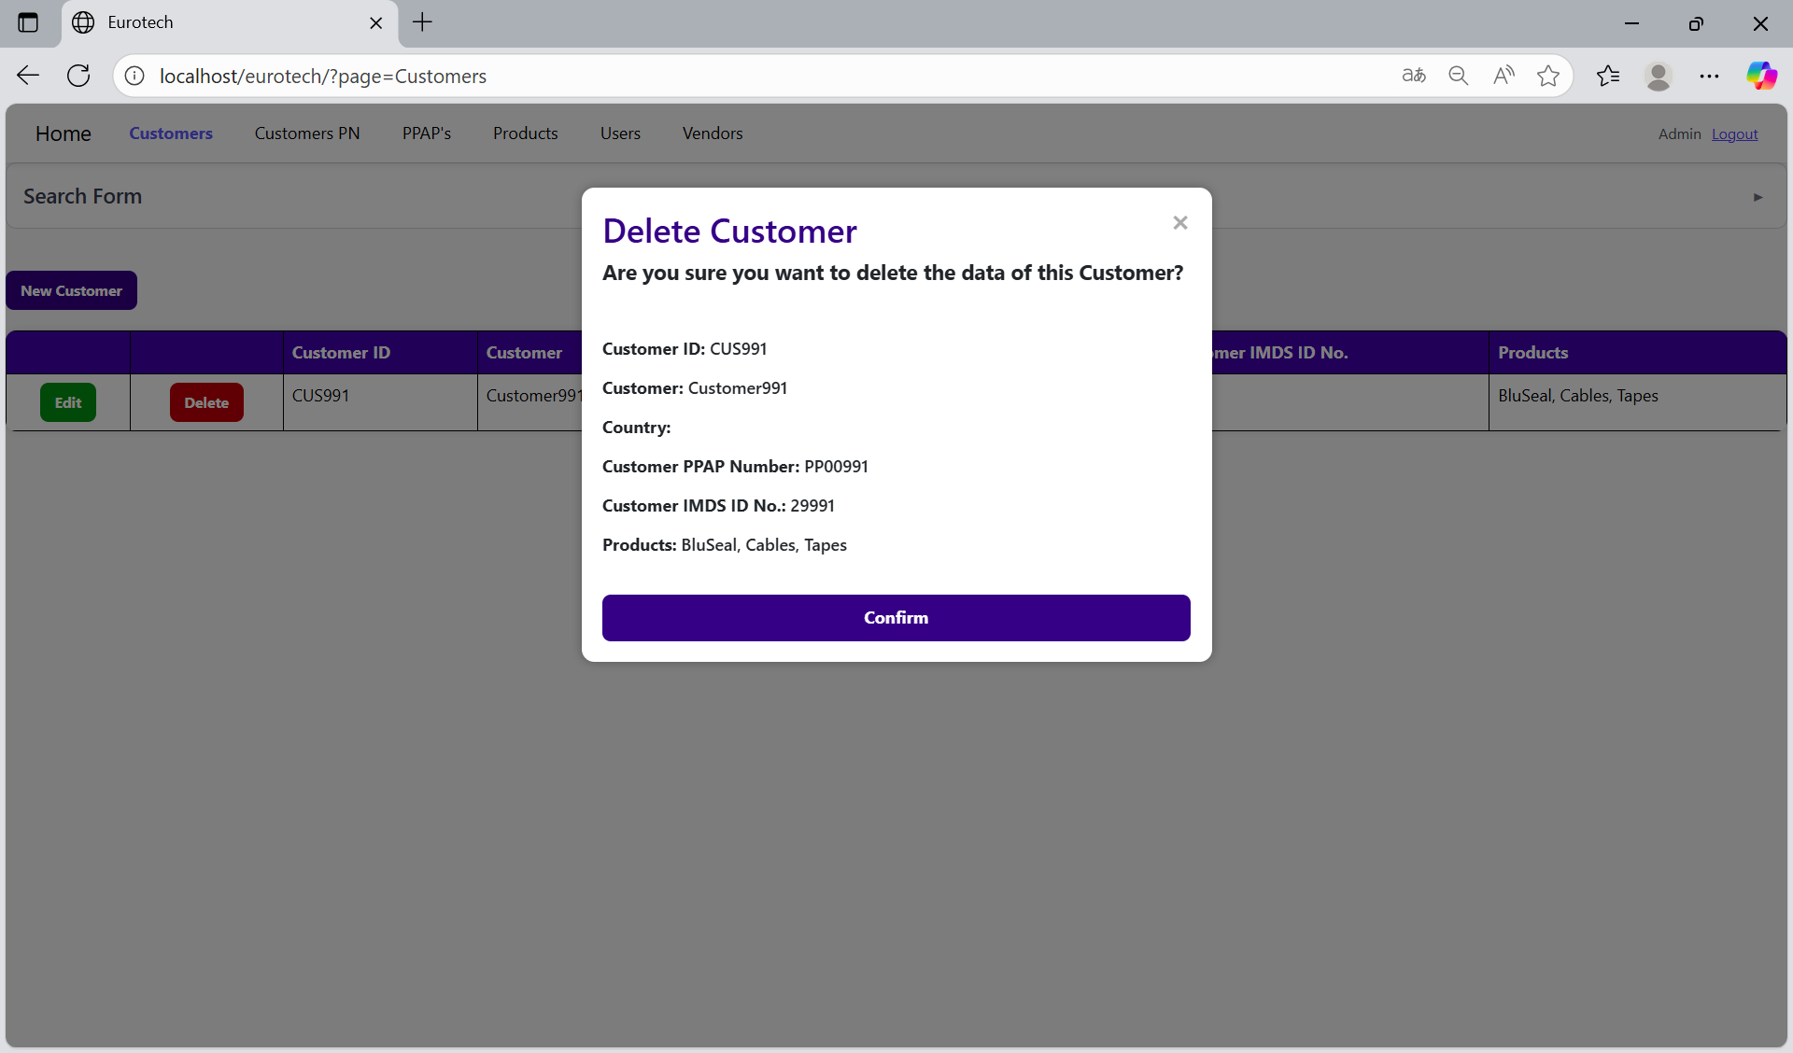

To confirm the delete action, you must click the “Confirm” button. It only deletes customers that doesn’t have registers in “Customer PN” and “PPAP’s”.



***- Customers PN Page.***

On the navigation bar, you can navigate to the “Customers PN Page”.

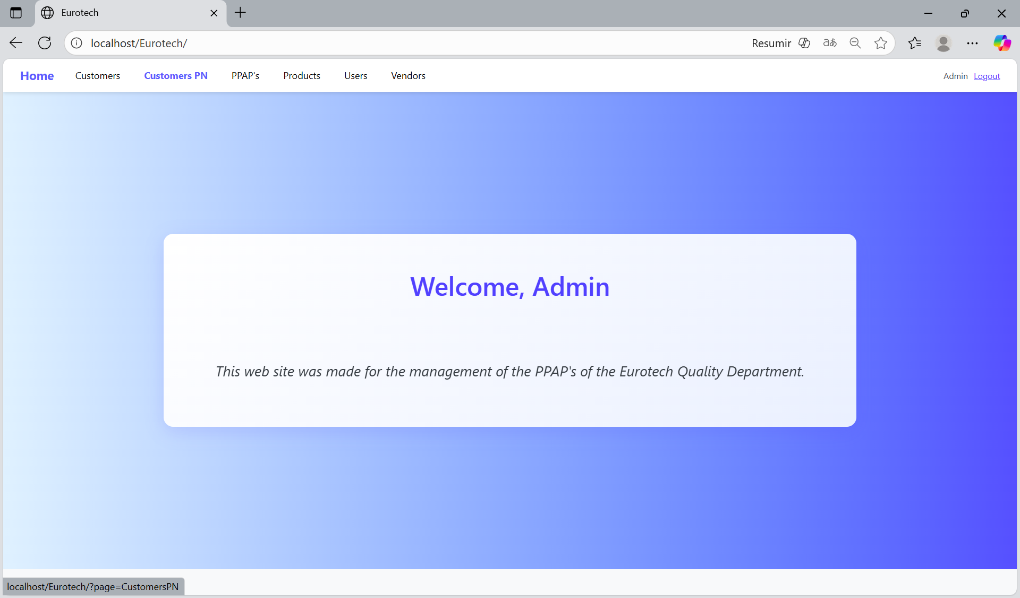

In this page you can manage the registers of all the Customer PN.

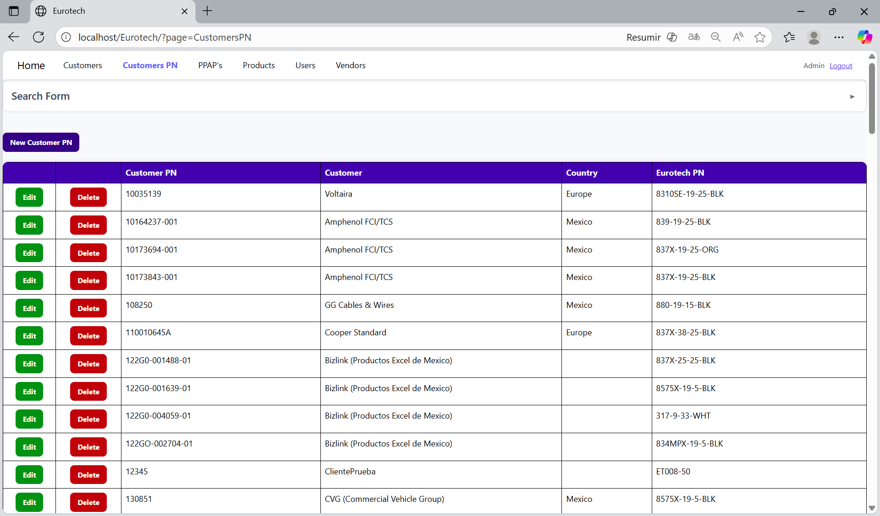

*Search Form.*

At the top of the page, it will be a dropdown “Search Form” that has all the fields of the table for querying registers.

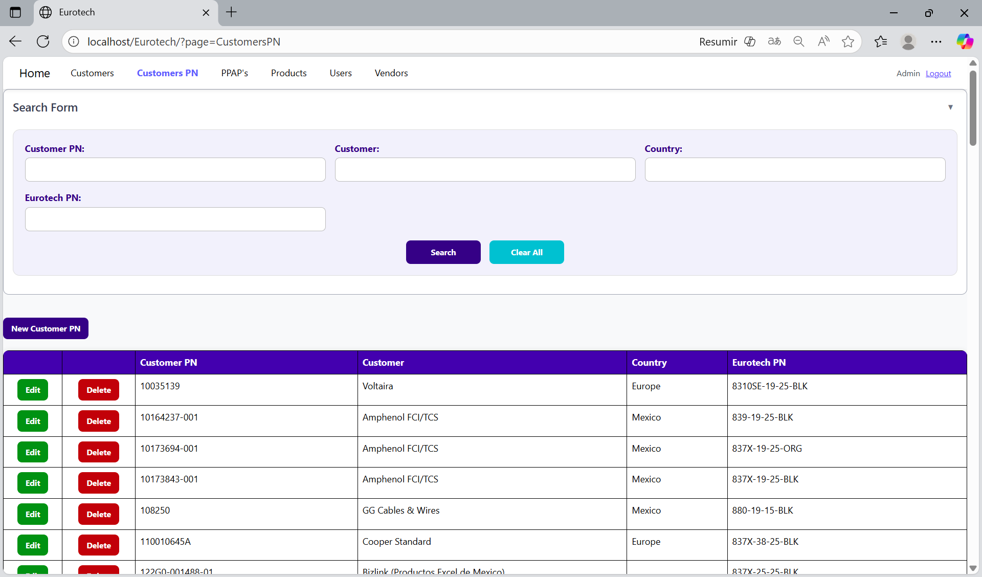

You can search by “Customer PN”, using the “Customer PN” field and clicking the “Search” button.

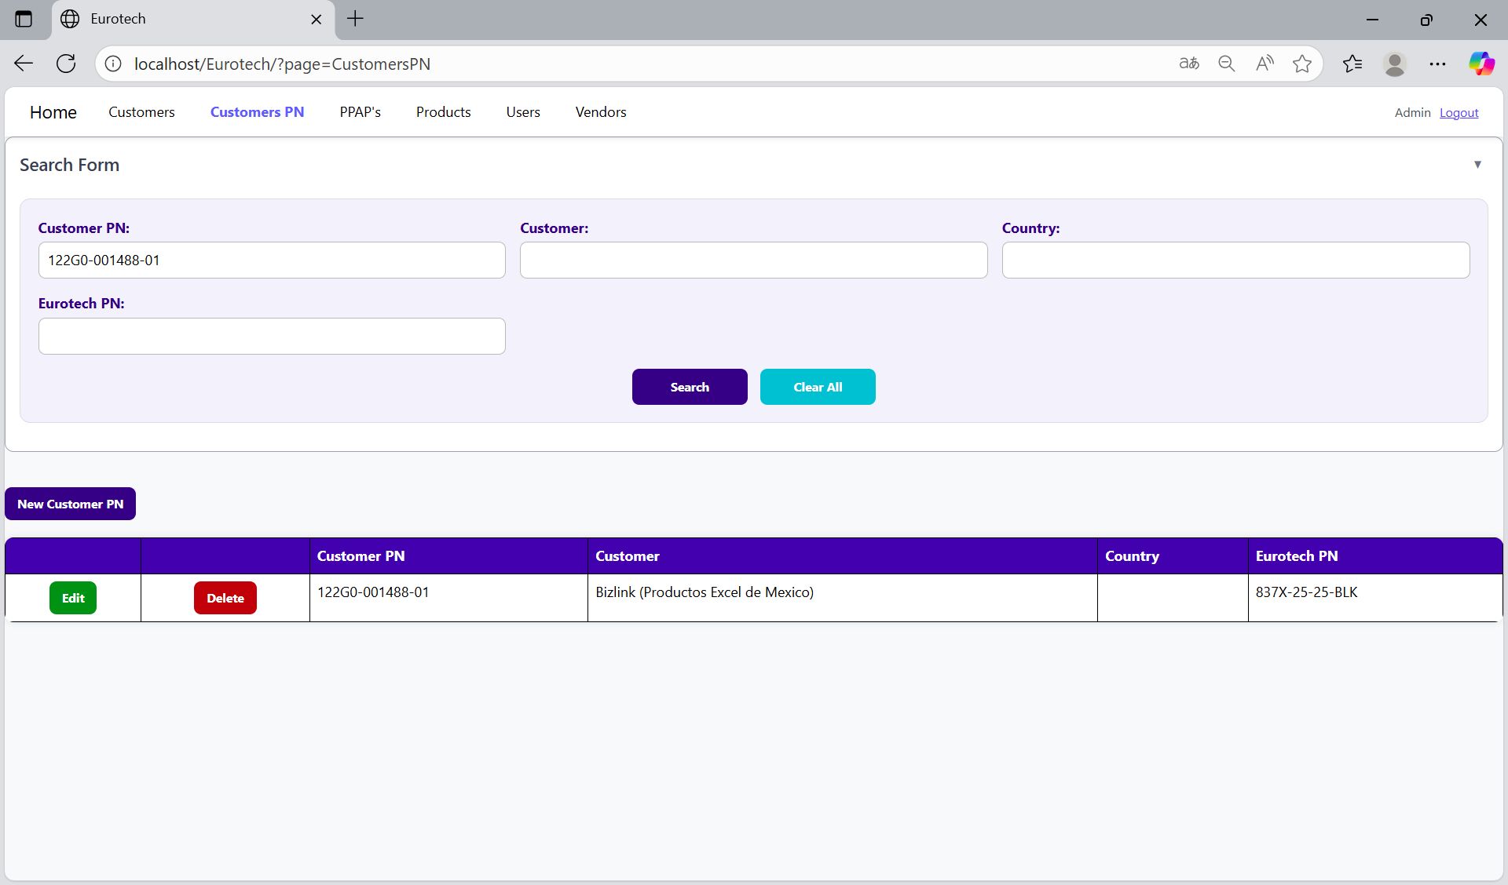

You can search by “Customer”, using the “Customer” field and clicking the “Search” button.

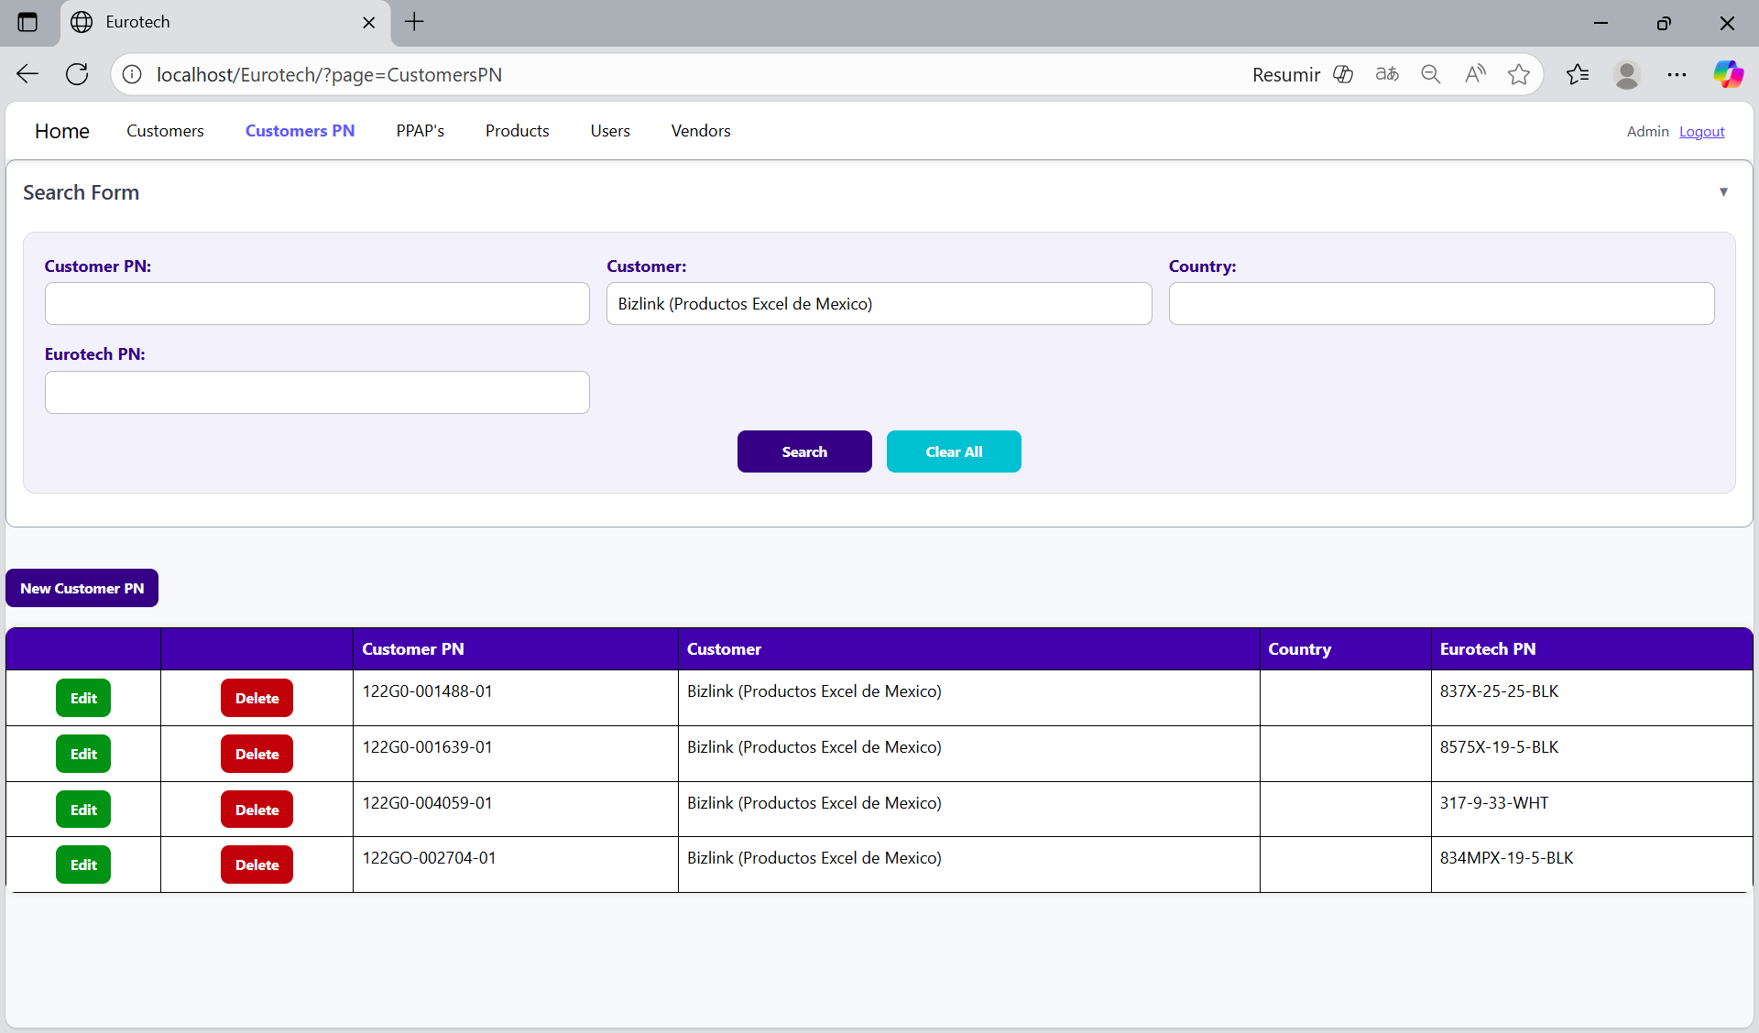

You can search by “Country”, using the “Country” field and clicking the “Search” button.

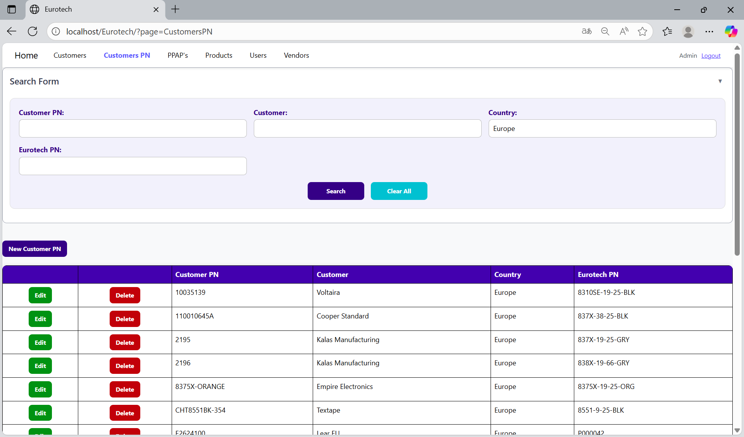

You can search by “Eurotech PN”, using the “Eurotech PN” field and clicking the “Search” button.

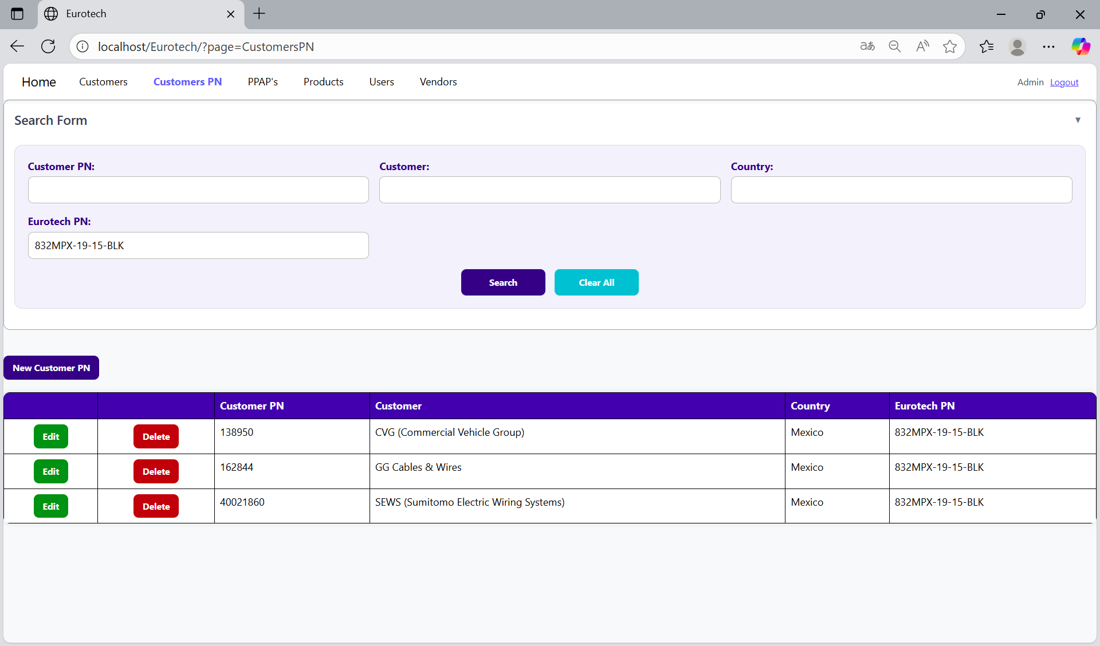

And with the “Clear All” button, you can clean the querying and see all the registers of the Customer PN.

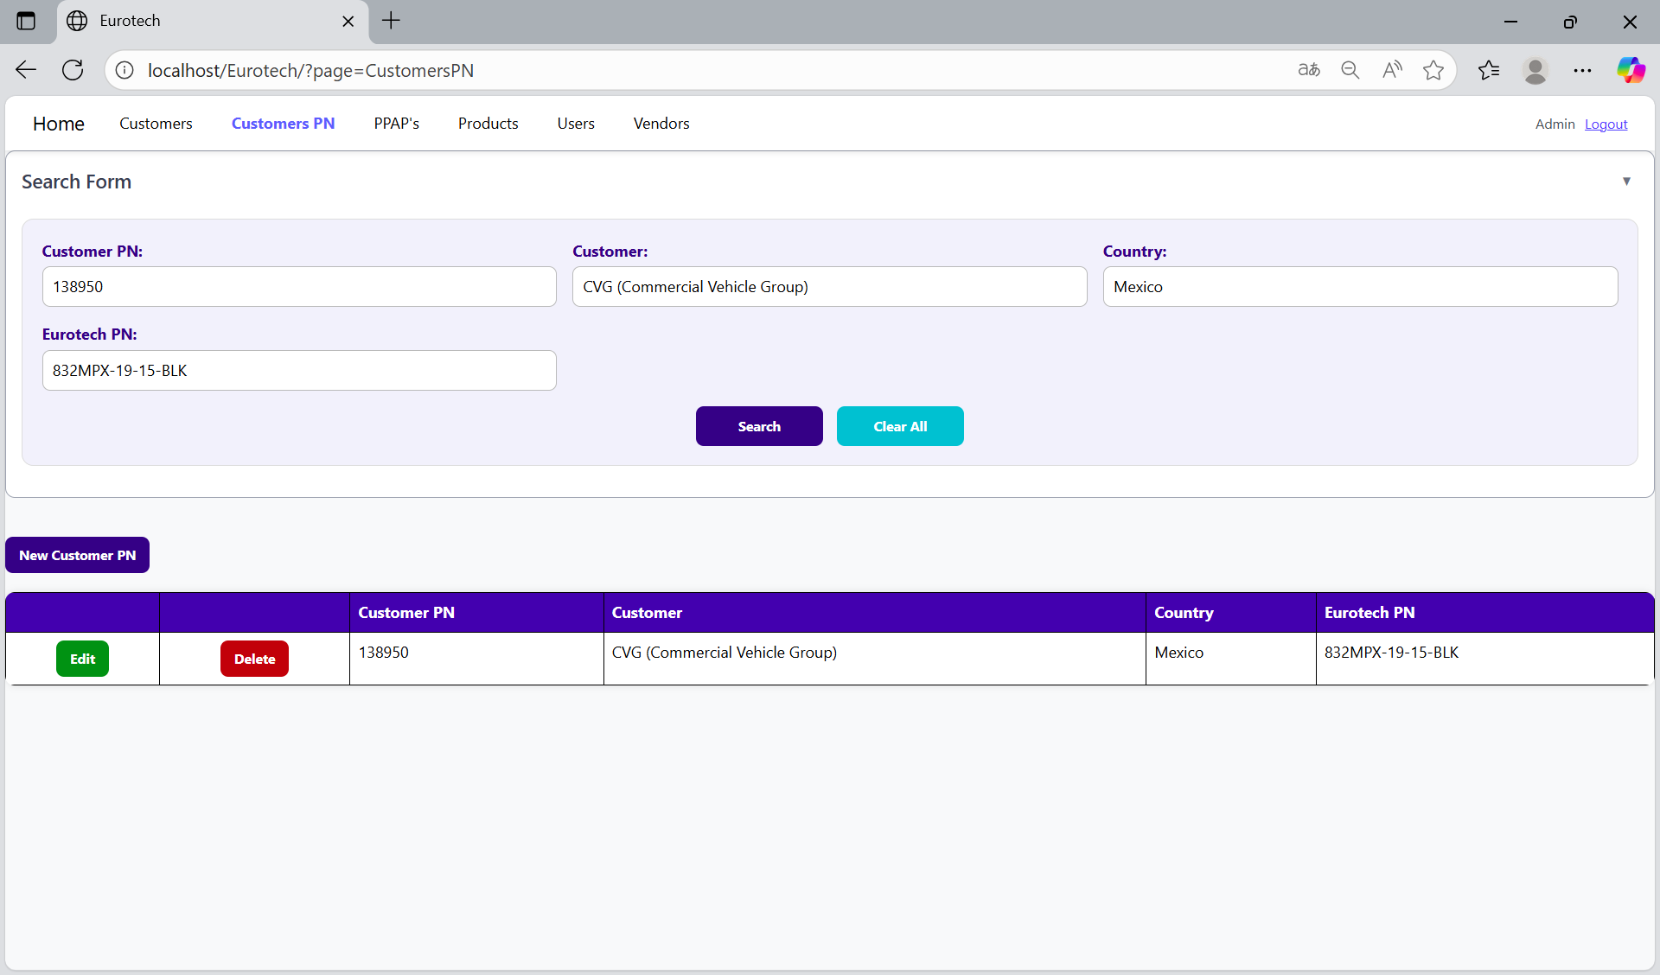

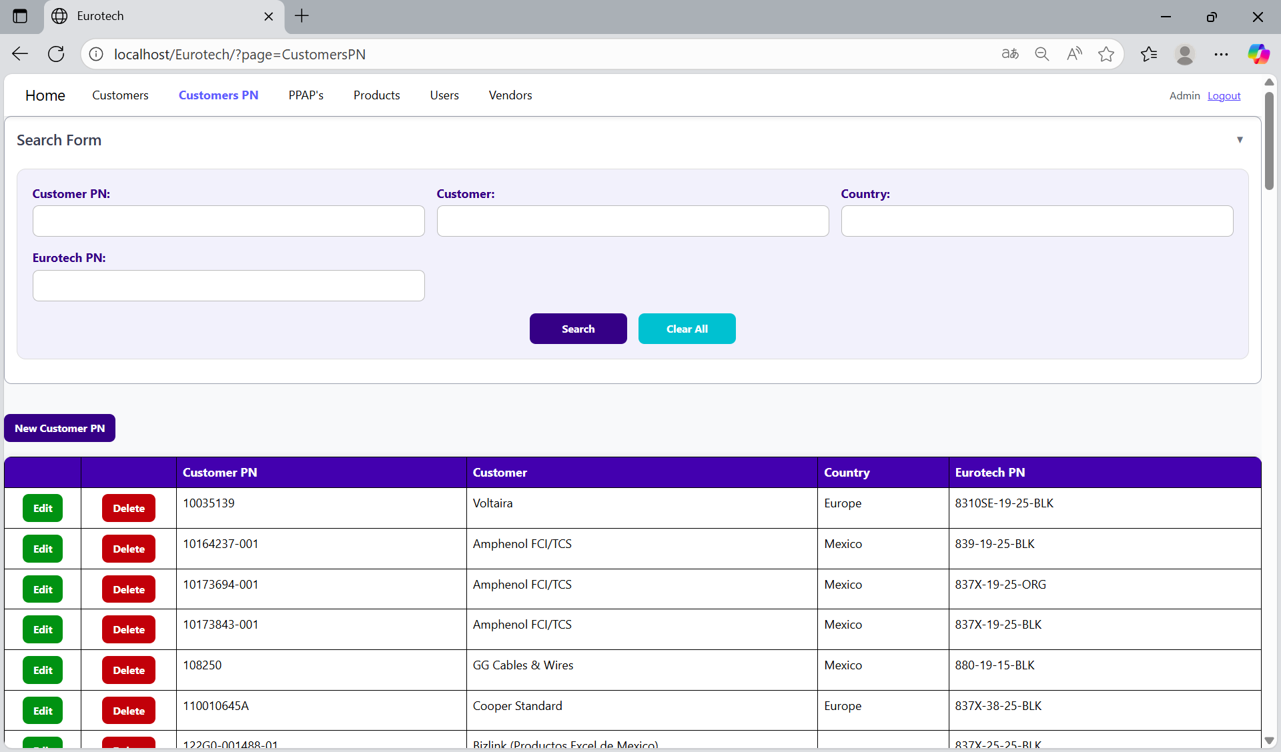

*New Customer PN.*

Below the “Search Form”, it is the “New Customer PN” button. If this button is clicked, it will display a register form to create a new Customer PN.

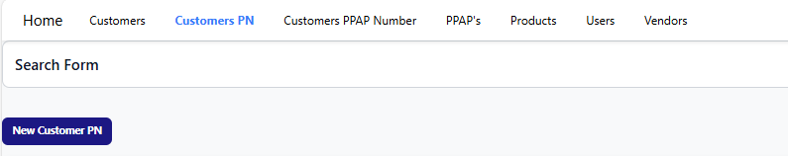

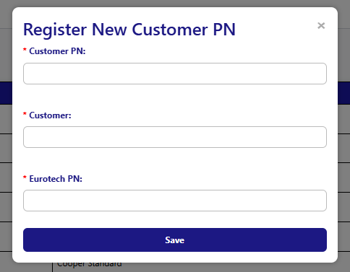

The register form has the “Customer PN”, “Customer” and “Eurotech PN” fields as mandatories. You can’t duplicate a register that already exists in the database.

If you want to save the register of a new Customer PN, you must click the “Save” button.

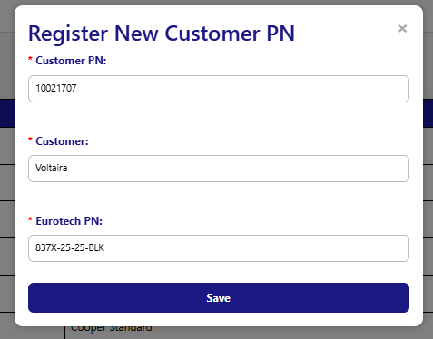

*Edit Customer PN.*

In each register from the table, it will be an “Edit” button. If this button is clicked, it will display an update form to edit the information of the selected Customer PN.

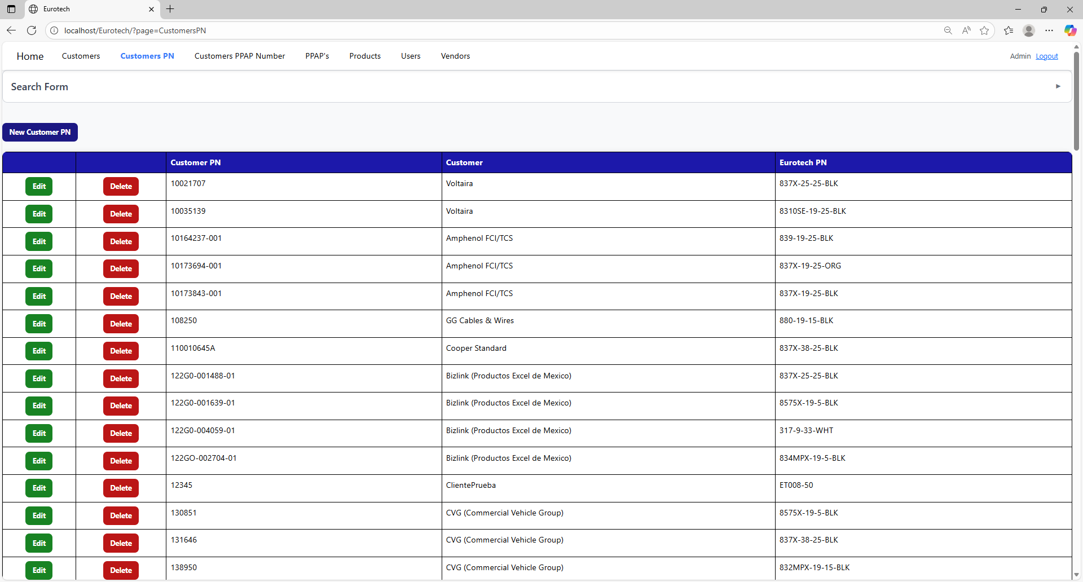

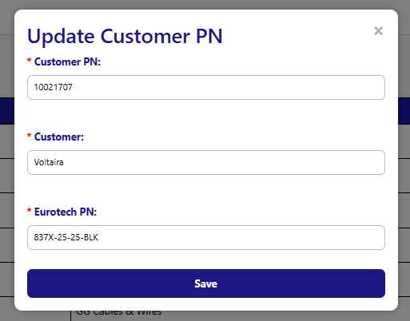

To save the changes, you must click the “Save” button.

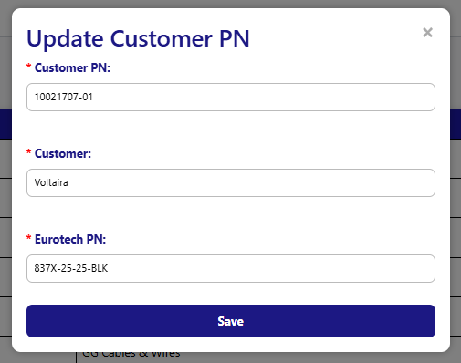

*Delete Customer PN.*

In each register from the table, it will be a “Delete” button. If this button is clicked, it will display the information of the selected Customer PN with a message to confirm the delete action.

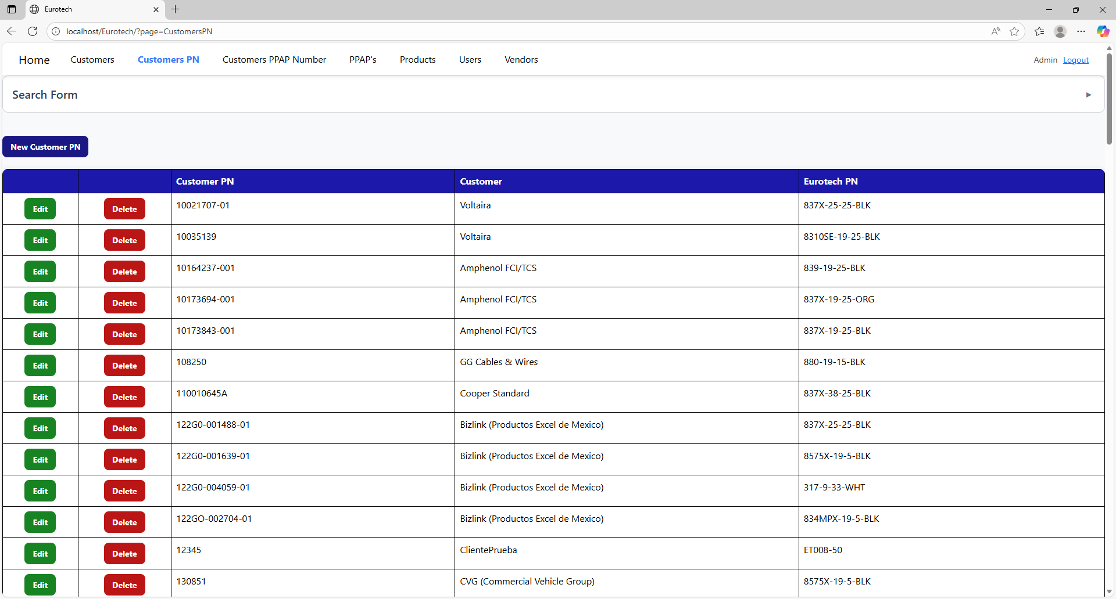

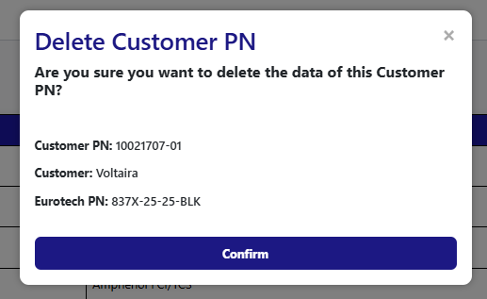

To confirm the delete action, you must click the “Confirm” button. It only deletes Customer PN that doesn’t have registers in “PPAP’s”.



***- PPAP’s Page.***

On the navigation bar, you can navigate to the “PPAP’s”.

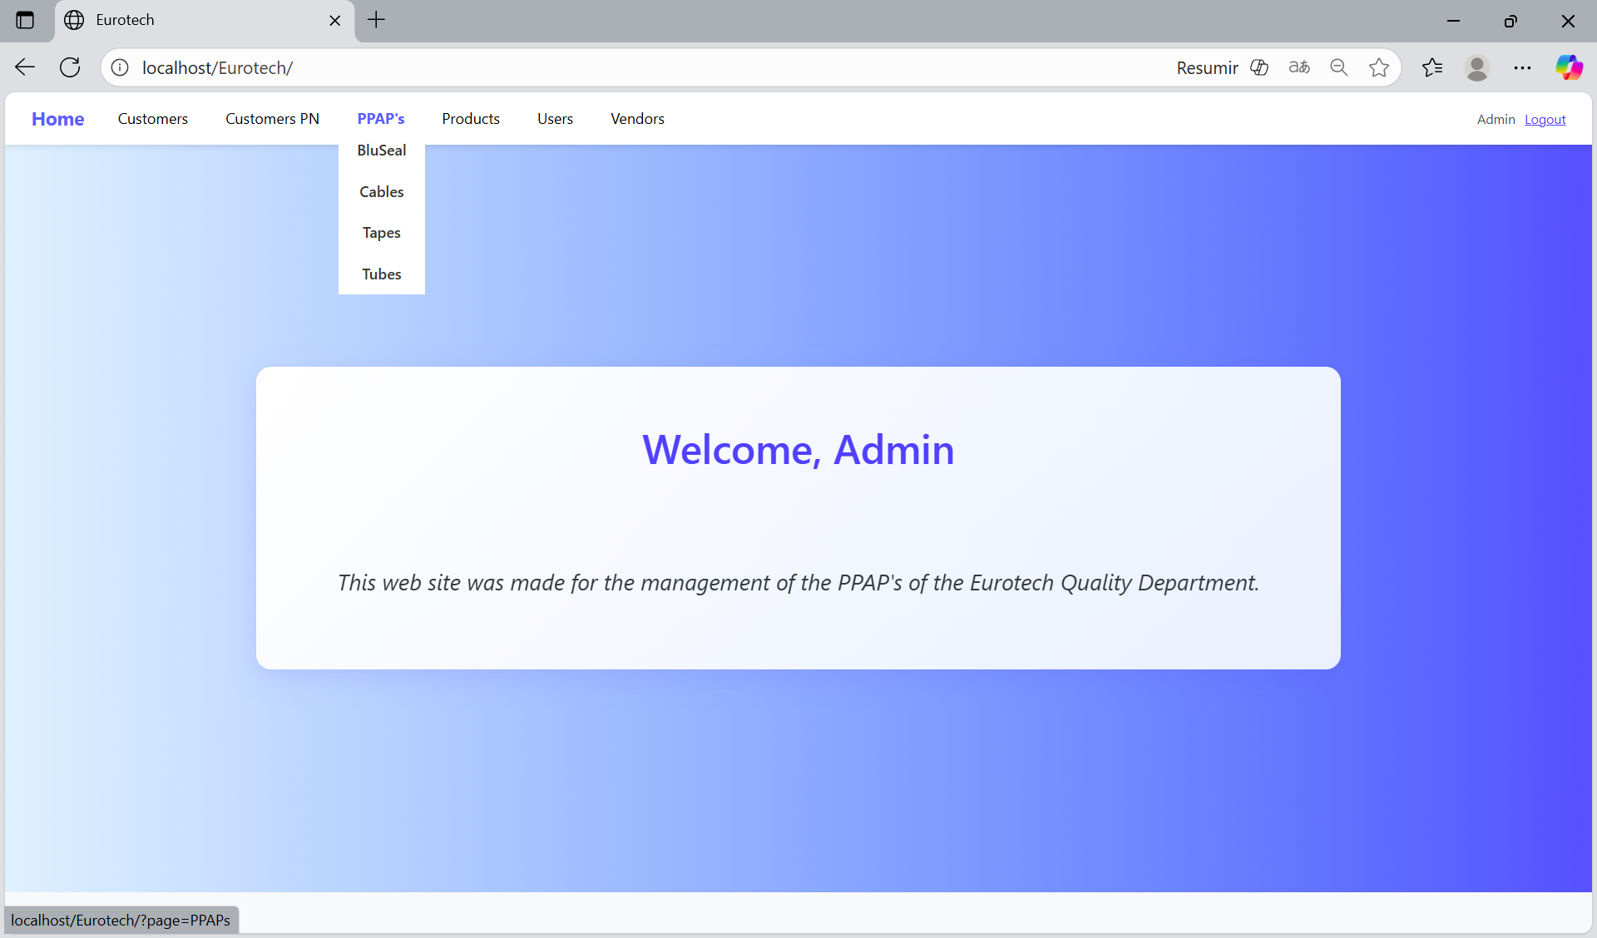

In this page you can manage the registers of all the PPAP’s of all the products.

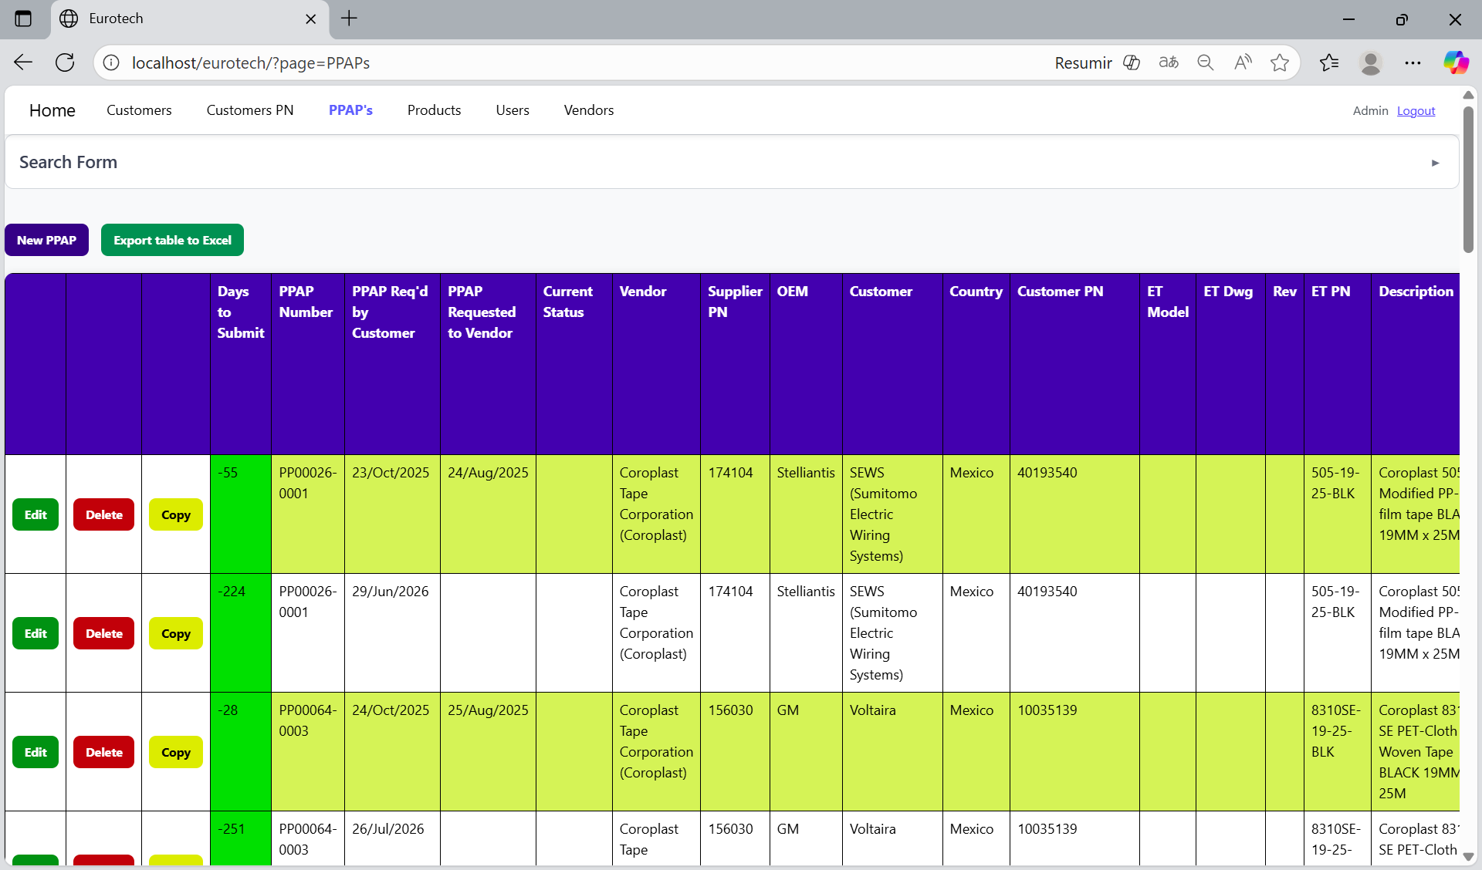

*Search Form.*

At the top of the page, it will be a dropdown “Search Form” that has all the fields of the table for querying registers.

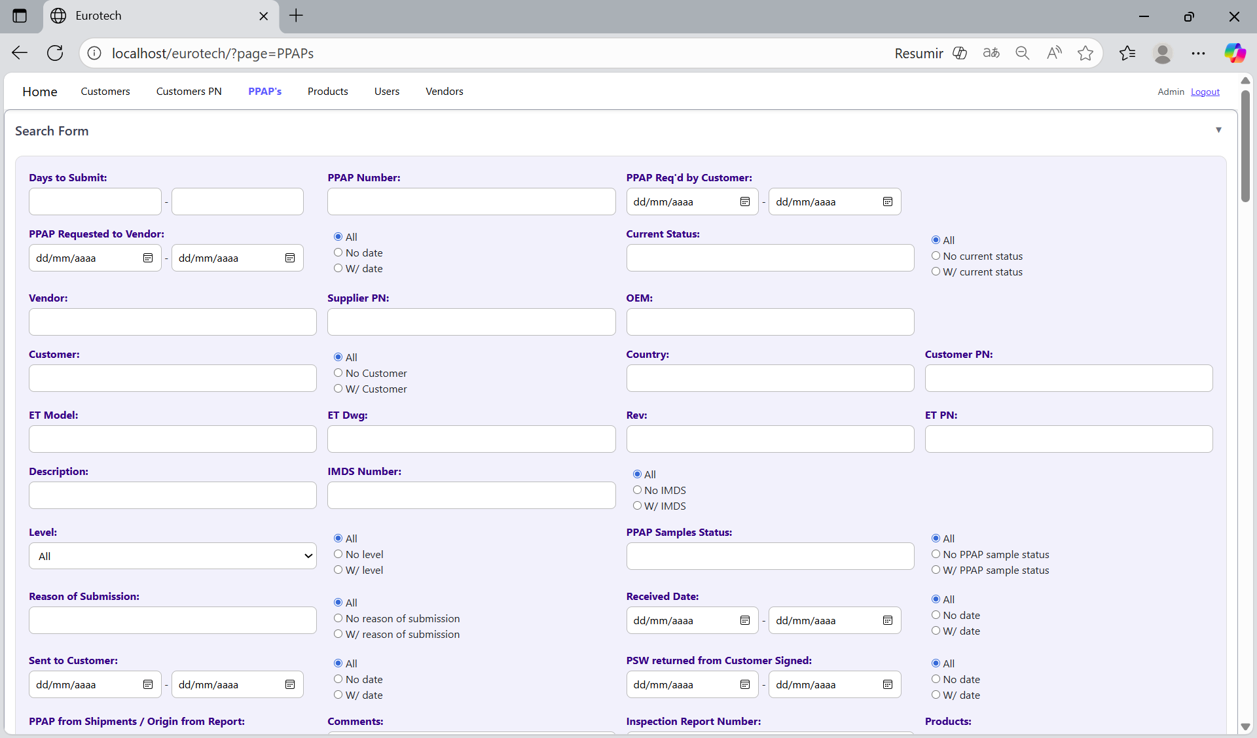

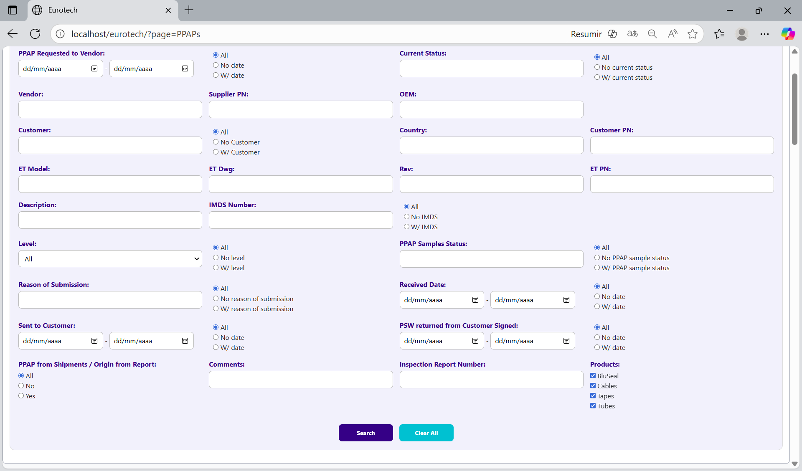

You can search by “Days to Submit”, using the “Days to Submit” fields (writing the range of days) and clicking the “Search” button.

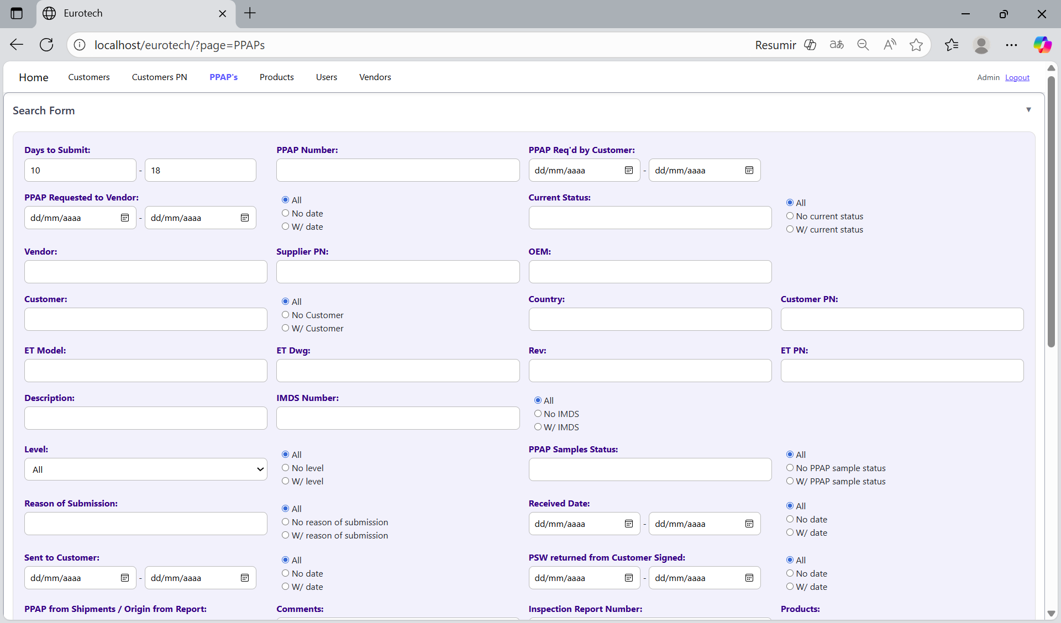

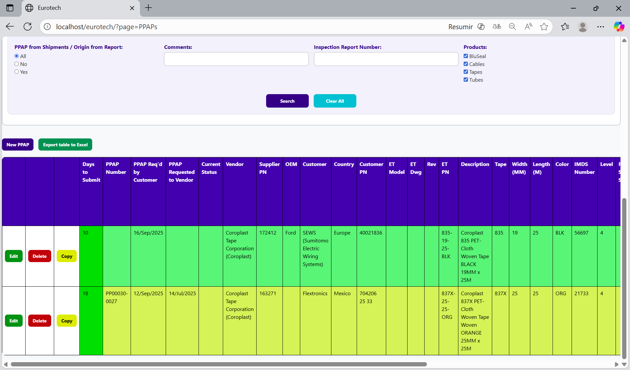

You can search by “PPAP Number”, using the “PPAP Number” field and clicking the “Search” button.

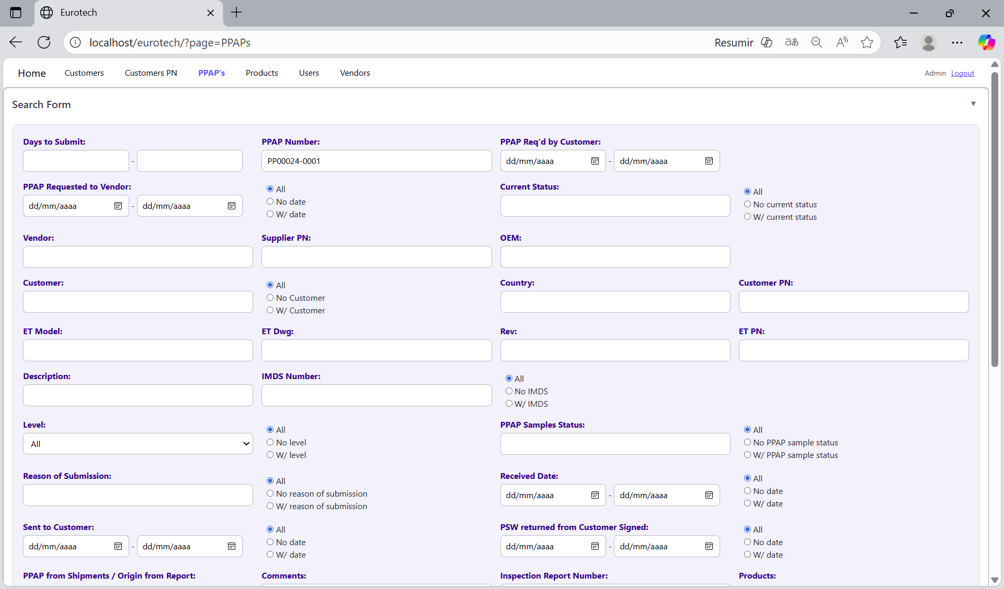



You can search by “Country”, using the “Country” field and clicking the “Search” button.



You can search by “Eurotech PN”, using the “Eurotech PN” field and clicking the “Search” button.



And with the “Clear All” button, you can clean the querying and see all the registers of the Customer PN.





*New Customer PN.*

Below the “Search Form”, it is the “New Customer PN” button. If this button is clicked, it will display a register form to create a new Customer PN.





The register form has the “Customer PN”, “Customer” and “Eurotech PN” fields as mandatories. You can’t duplicate a register that already exists in the database.

If you want to save the register of a new Customer PN, you must click the “Save” button.



*Edit Customer PN.*

In each register from the table, it will be an “Edit” button. If this button is clicked, it will display an update form to edit the information of the selected Customer PN.





To save the changes, you must click the “Save” button.



*Delete Customer PN.*

In each register from the table, it will be a “Delete” button. If this button is clicked, it will display the information of the selected Customer PN with a message to confirm the delete action.





To confirm the delete action, you must click the “Confirm” button. It only deletes Customer PN that doesn’t have registers in “PPAP’s”.



***- BluSeal Page.***

***- Cables Page.***

***- Tapes Page.***

***- Tubes Page.***

***- Products Page.***

On the navigation bar, you can navigate to the “Products Page”.

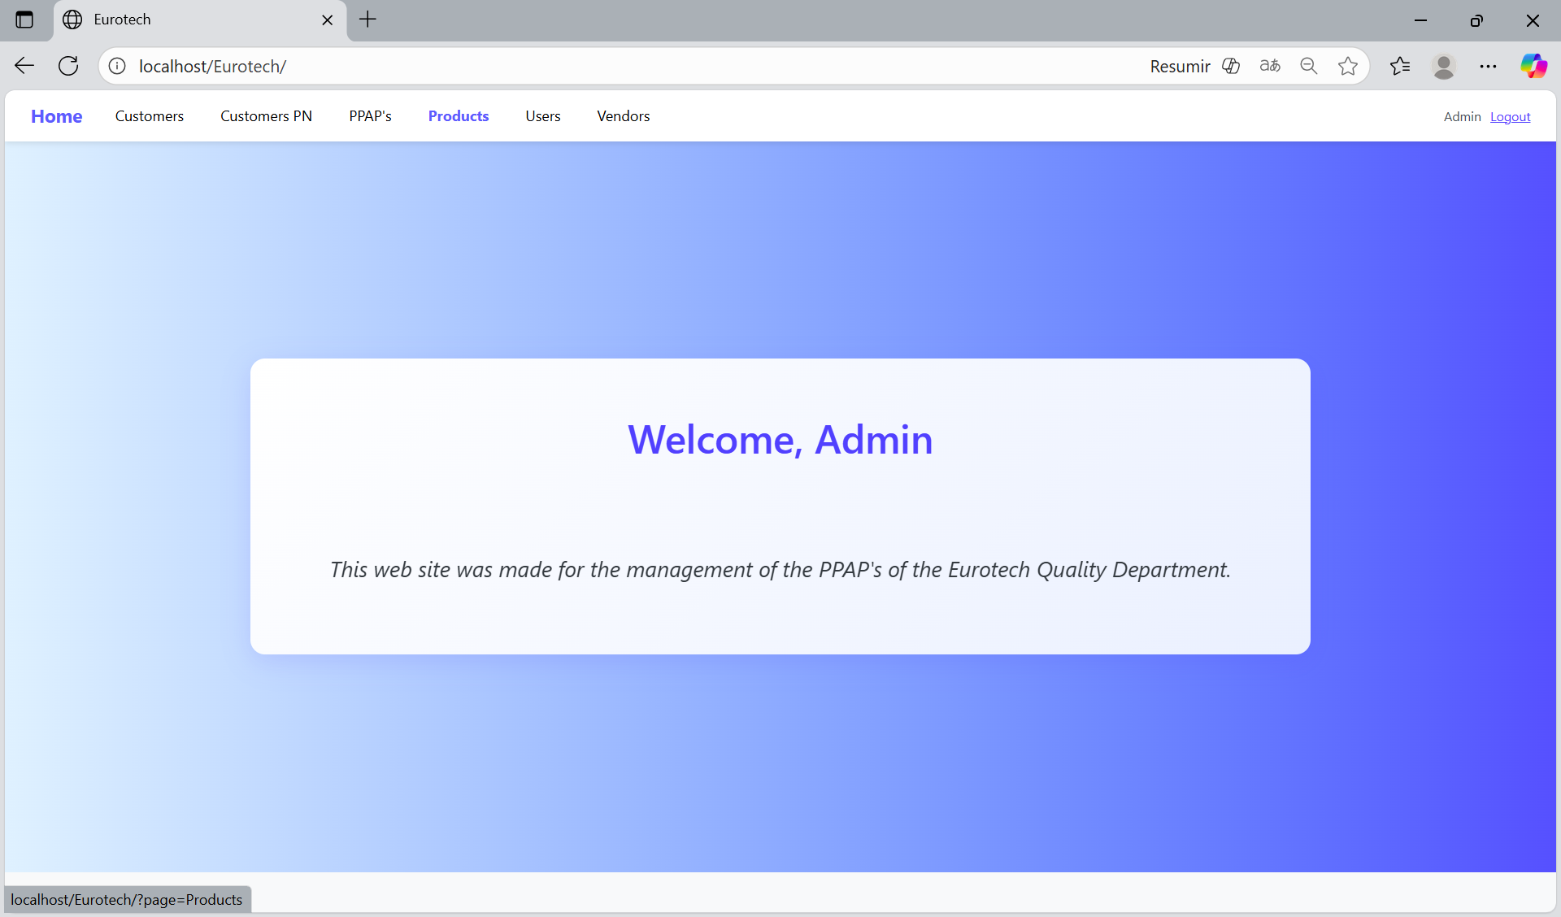

In this page you can manage the registers of all the products.

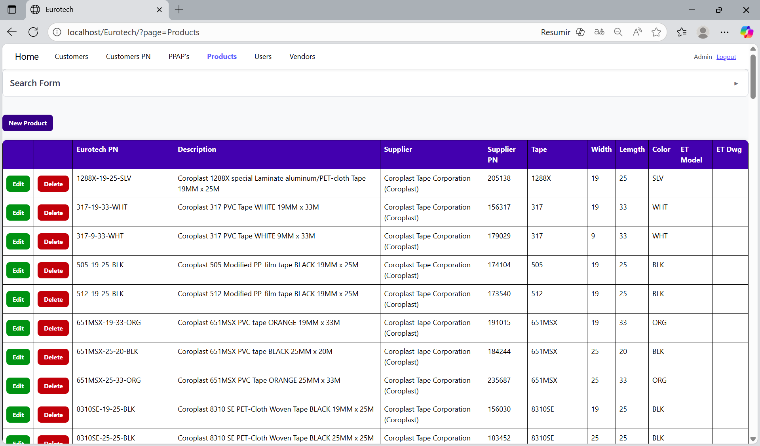

*Search Form.*

At the top of the page, it will be a dropdown “Search Form” that has all the fields of the table for querying registers.

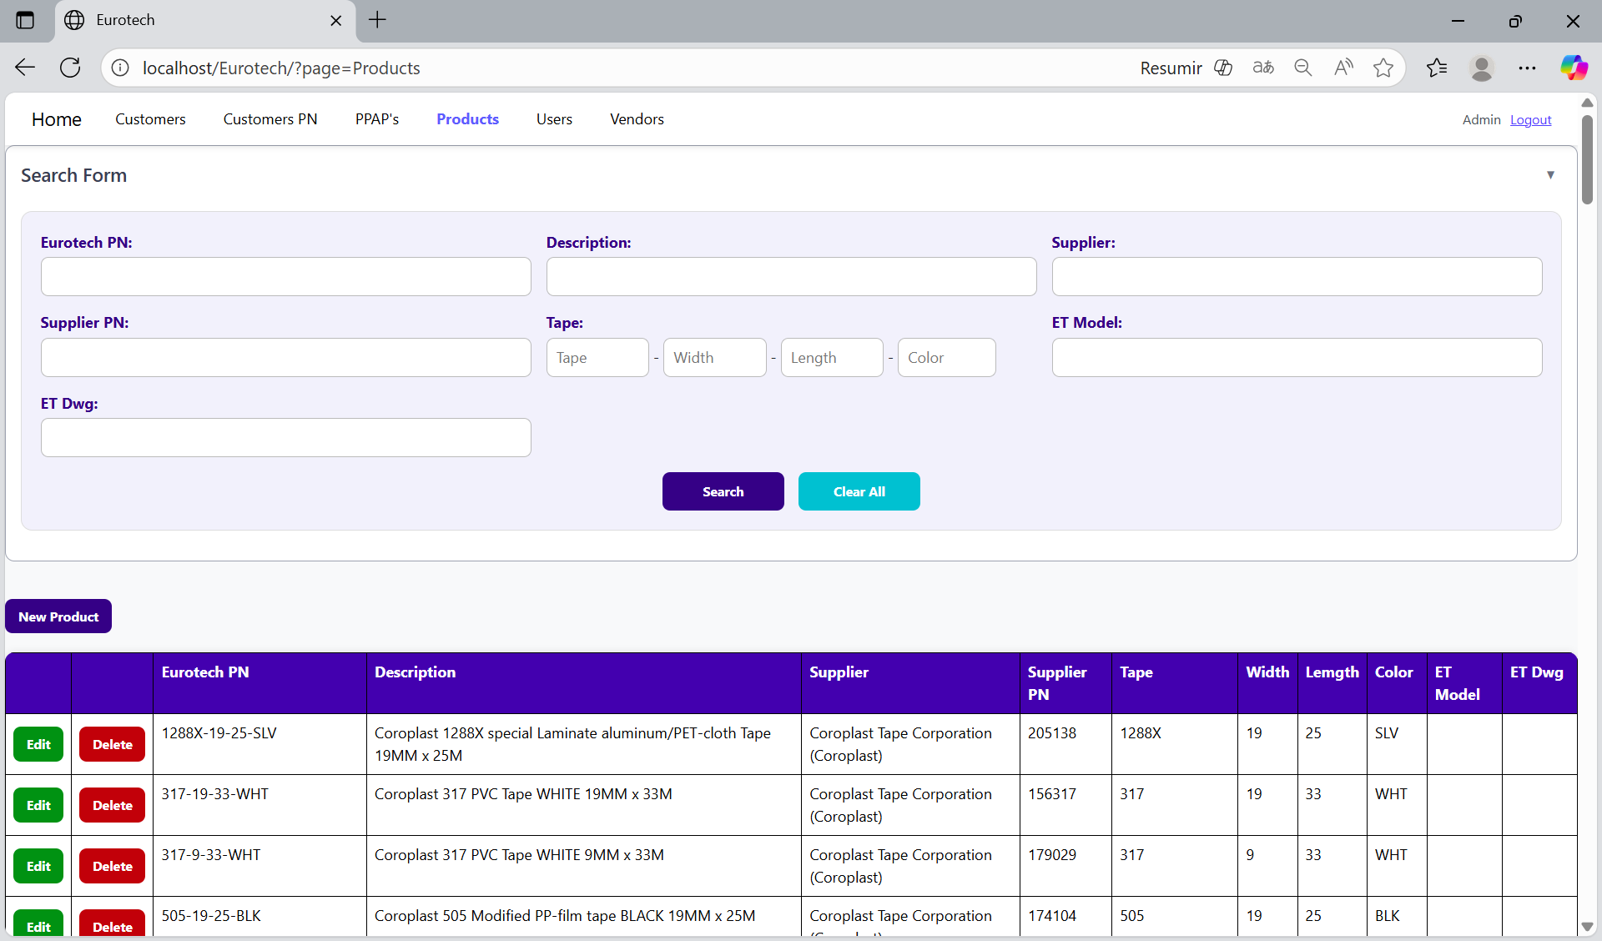

You can search by “Eurotech PN”, using the “Eurotech PN” field and clicking the “Search” button.

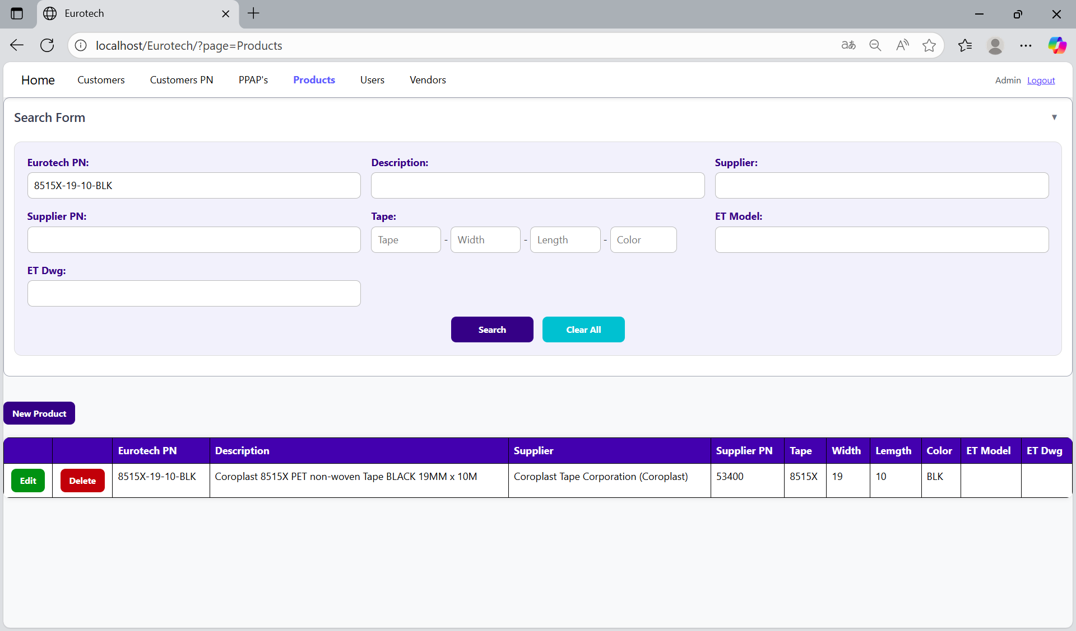

You can search by “Description”, using the “Description” field and clicking the “Search” button.

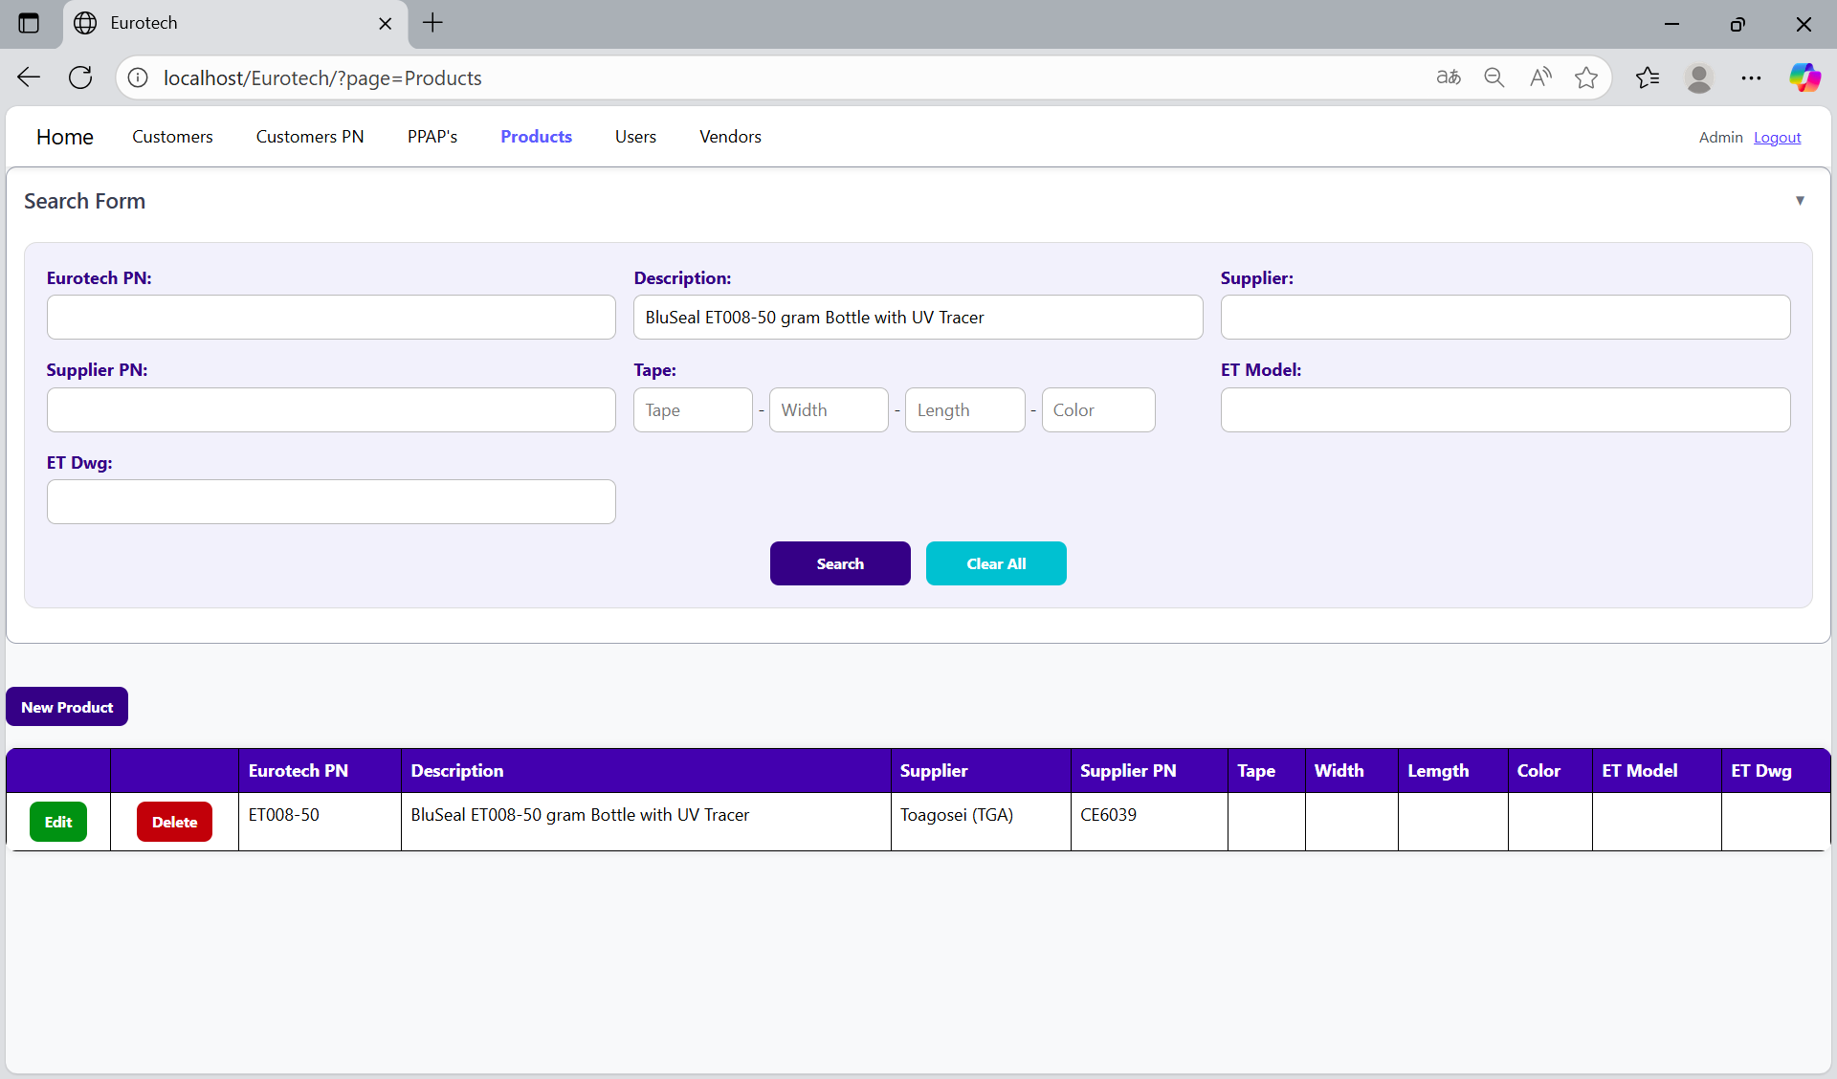

You can search by “Supplier”, using the “Supplier” field and clicking the “Search” button.

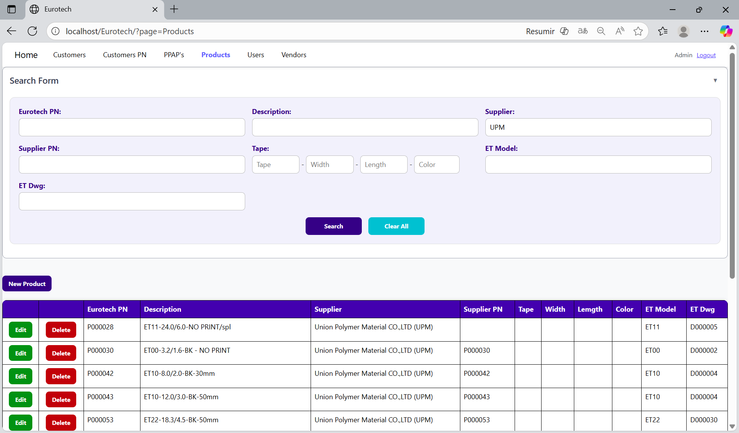

You can search by “Supplier PN”, using the “Supplier PN” field and clicking the “Search” button.

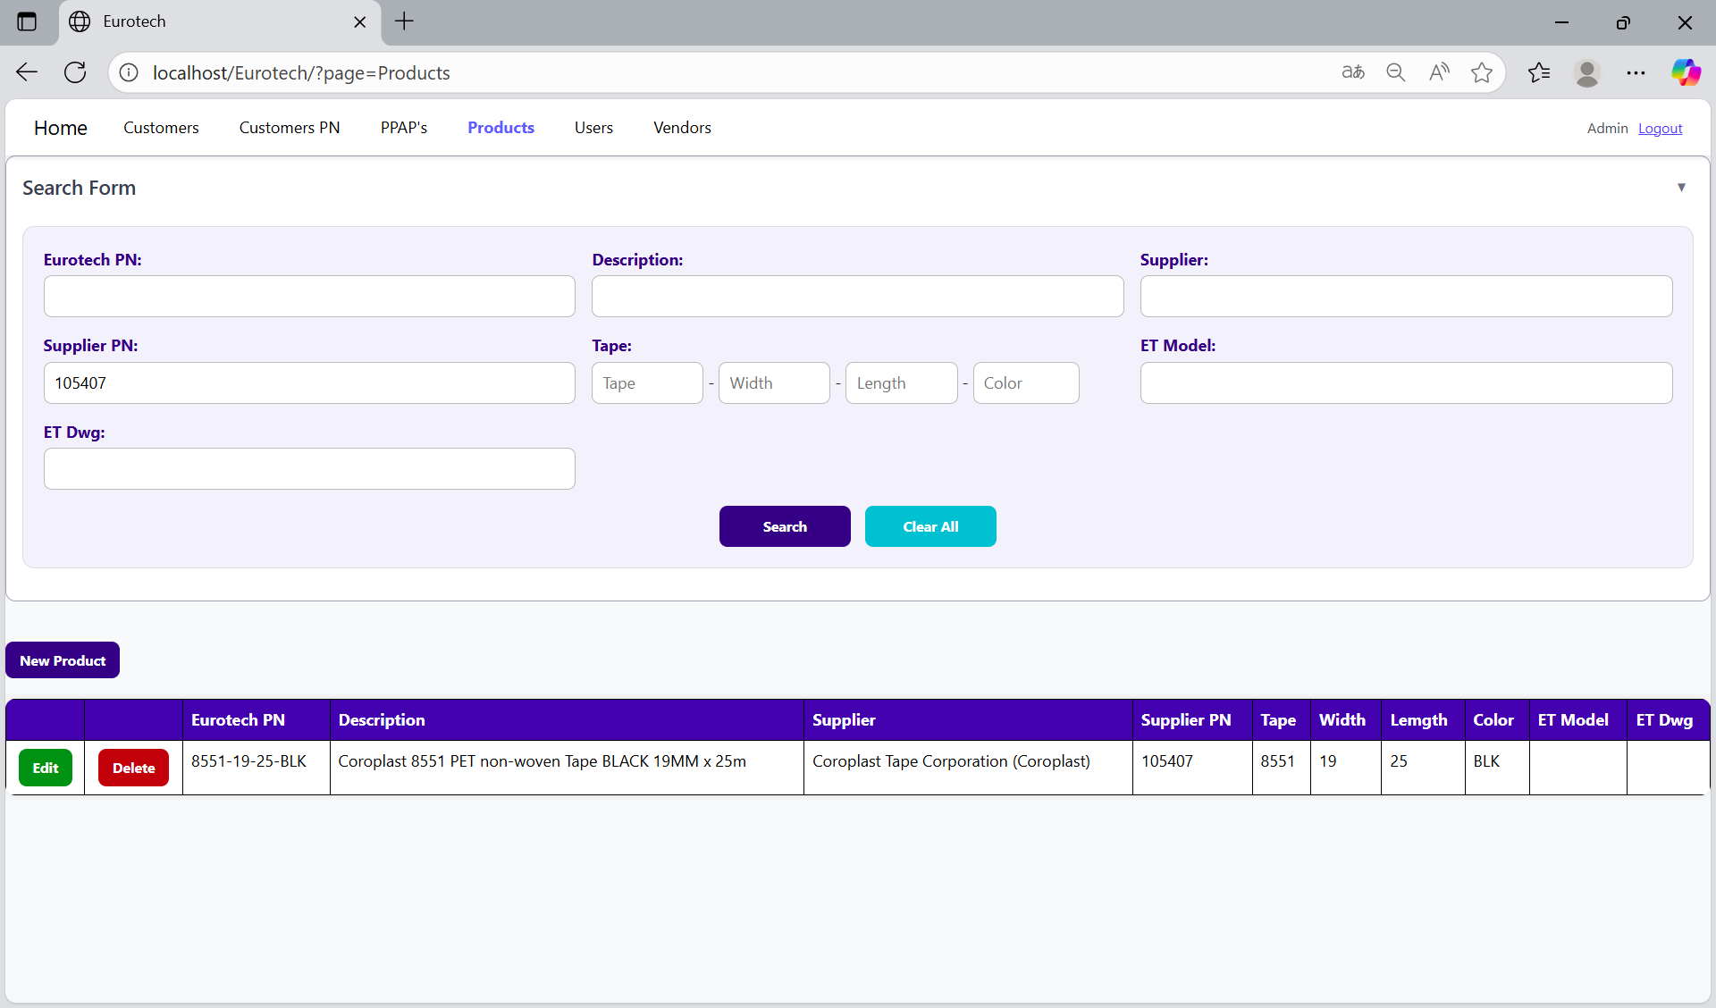

You can search by “Tape”, using the “Tape” field and clicking the “Search” button.

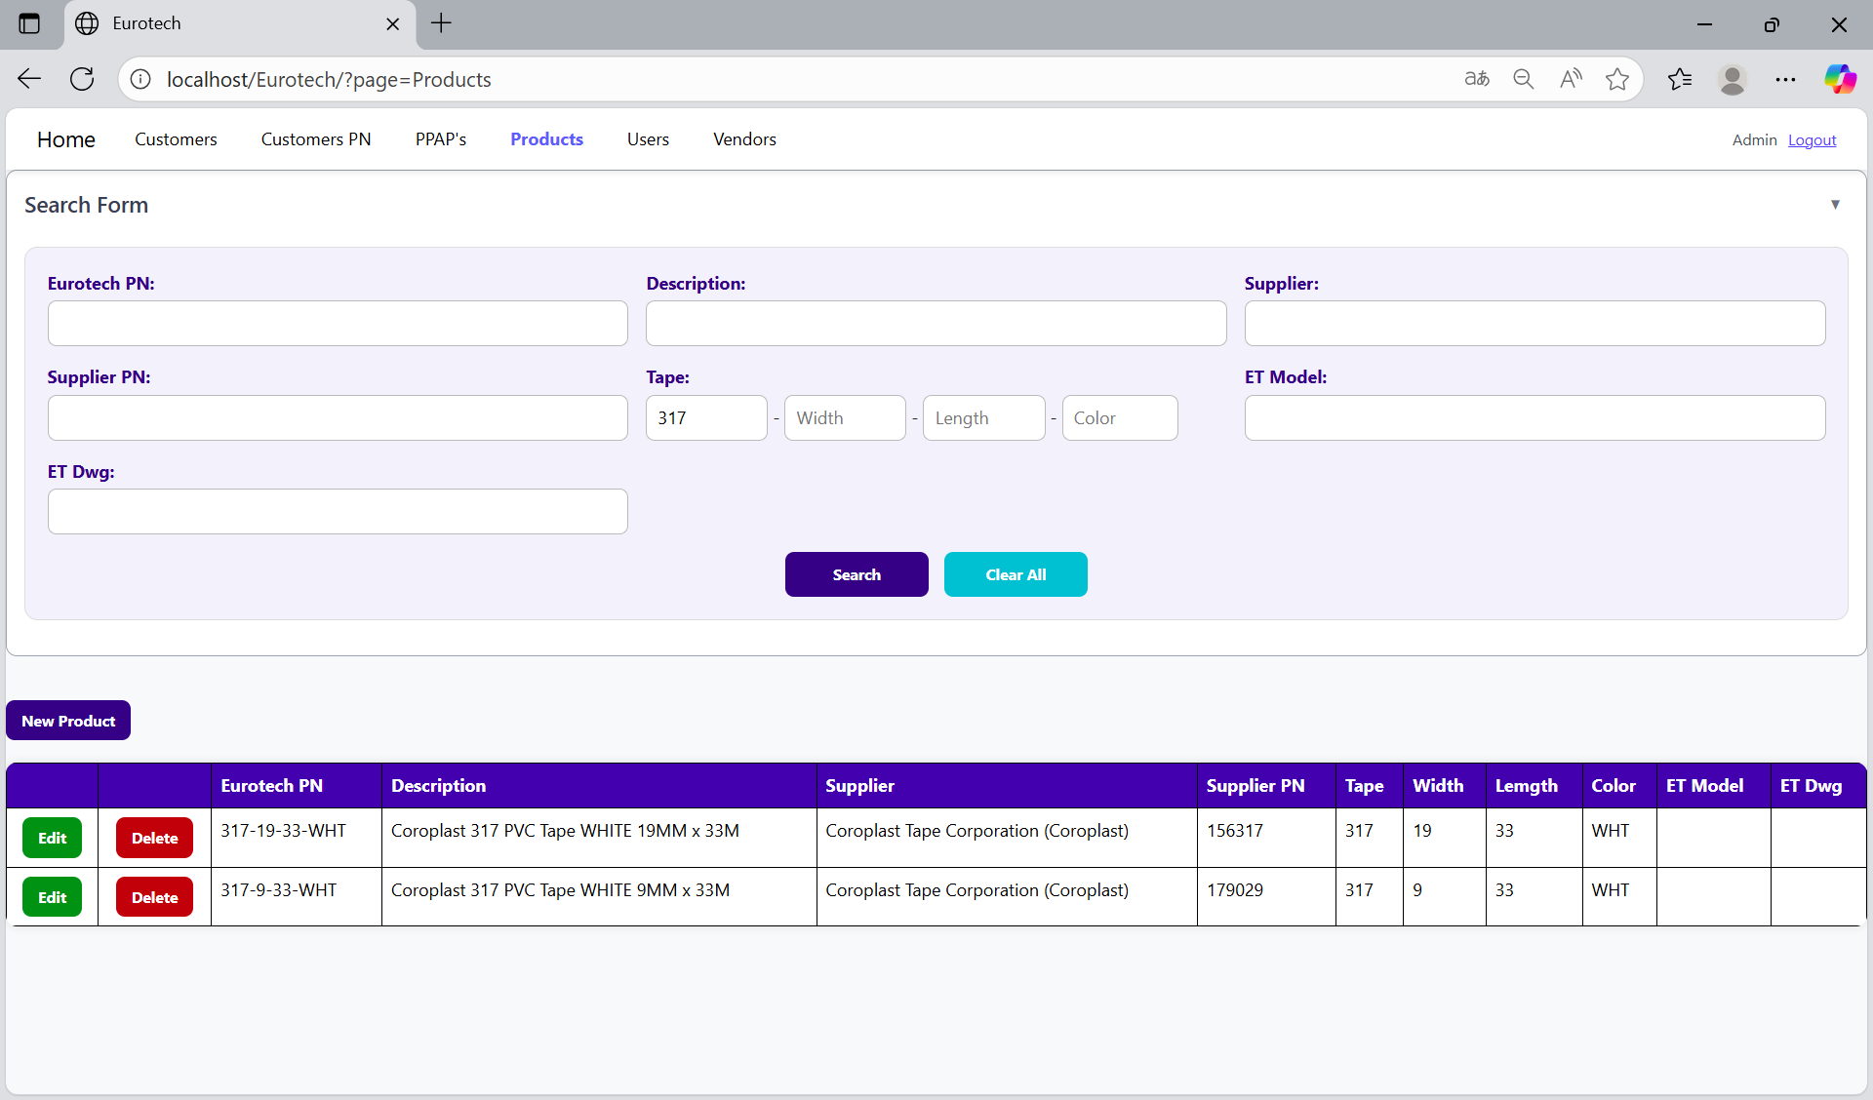

You can search by “Width”, using the “Width” field and clicking the “Search” button.

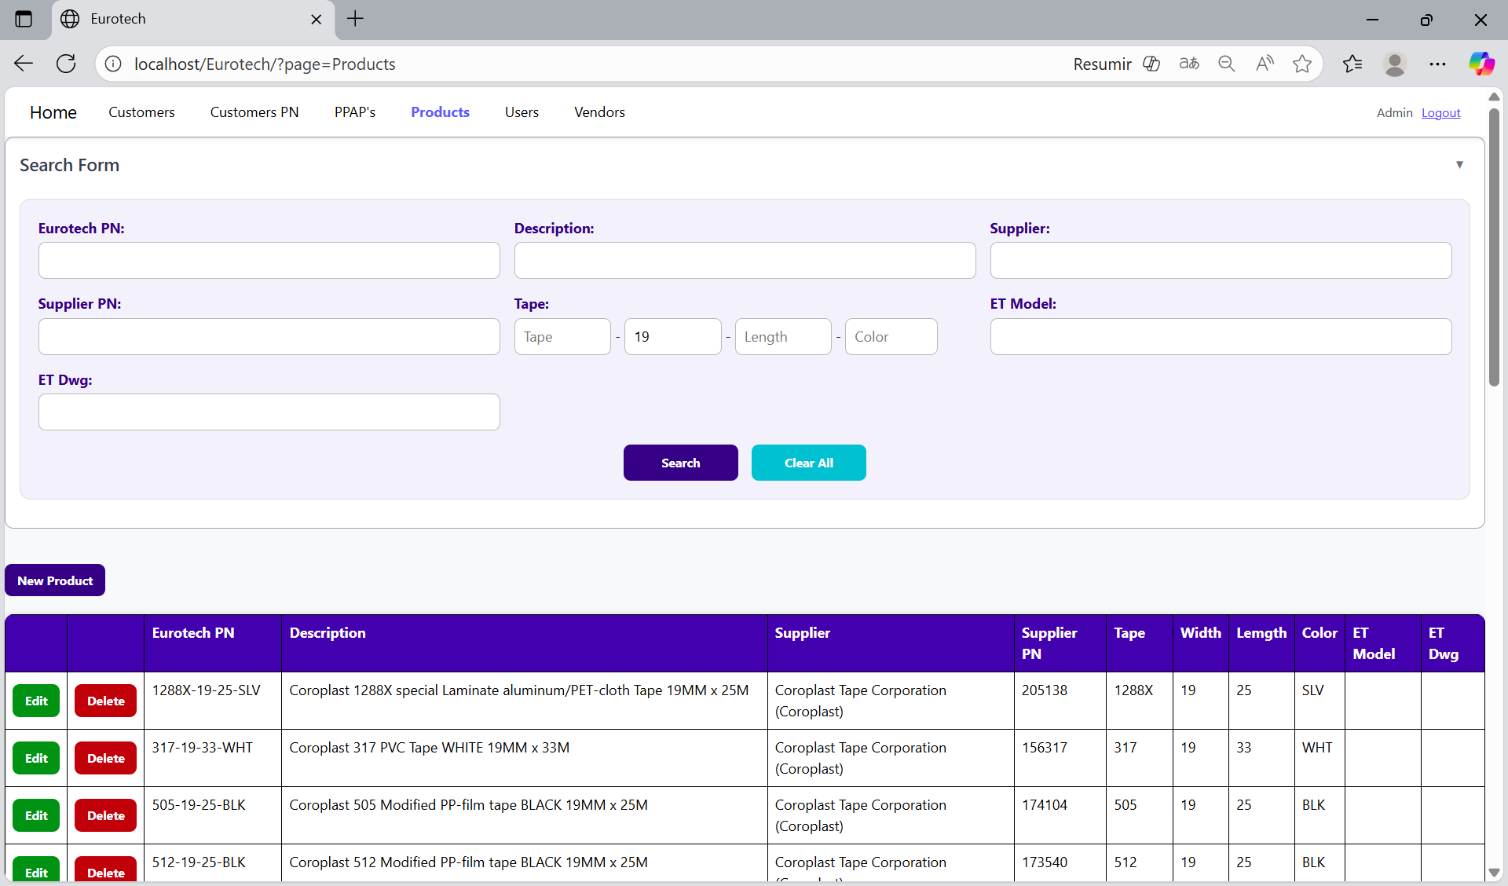

You can search by “Length”, using the “Length” field and clicking the “Search” button.

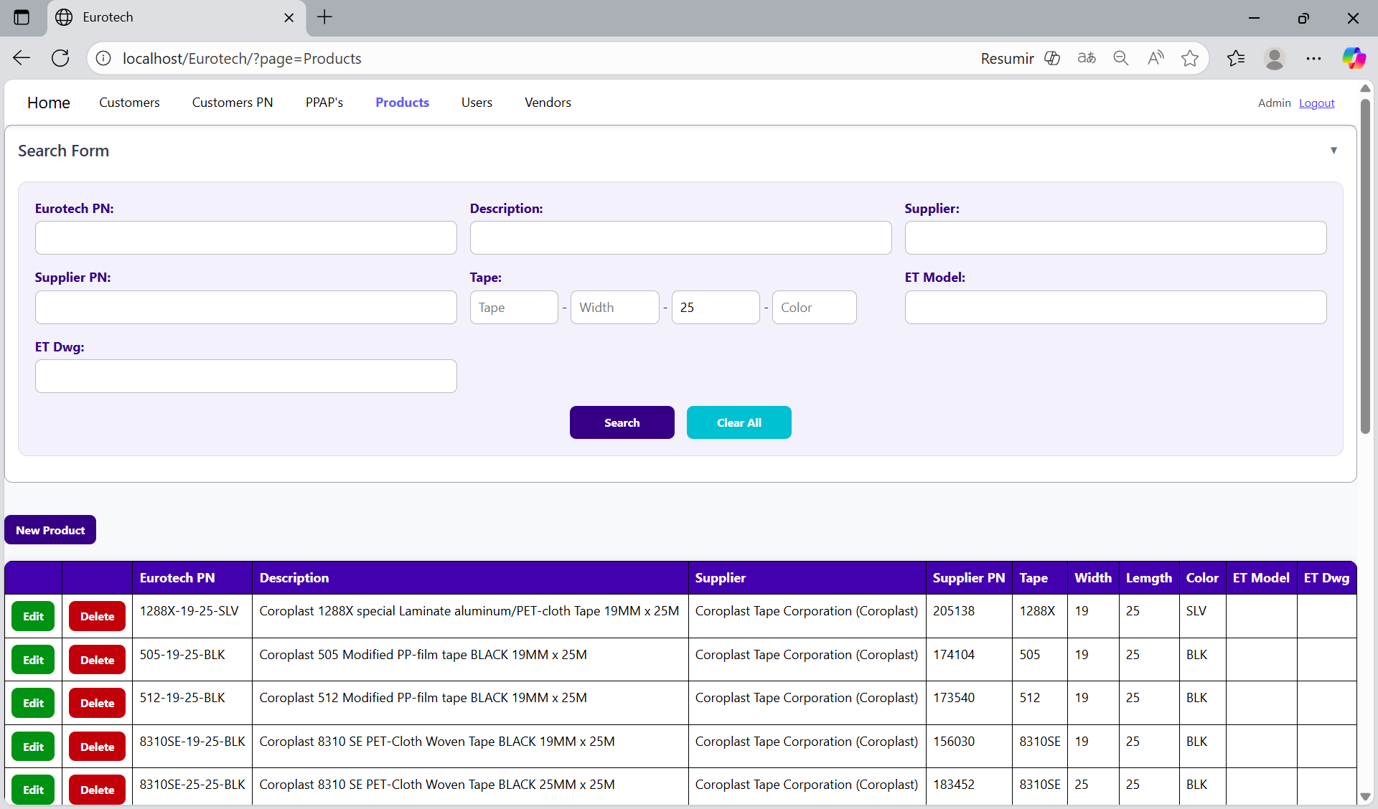

You can search by “Color”, using the “Color” field and clicking the “Search” button.

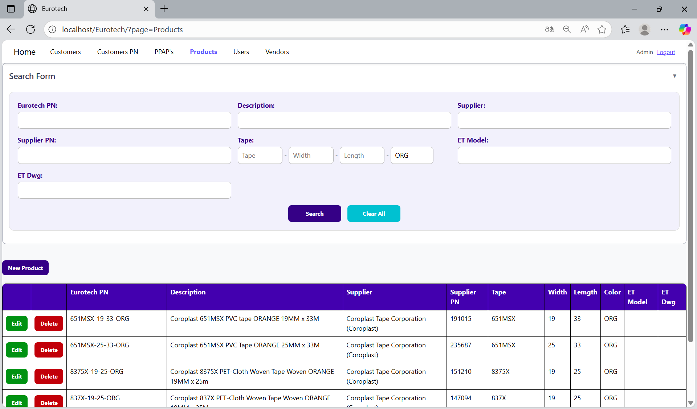

You can search by “ET Model”, using the “ET Model” field and clicking the “Search” button.

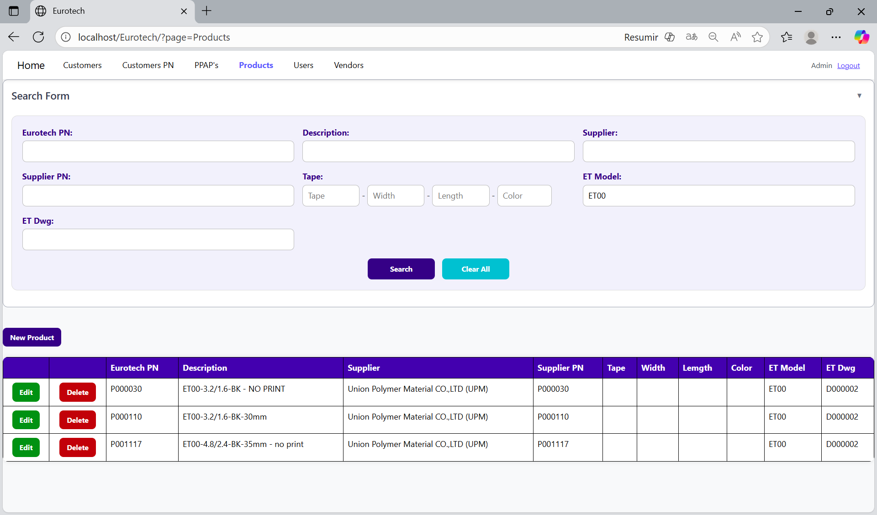

You can search by “ET Dwg”, using the “ET Dwg” field and clicking the “Search” button.

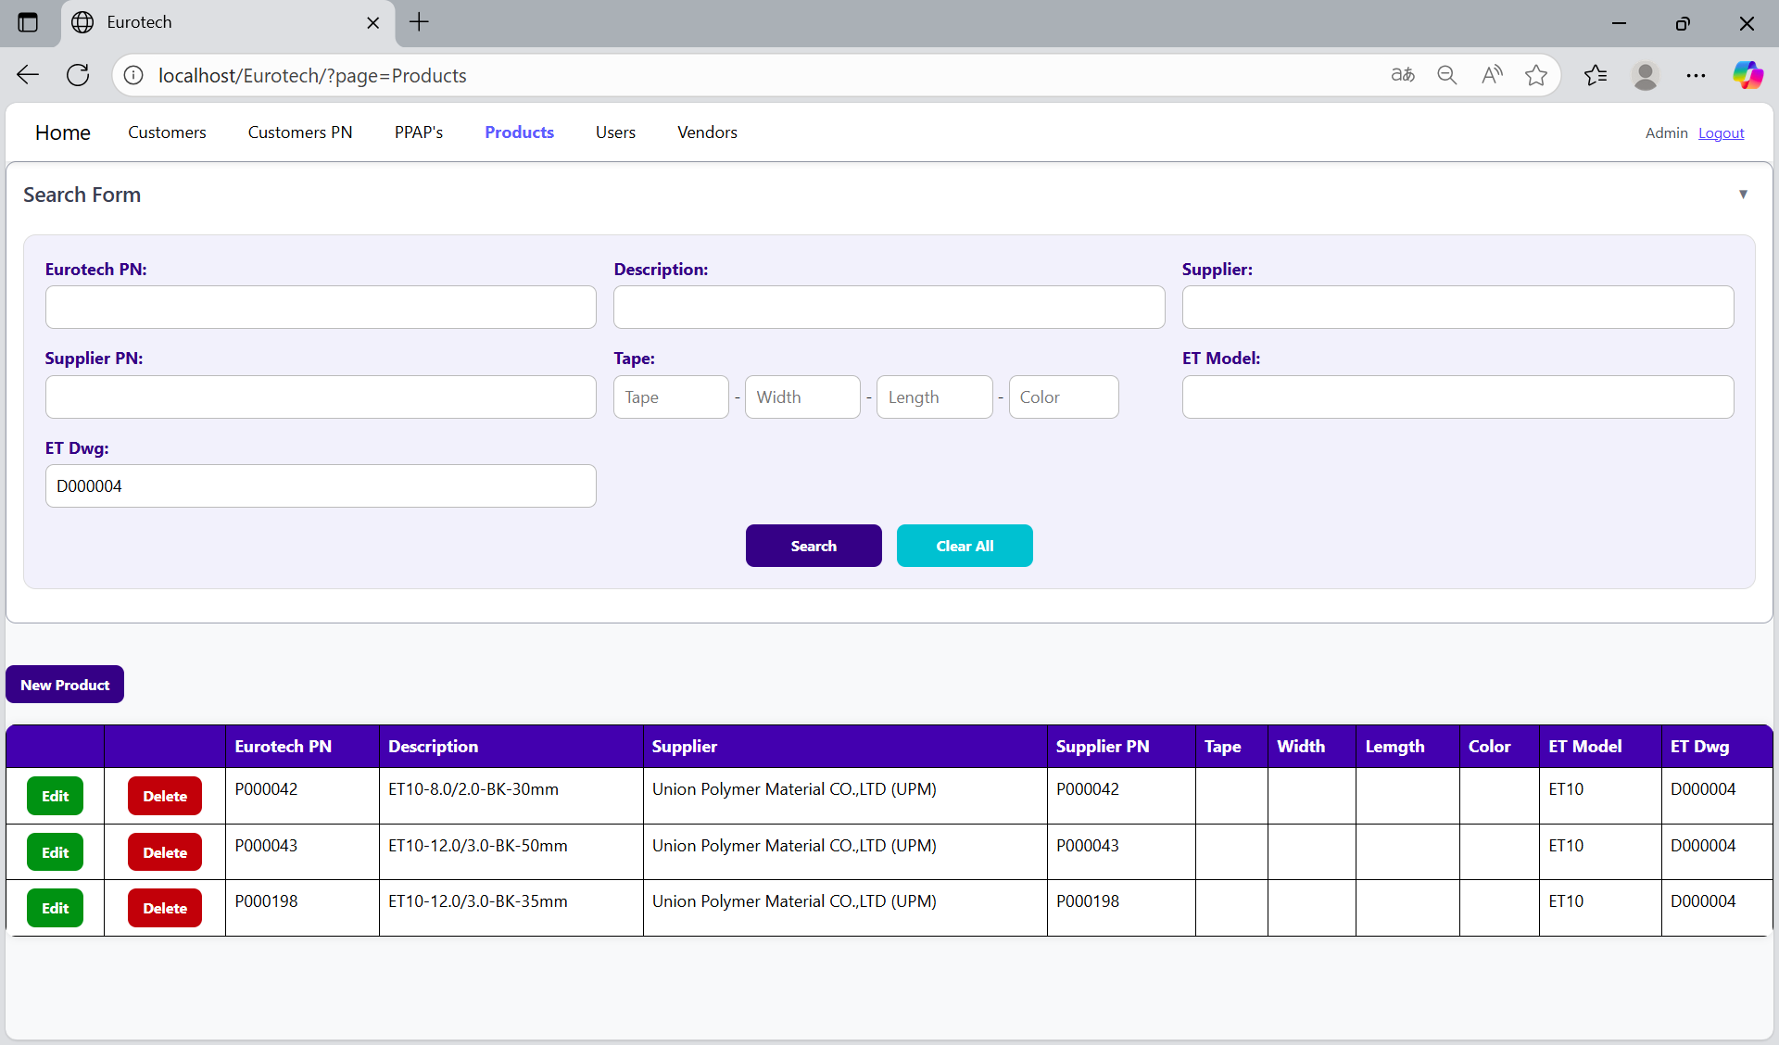

And with the “Clear All” button, you can clean the querying and see all the registers of the products.

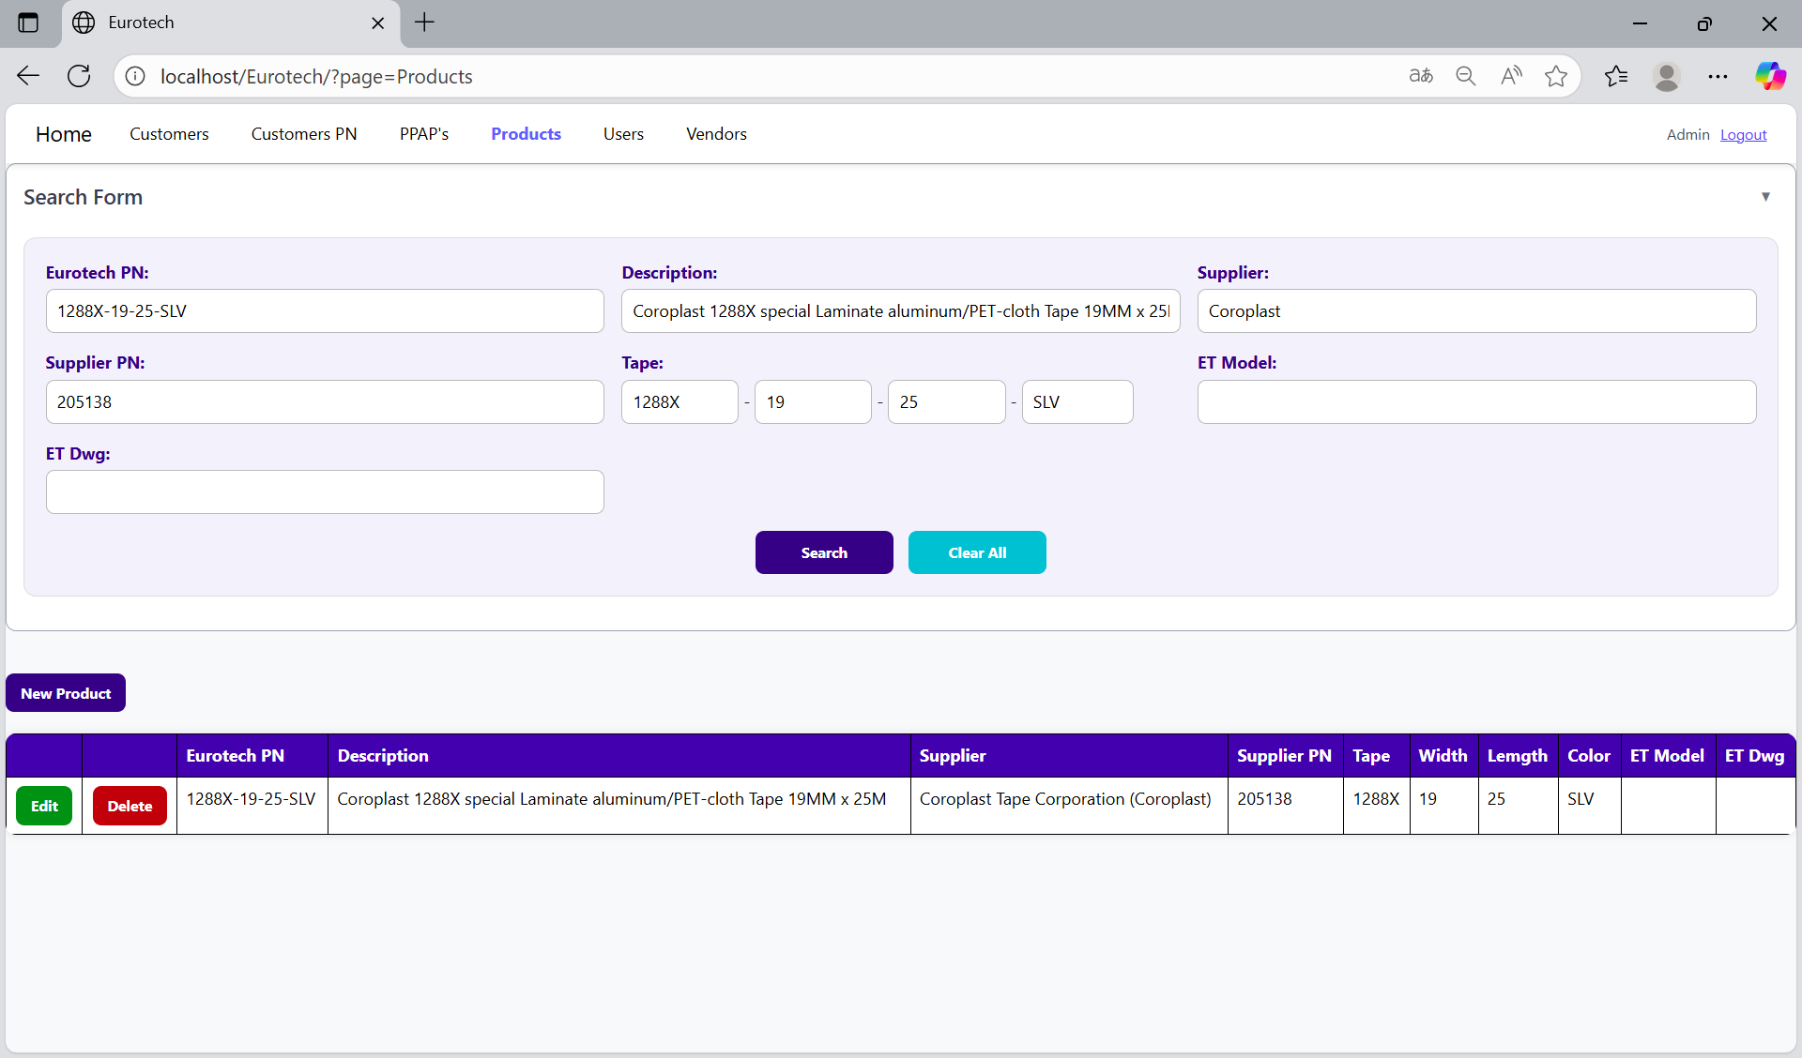

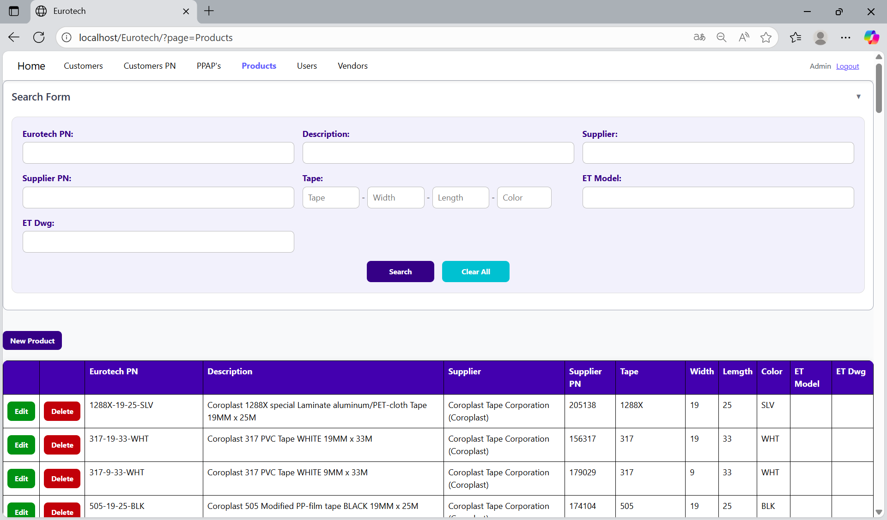

*New Product.*

Below the “Search Form”, it is the “New Product” button. If this button is clicked, it will display a register form to create a new product.



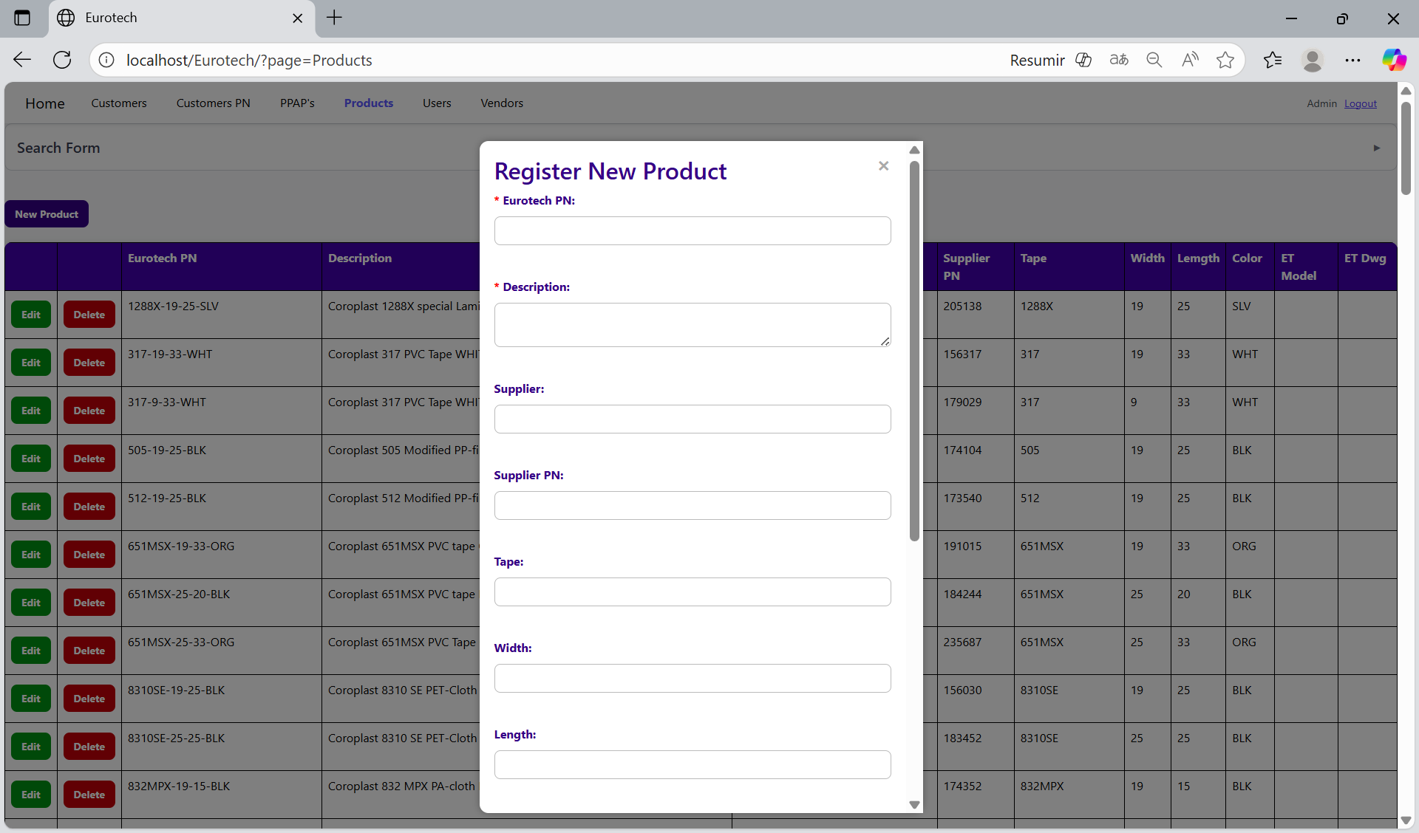

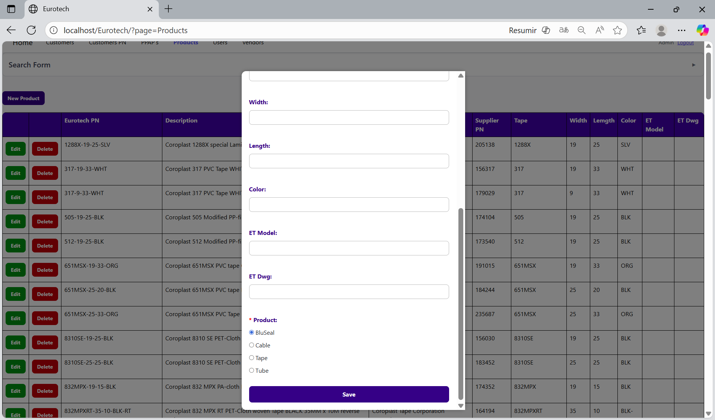

The register form has the “Eurotech PN”, “Description” and “Product” fields as mandatories, and the “Supplier”, “Supplier PN”, “Tape”, “Width”, “Length”, “Color”, “ET Model” and “ET Dwg” fields that aren’t mandatories. You can’t duplicate registers that already exist in the database.

If you want to save the register of a new product, you must click the “Save” button.

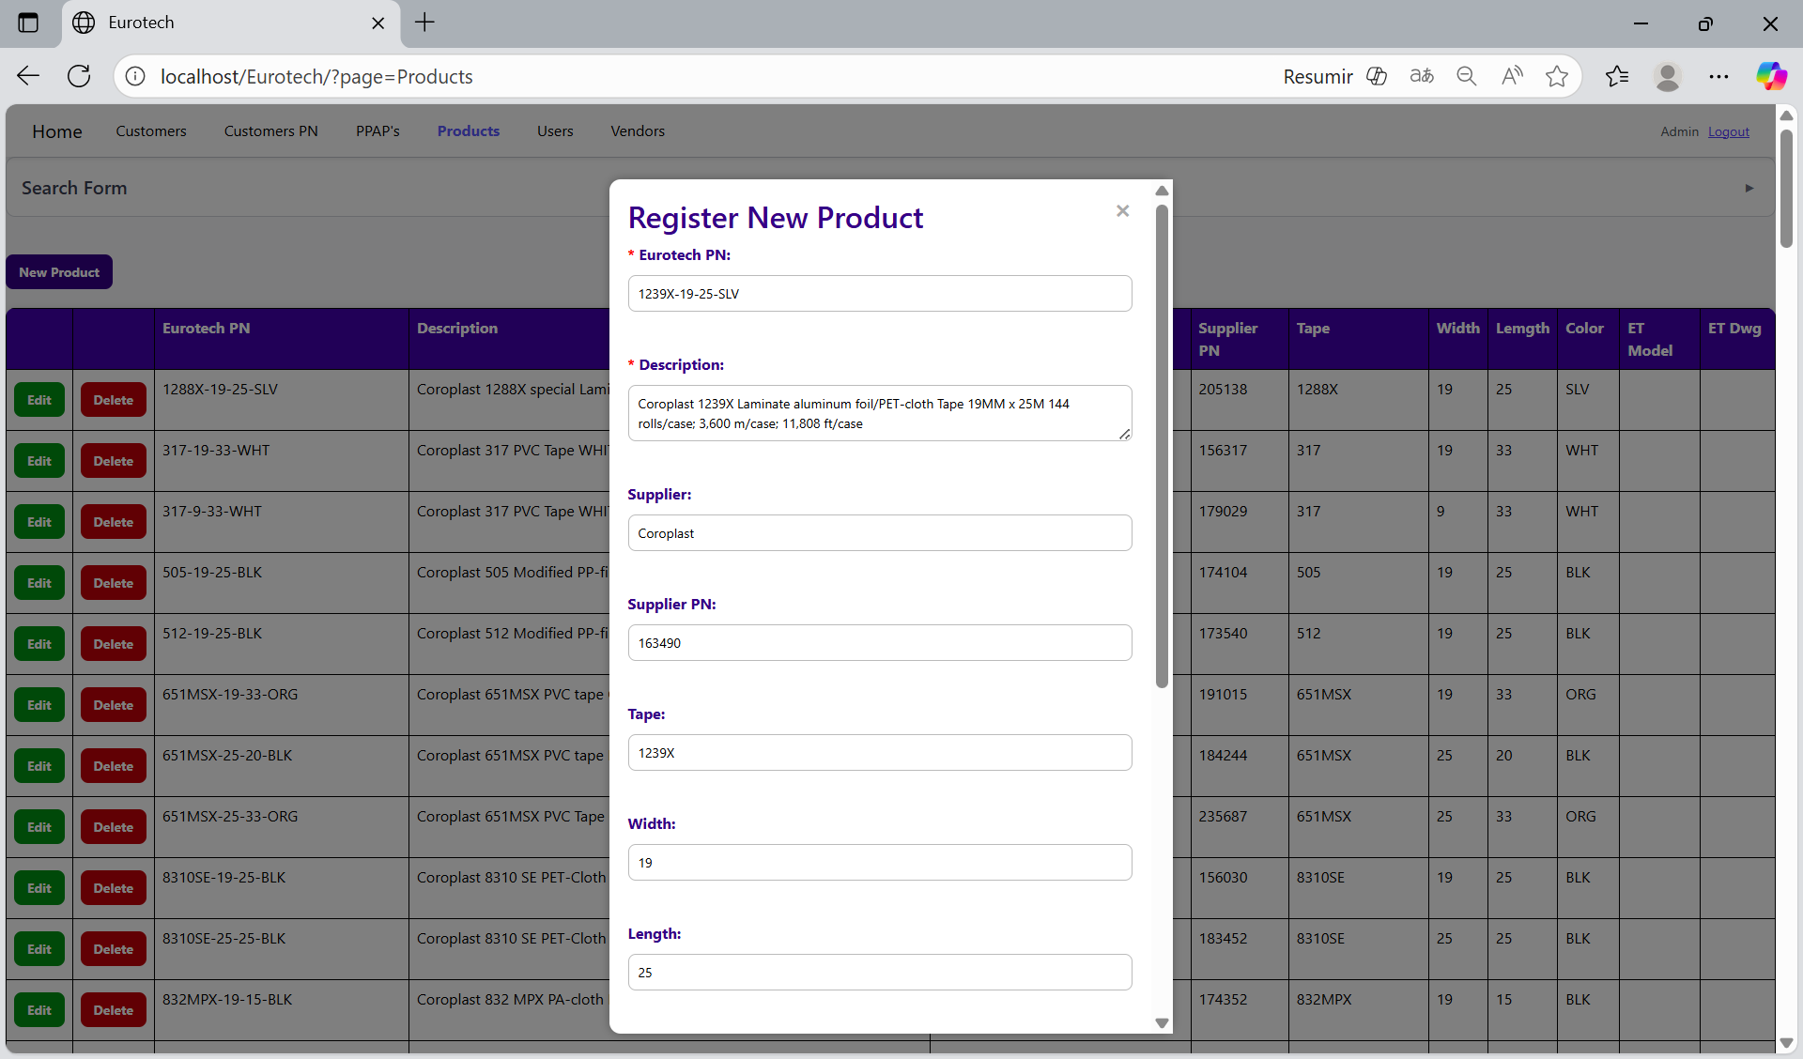

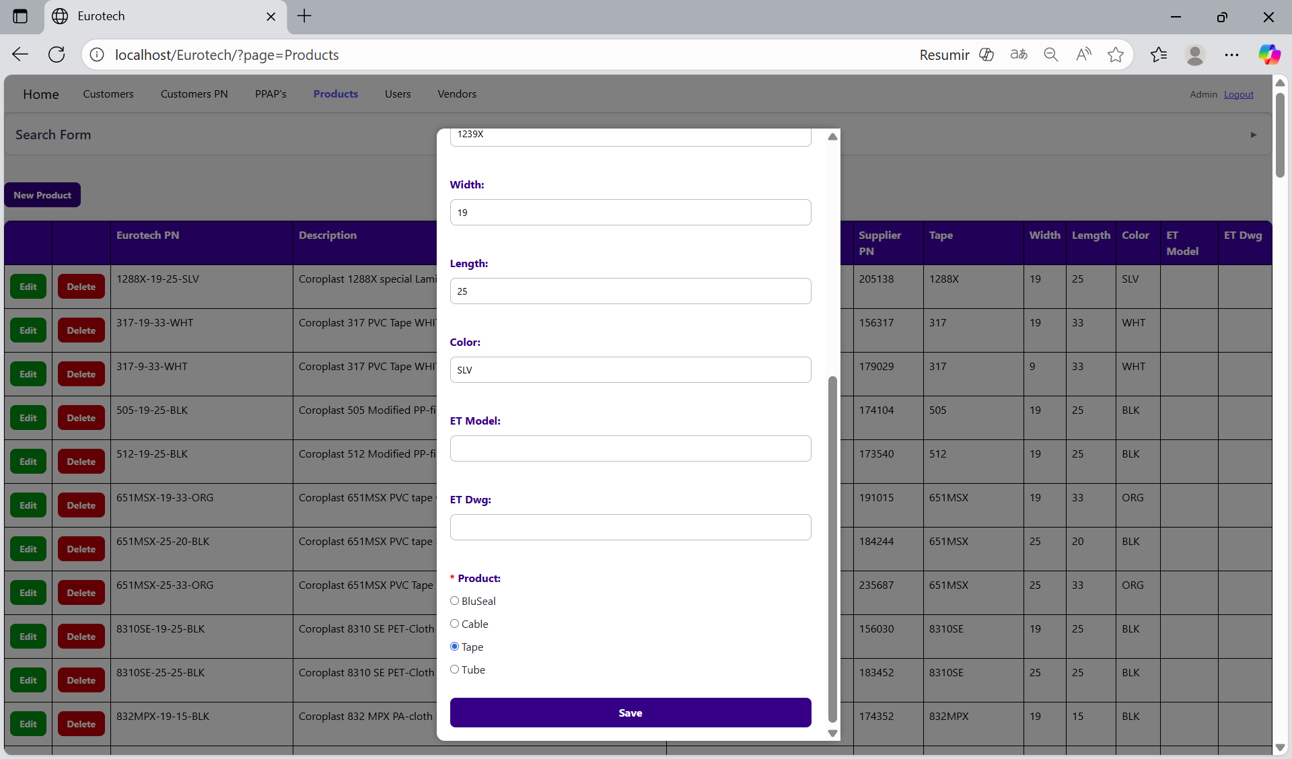

*Edit Product.*

In each register from the table, it will be an “Edit” button. If this button is clicked, it will display an update form to edit the information of the selected product.

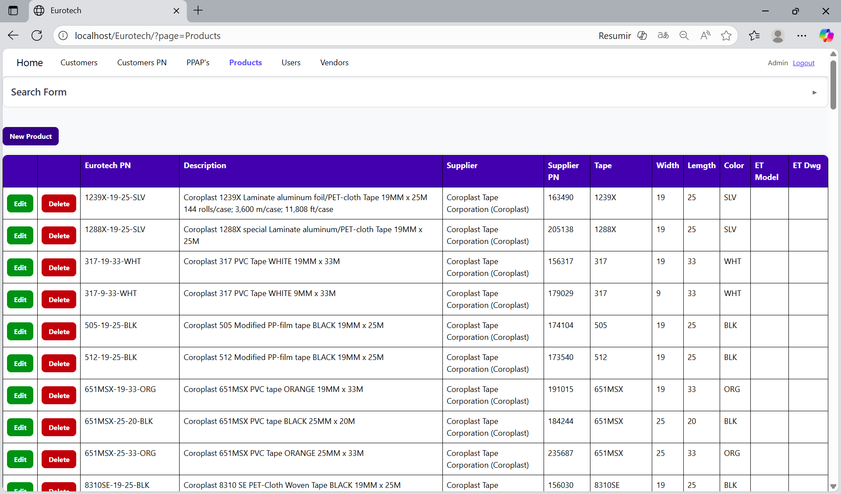

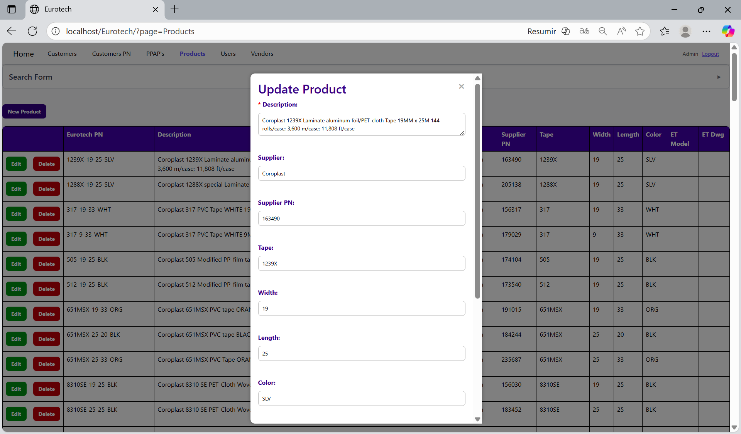

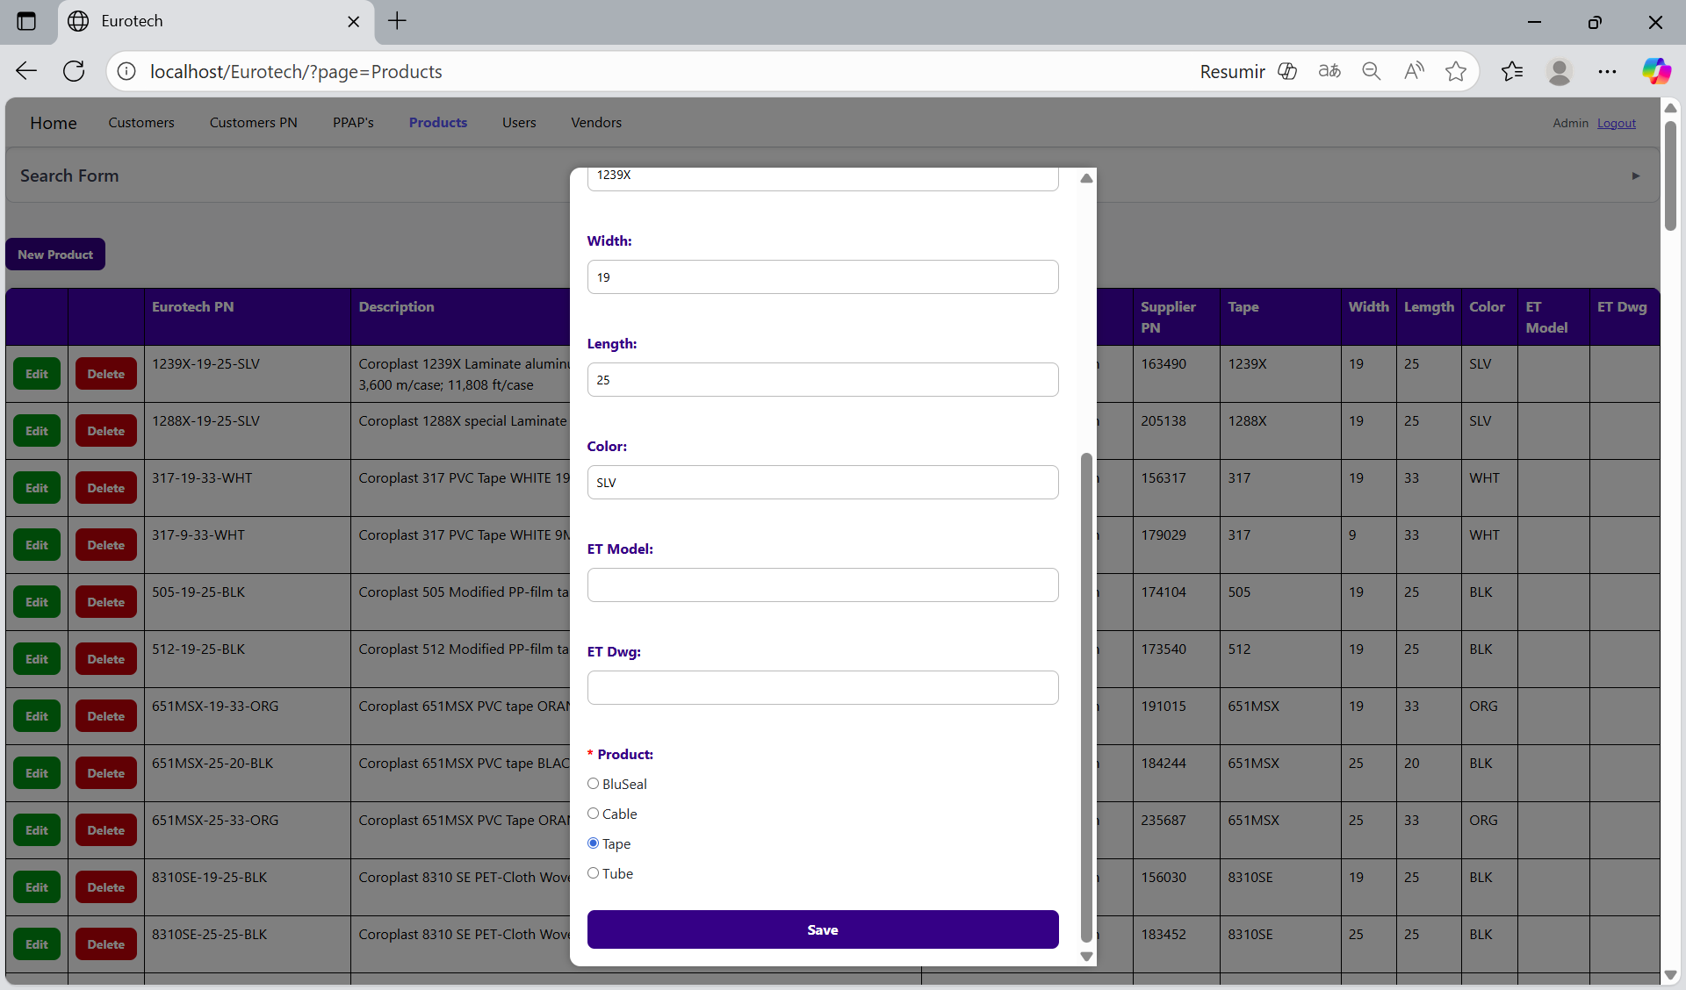

To save the changes, you must click the “Save” button.

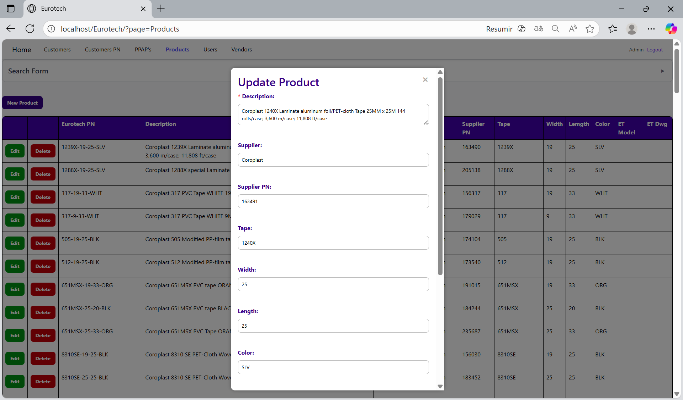

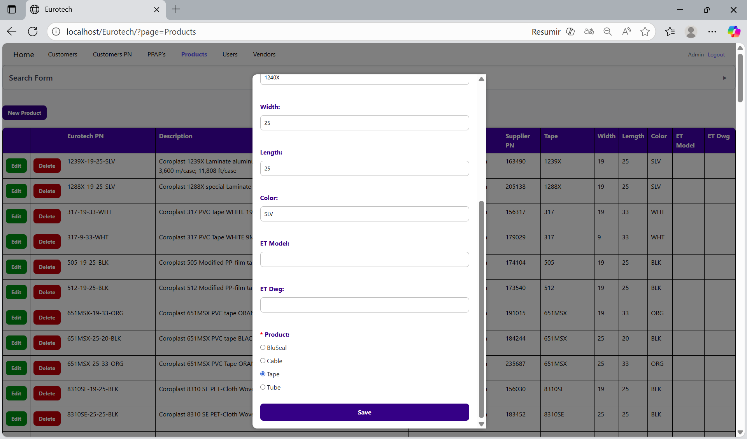

*Delete Product.*

In each register from the table, it will be a “Delete” button. If this button is clicked, it will display the information of the selected product with a message to confirm the delete action.

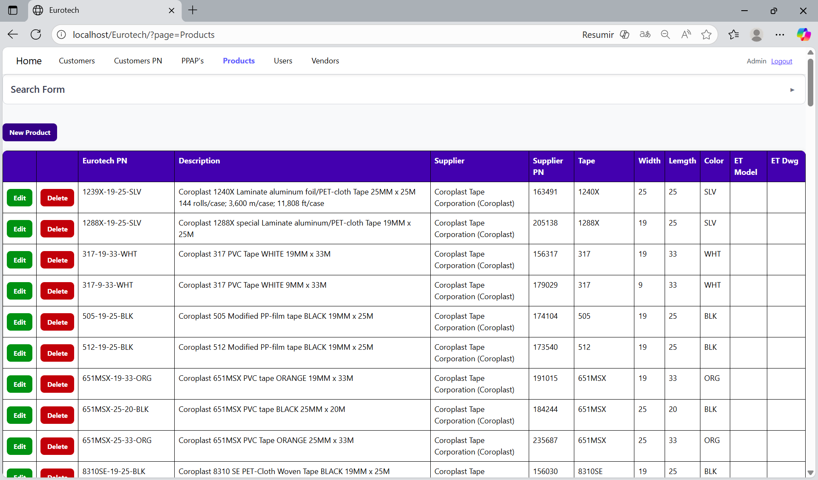

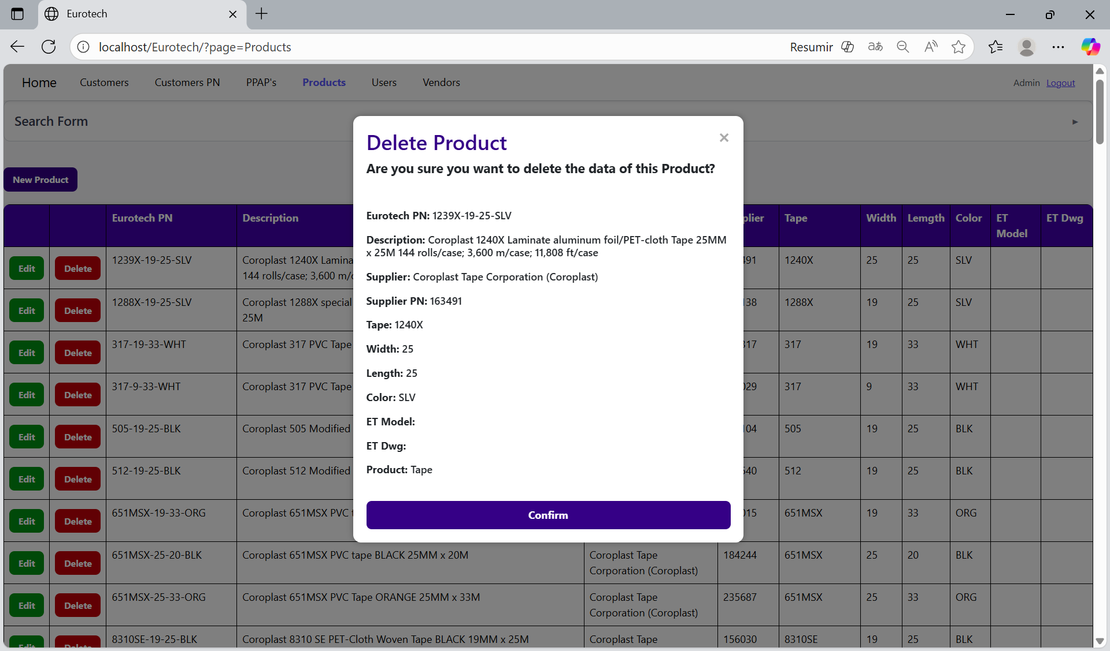

To confirm the delete action, you must click the “Confirm” button. It only deletes products that doesn’t have registers in “Customer PN” and “PPAP’s”.



***- Users Page.***

On the navigation bar, you can navigate to the “Users Page”.

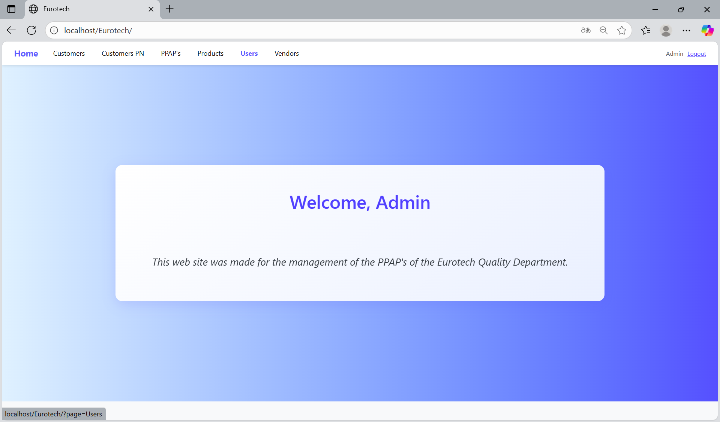

In this page you can manage the registers of all the users.

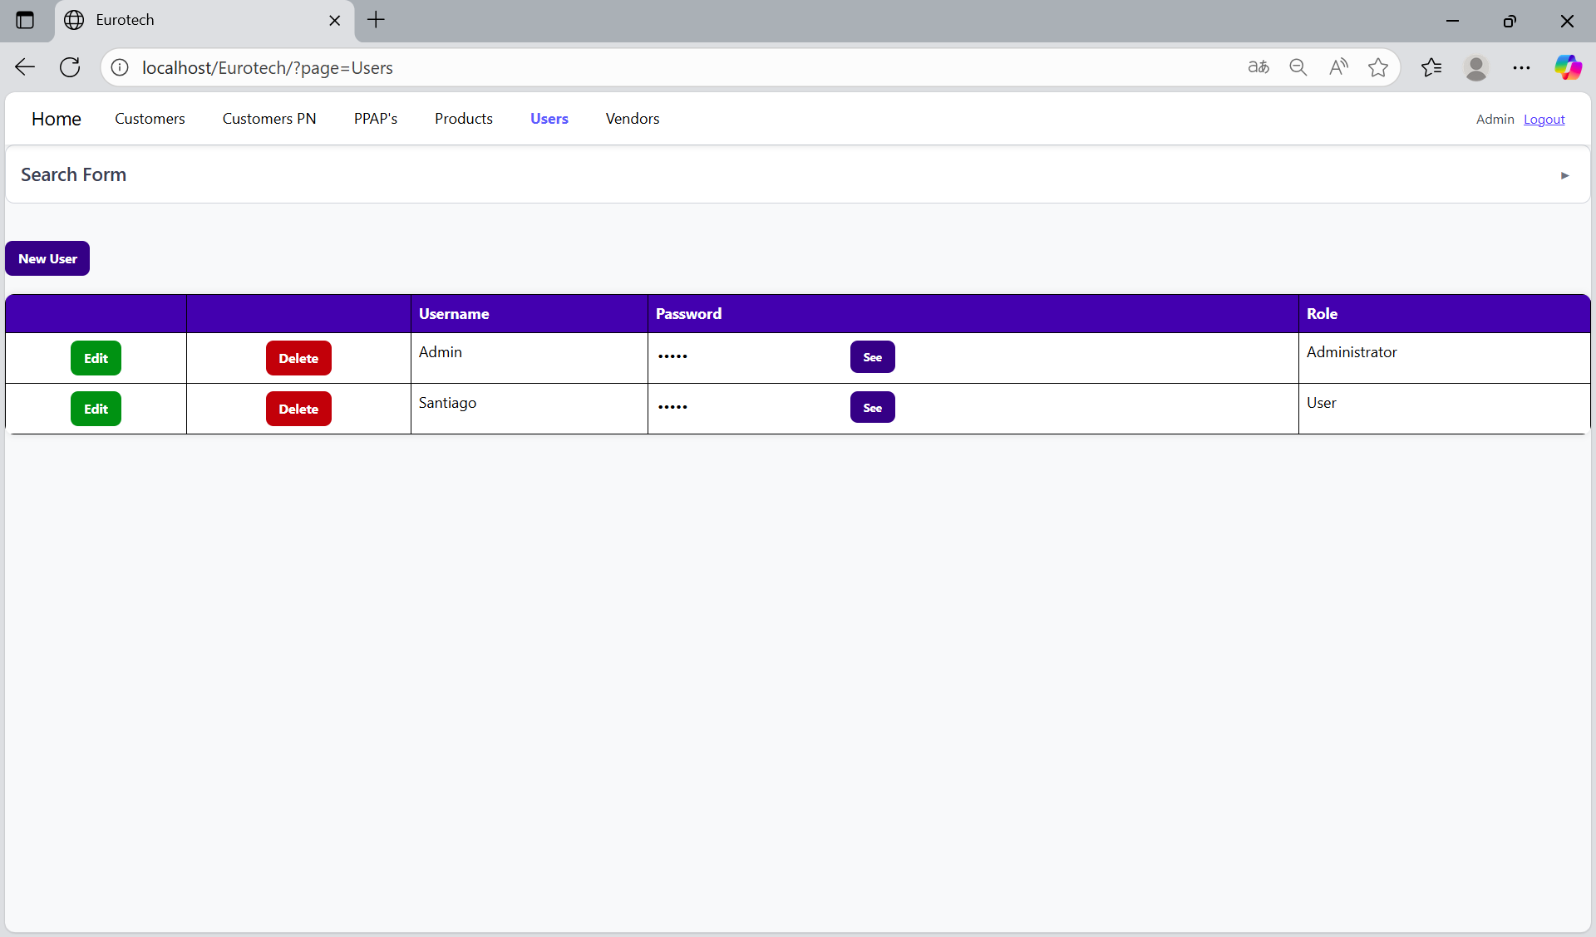

*Search Form.*

At the top of the page, it will be a dropdown “Search Form” that has all the fields of the table for querying registers.

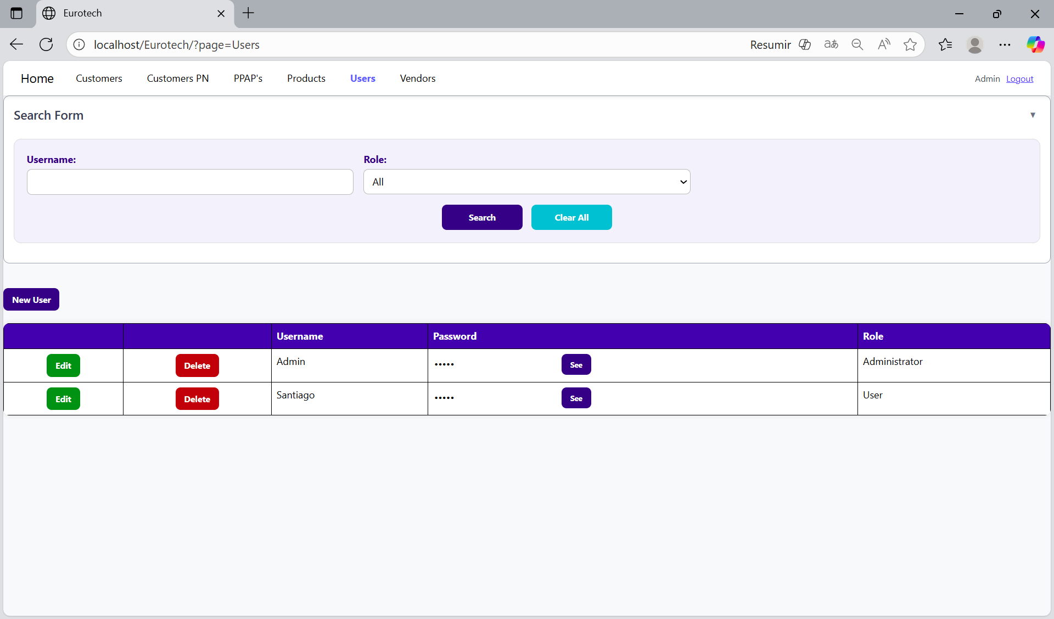

You can search by “Username”, using the “Username” field and clicking the “Search” button.

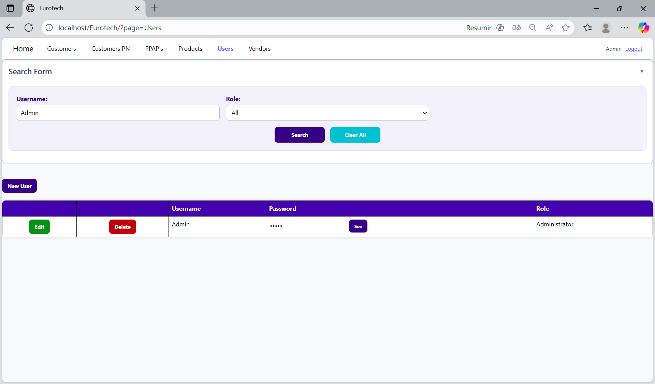

You can search by “Role”, using the “Role” field and clicking the “Search” button.

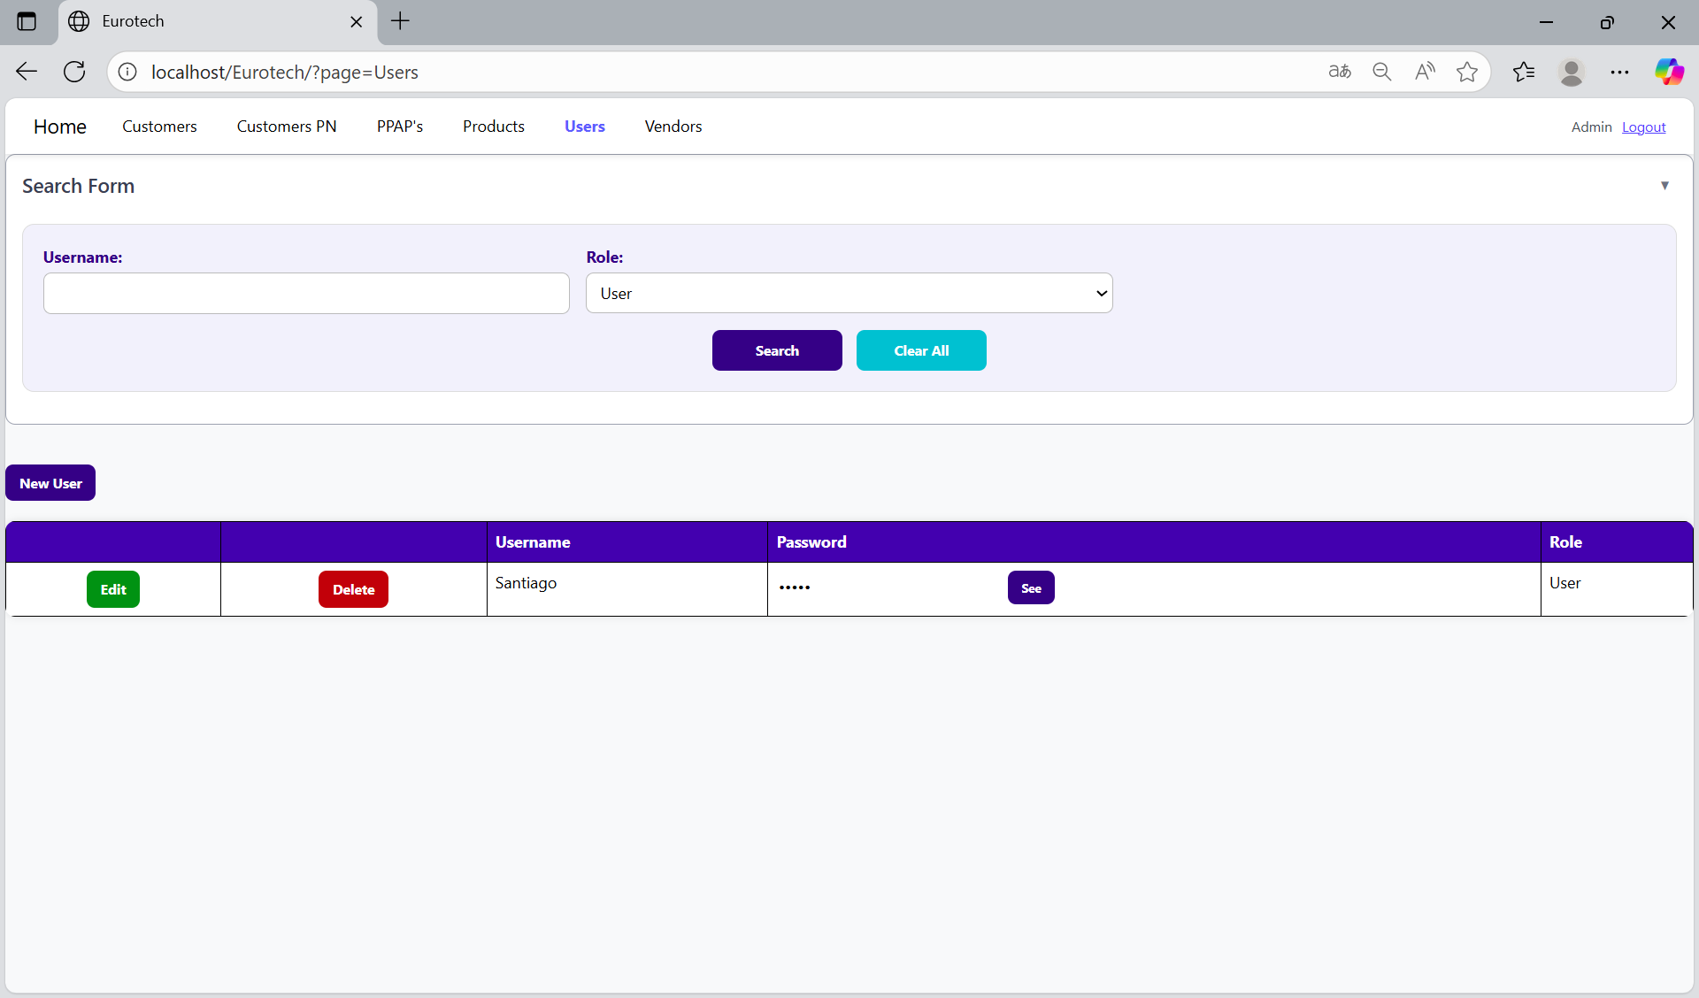

And with the “Clear All” button, you can clean the querying and see all the registers of the users.

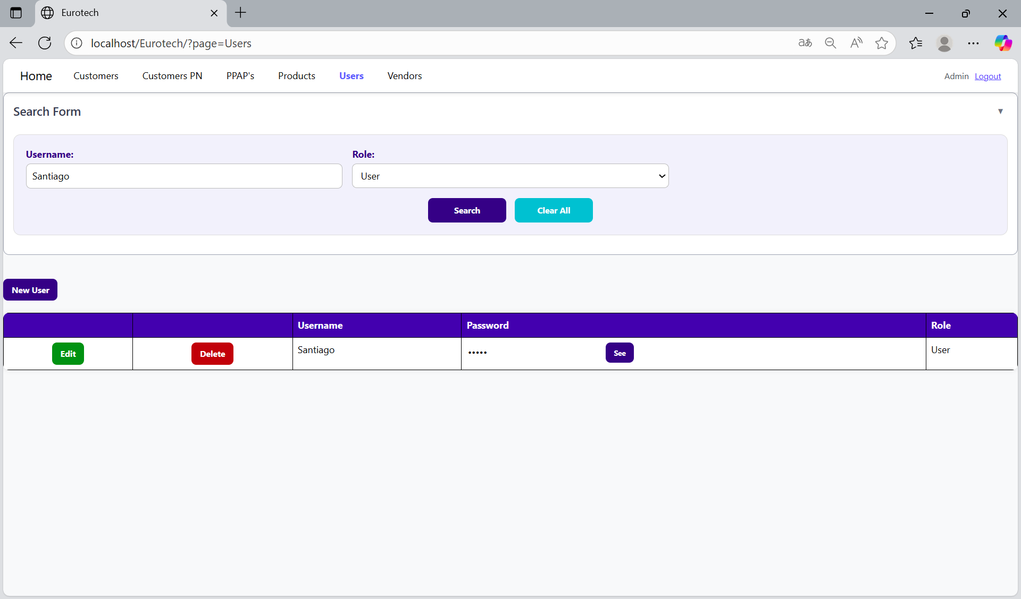

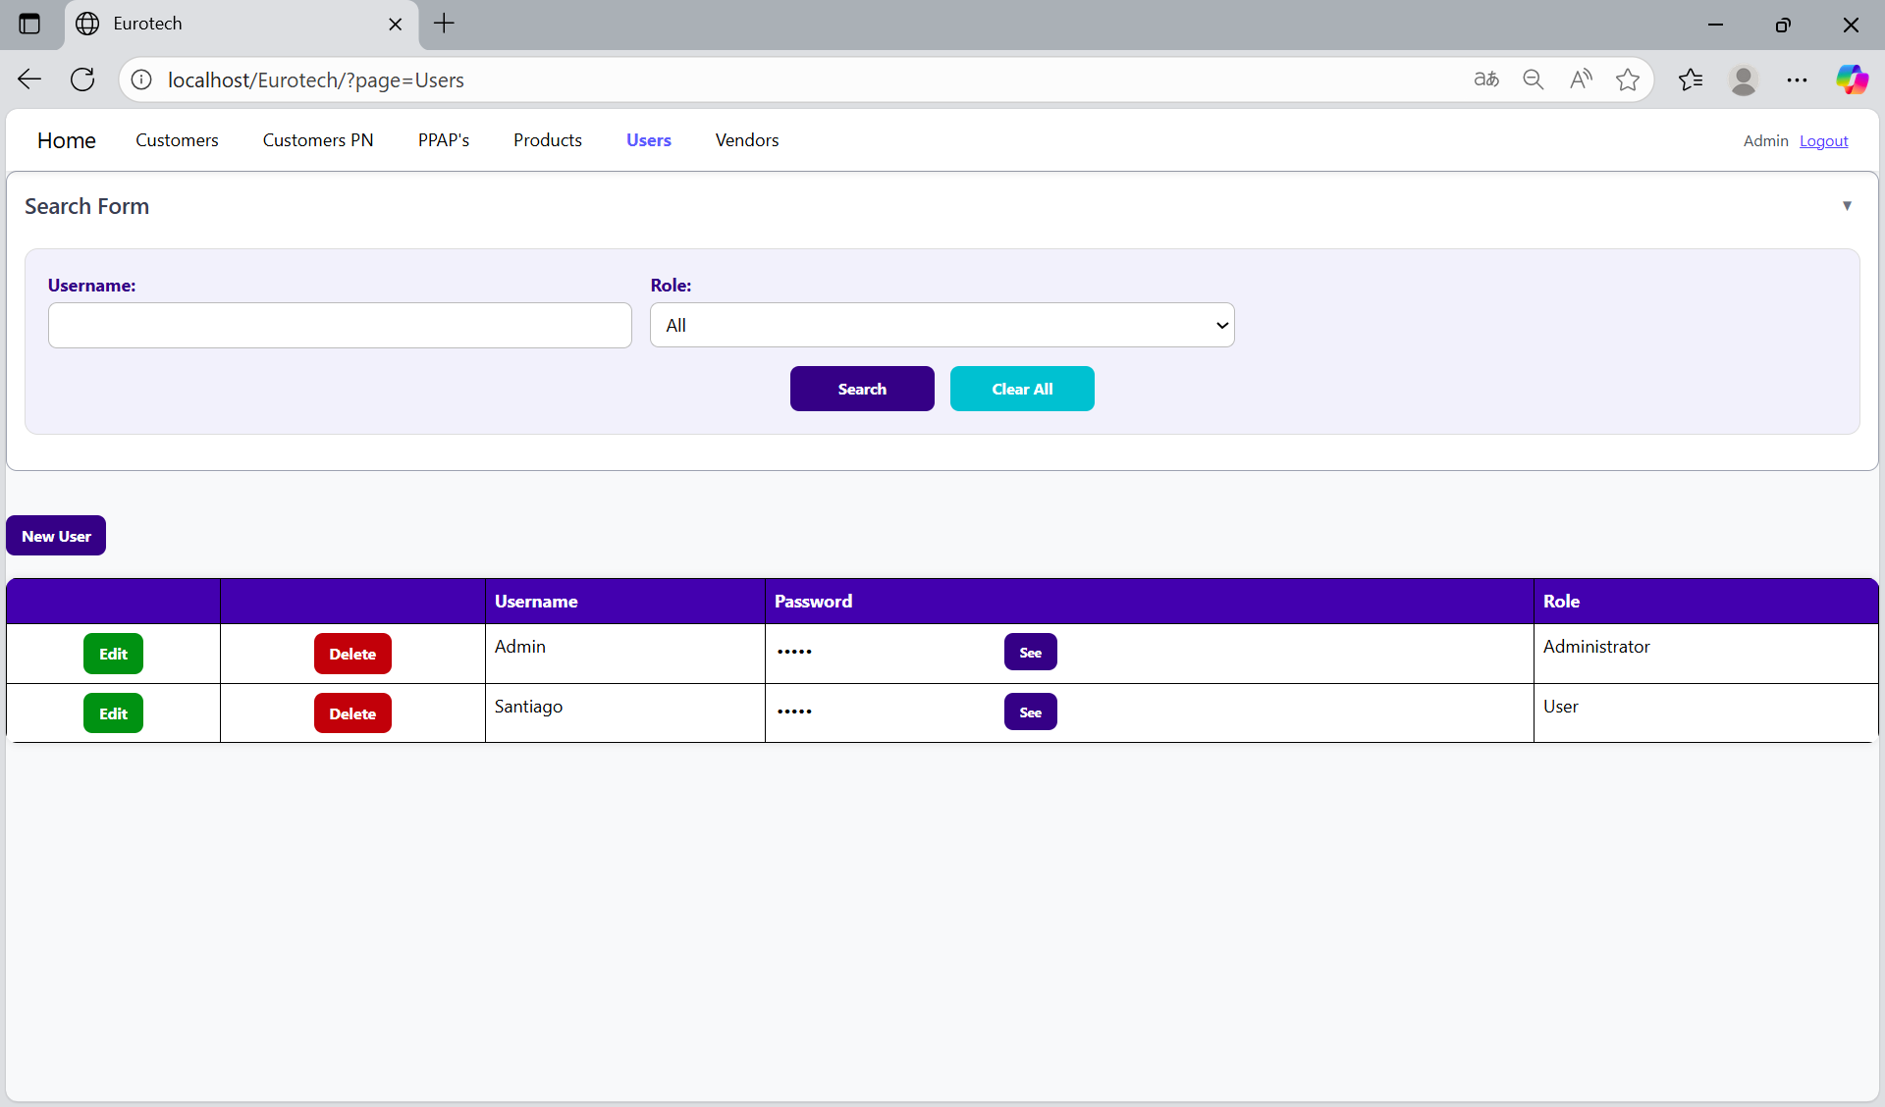

*New User.*

Below the “Search Form”, it is the “New User” button. If this button is clicked, it will display a register form to create a new user.

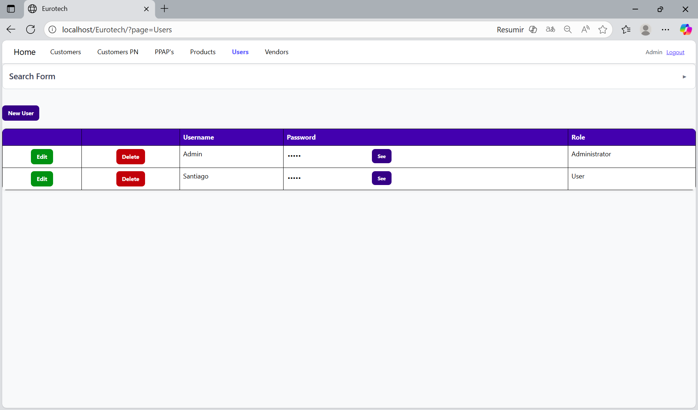

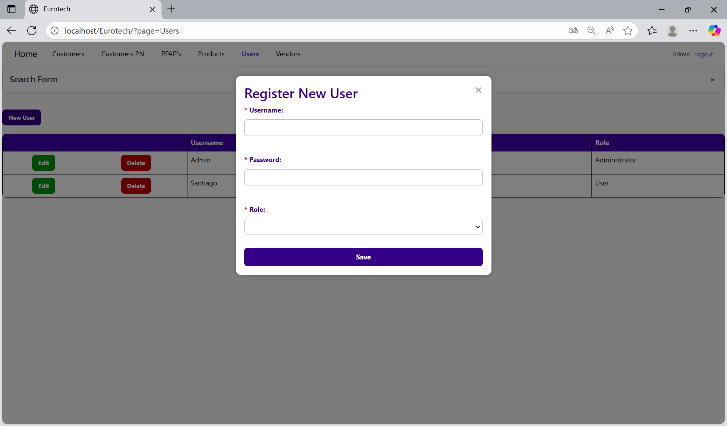

The register form has the “Username”, “Password” and “Role” fields as mandatories. You can’t duplicate registers that already exist in the database.

If you want to save the register of a new user, you must click the “Save” button.

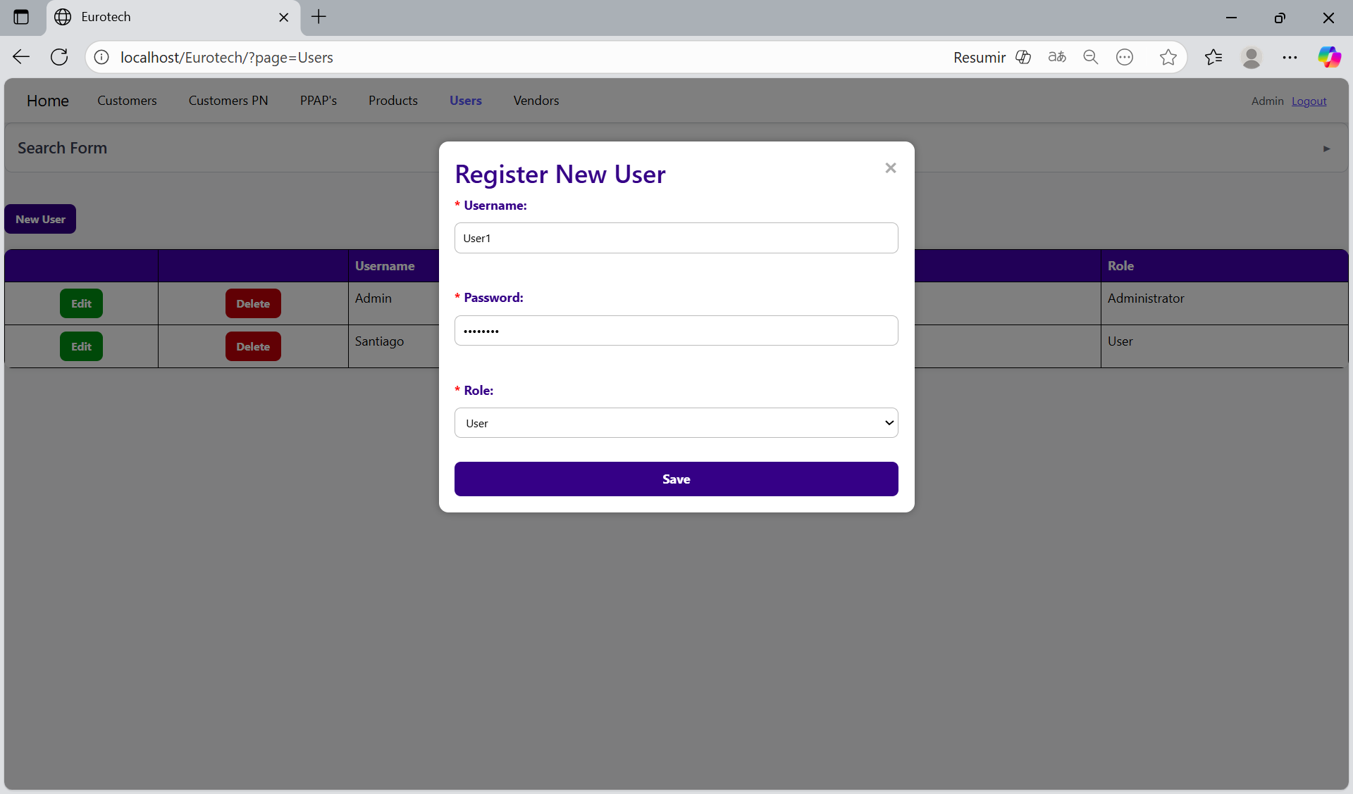

*Edit User.*

In each register from the table, it will be an “Edit” button. If this button is clicked, it will display an update form to edit the information of the selected user.

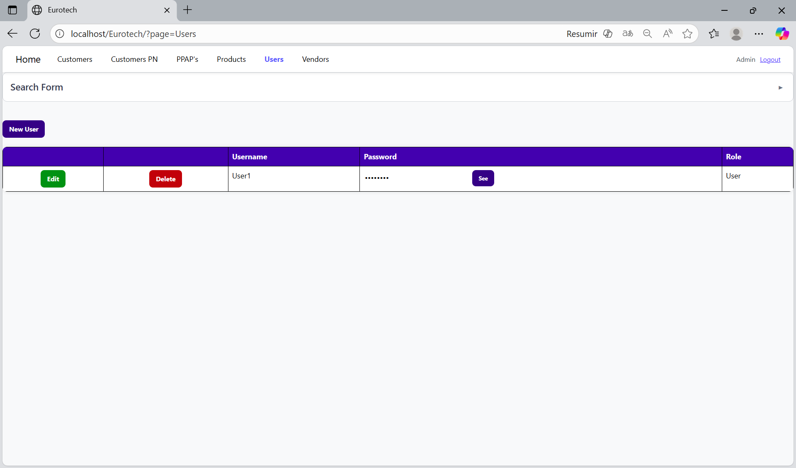

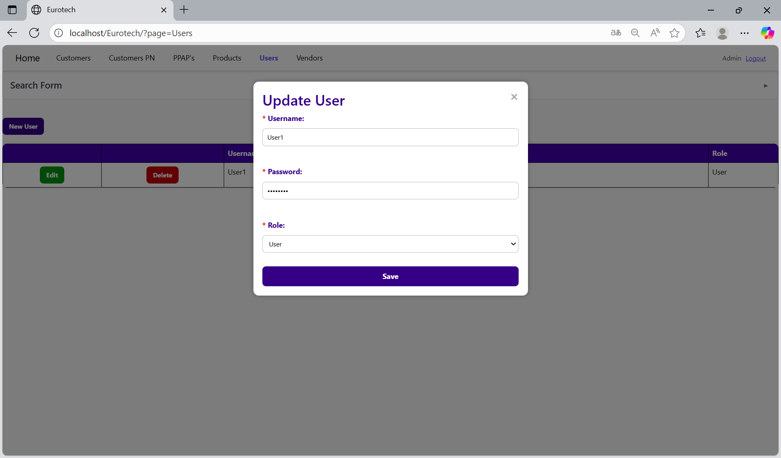

To save the changes, you must click the “Save” button.

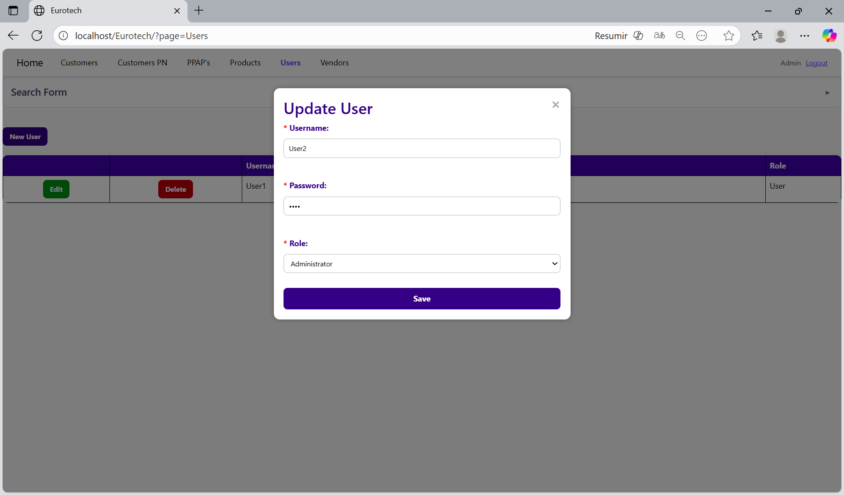

*Delete User.*

In each register from the table, it will be a “Delete” button. If this button is clicked, it will display the information of the selected user with a message to confirm the delete action.

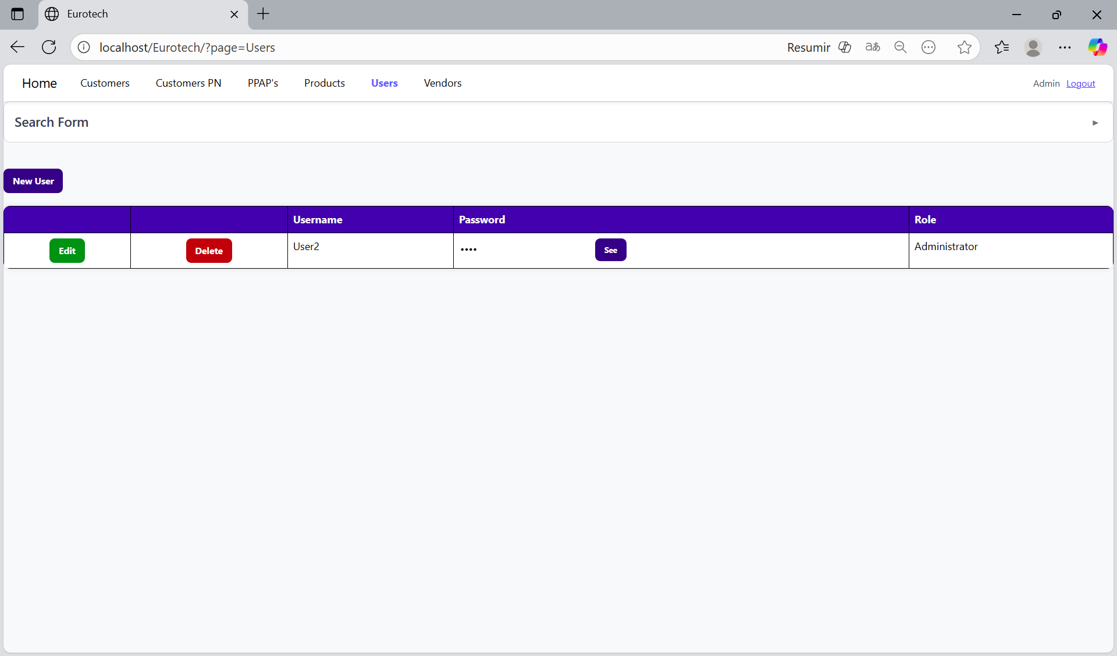

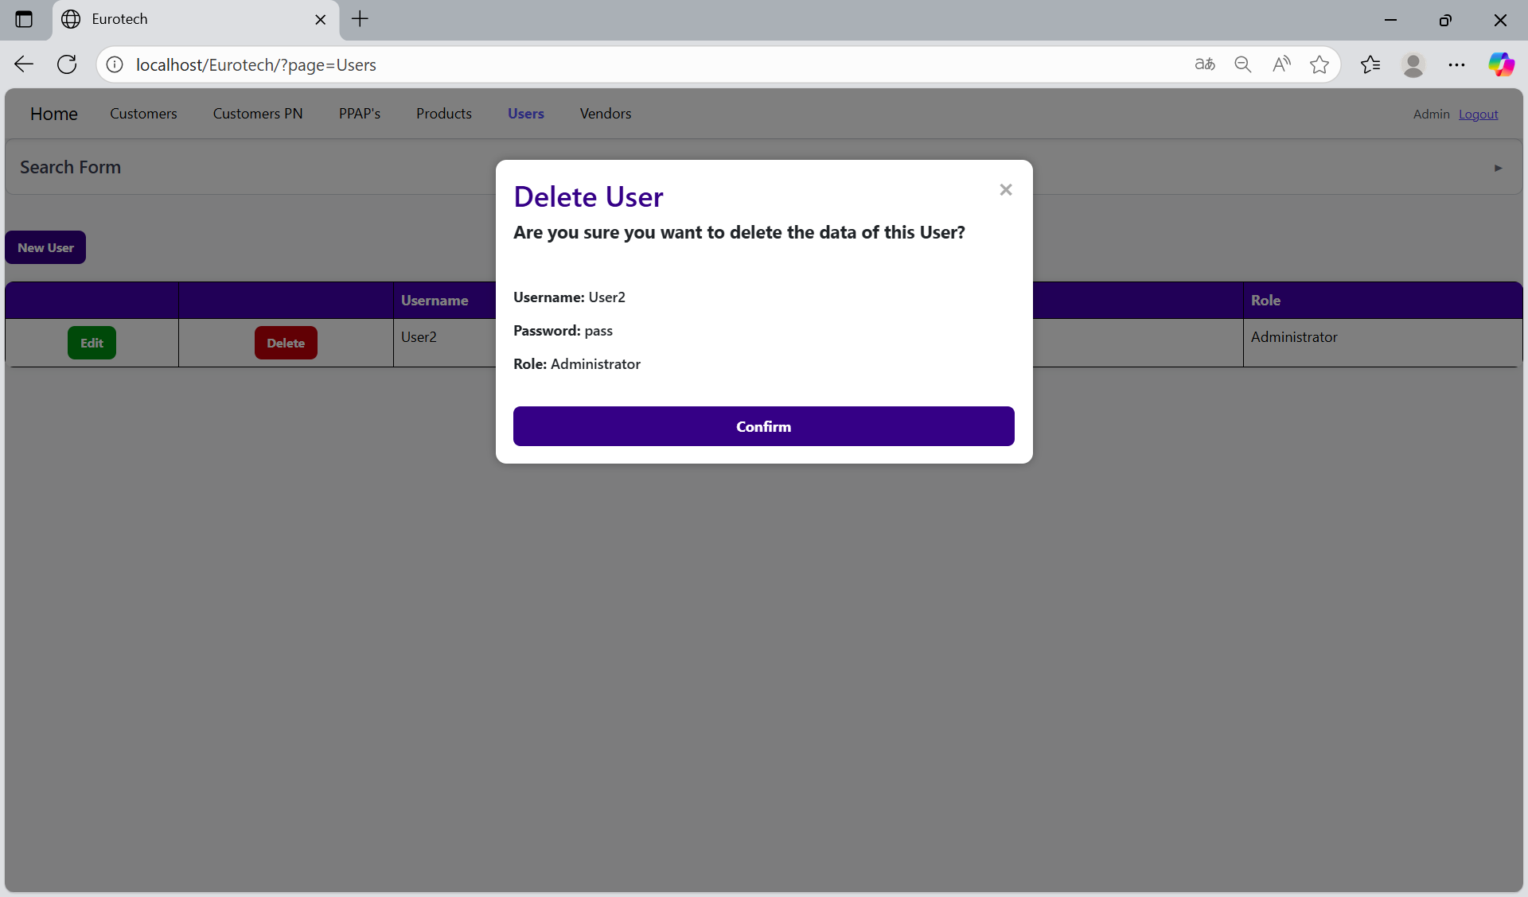

To confirm the delete action, you must click the “Confirm” button.



***- Vendors Page.***

On the navigation bar, you can navigate to the “Vendors Page”.

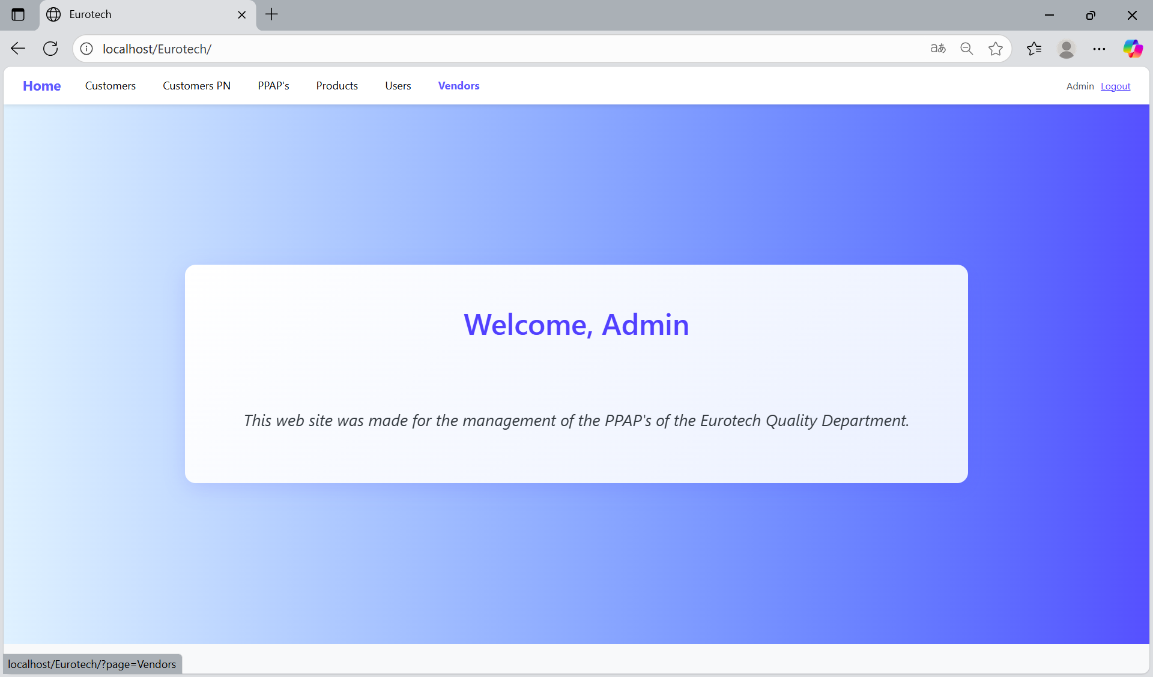

In this page you can manage the registers of all the vendors.

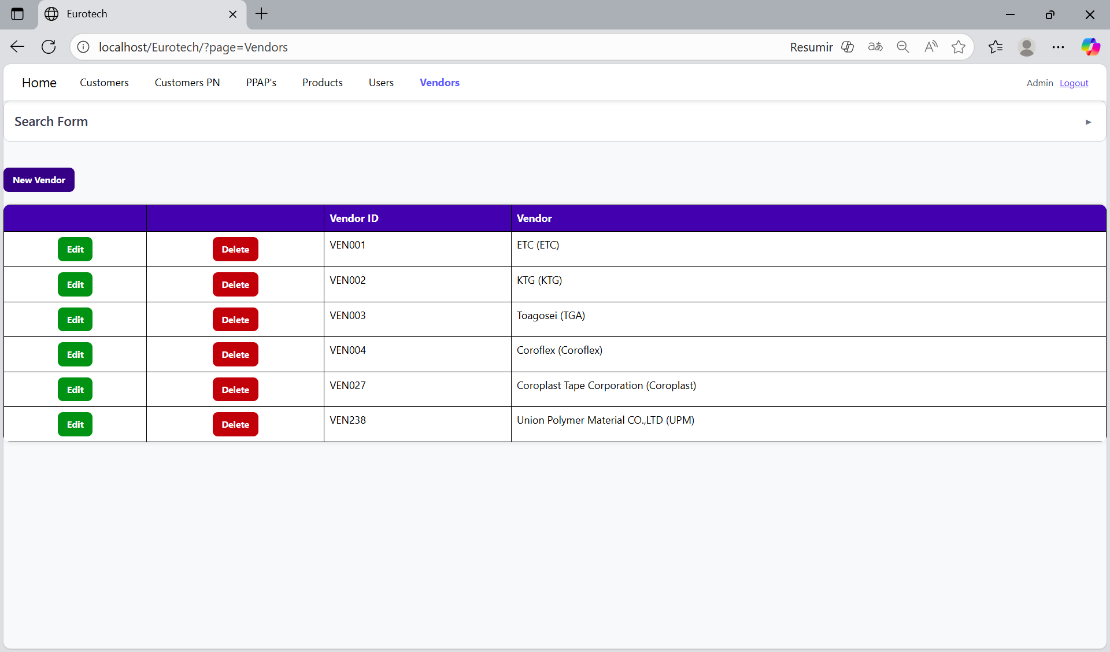

*Search Form.*

At the top of the page, it will be a dropdown “Search Form” that has all the fields of the table for querying registers.

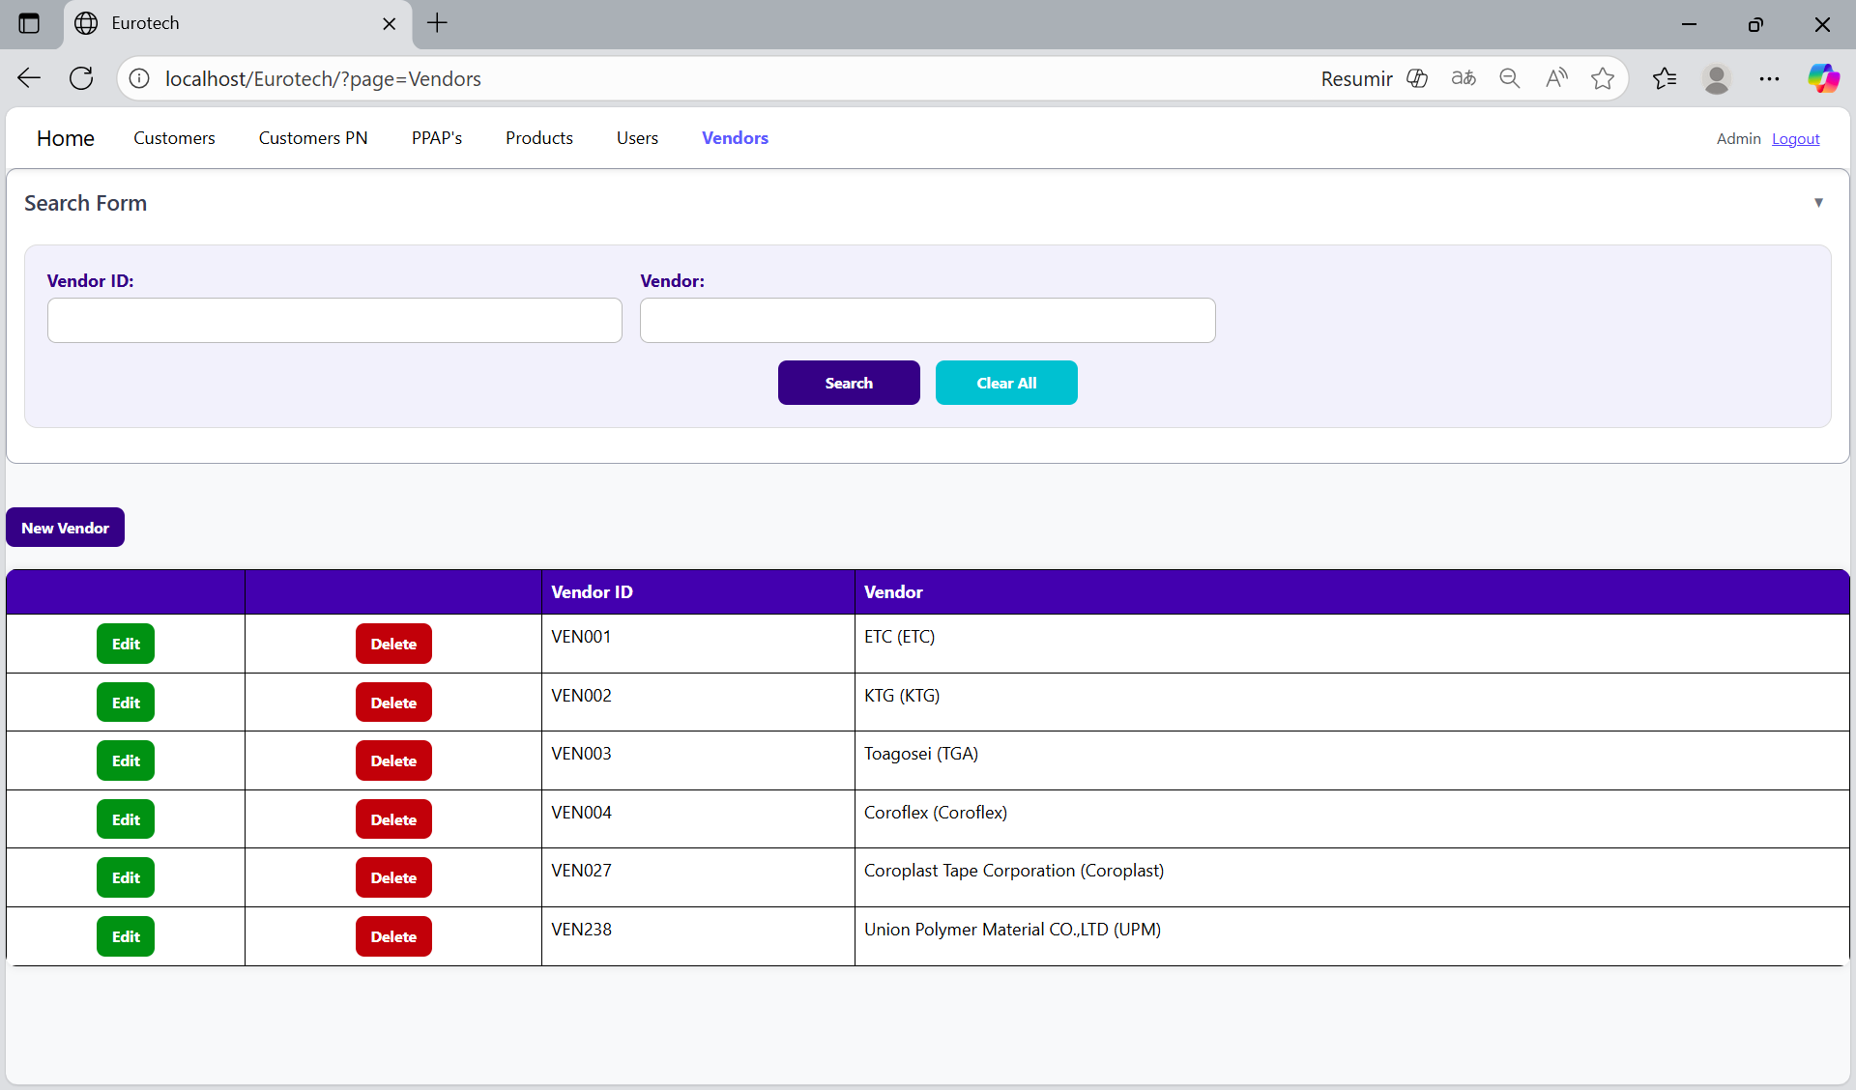

You can search by “Vendor ID”, using the “Vendor ID” field and clicking the “Search” button.

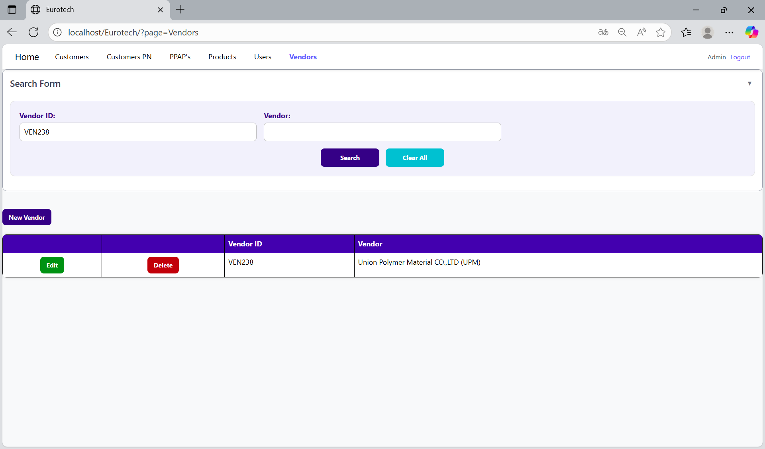

You can search by “Vendor”, using the “Vendor” field and clicking the “Search” button.

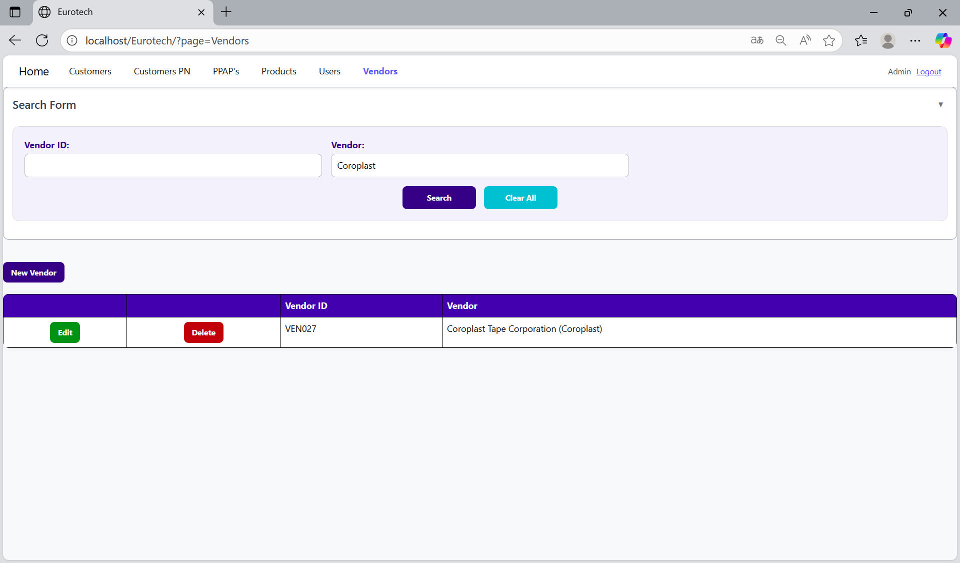

And with the “Clear All” button, you can clean the querying and see all the registers of the users.

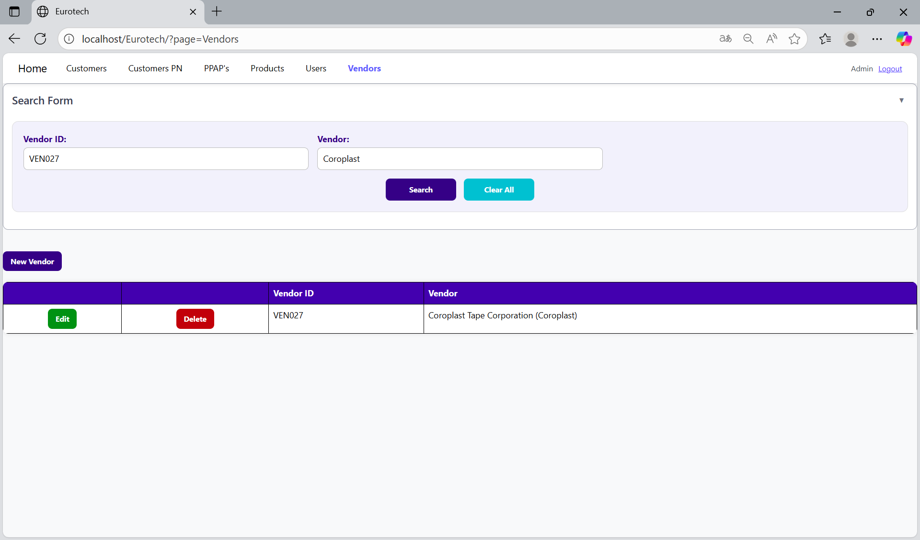

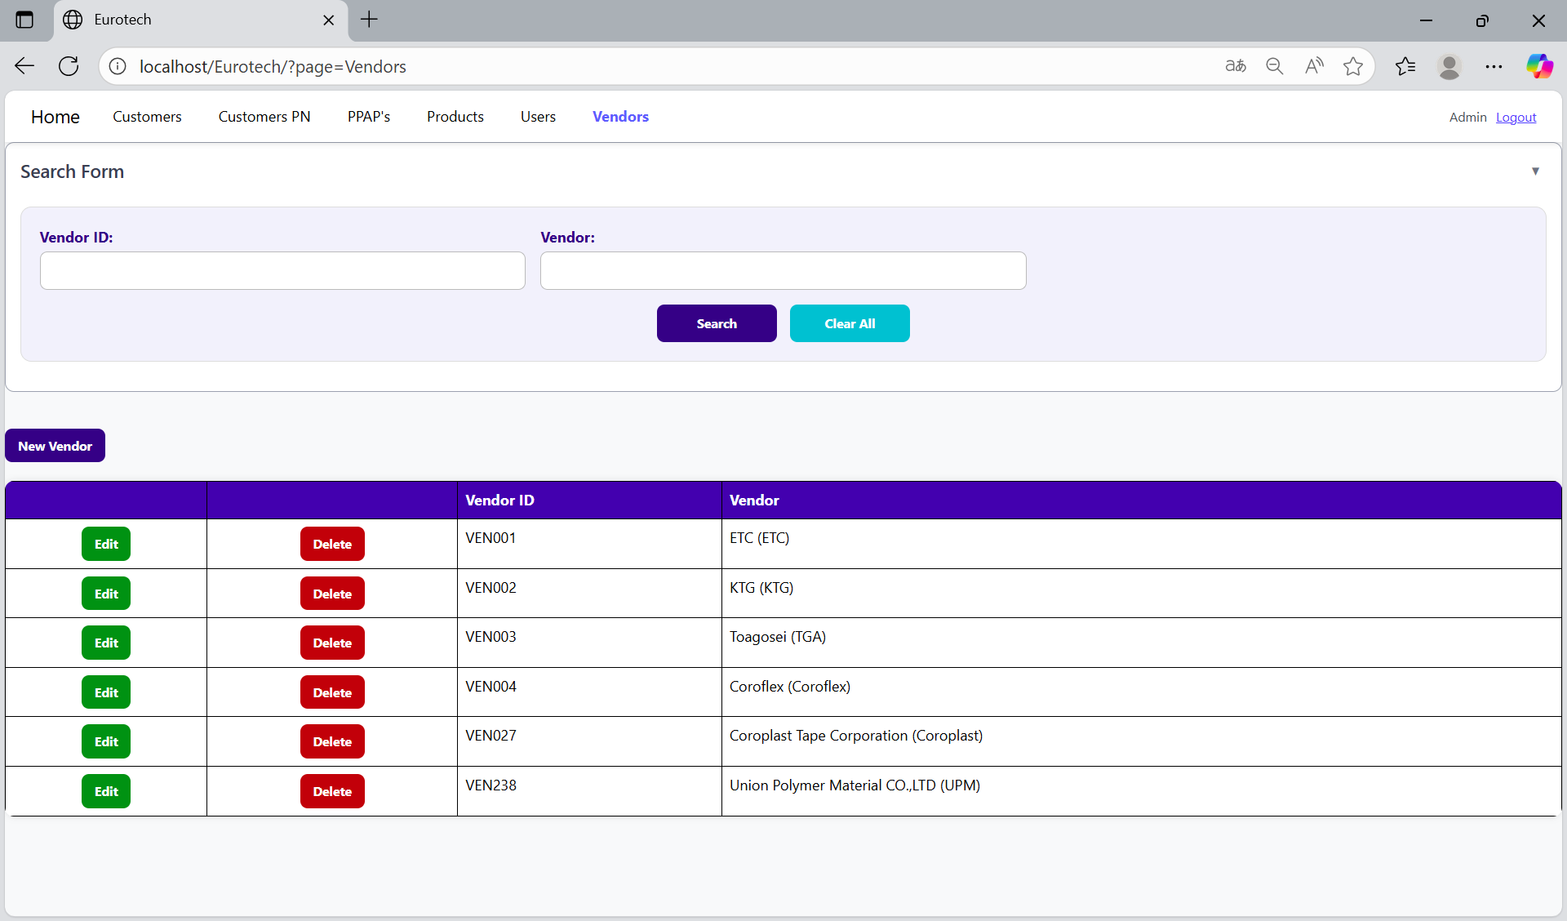

*New Vendor.*

Below the “Search Form”, it is the “New Vendor” button. If this button is clicked, it will display a register form to create a new vendor.



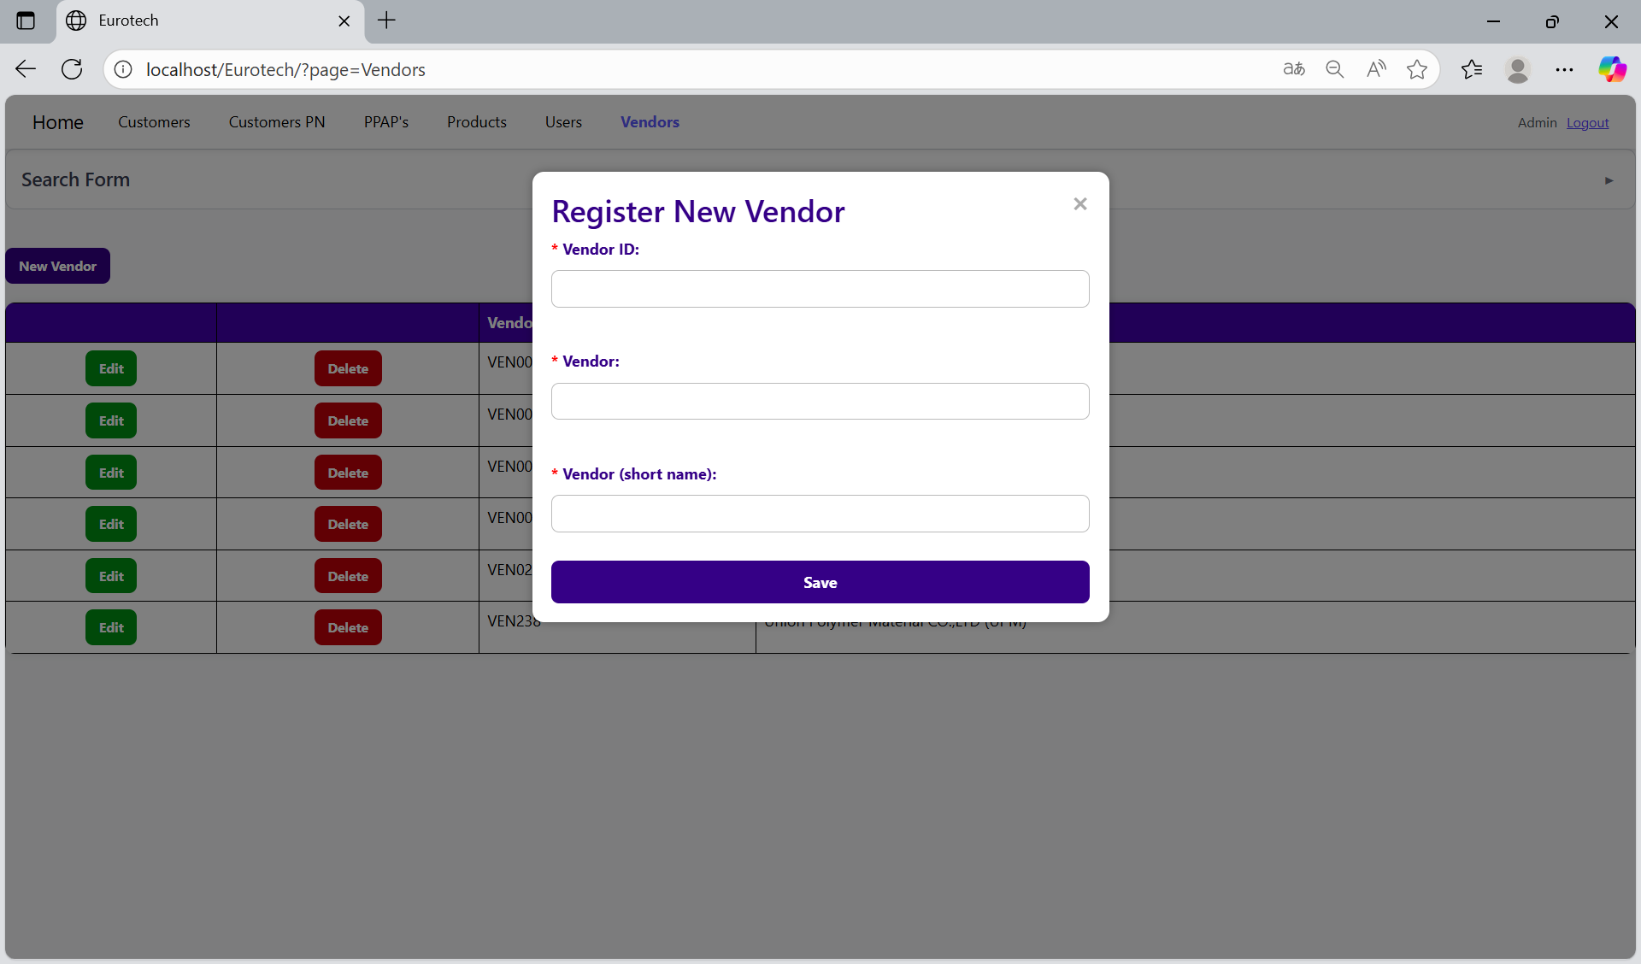

The register form has the “Vendor ID”, “Vendor” and “Vendor (short name)” fields as mandatories. You can’t duplicate registers that already exist in the database.

If you want to save the register of a new vendor, you must click the “Save” button.

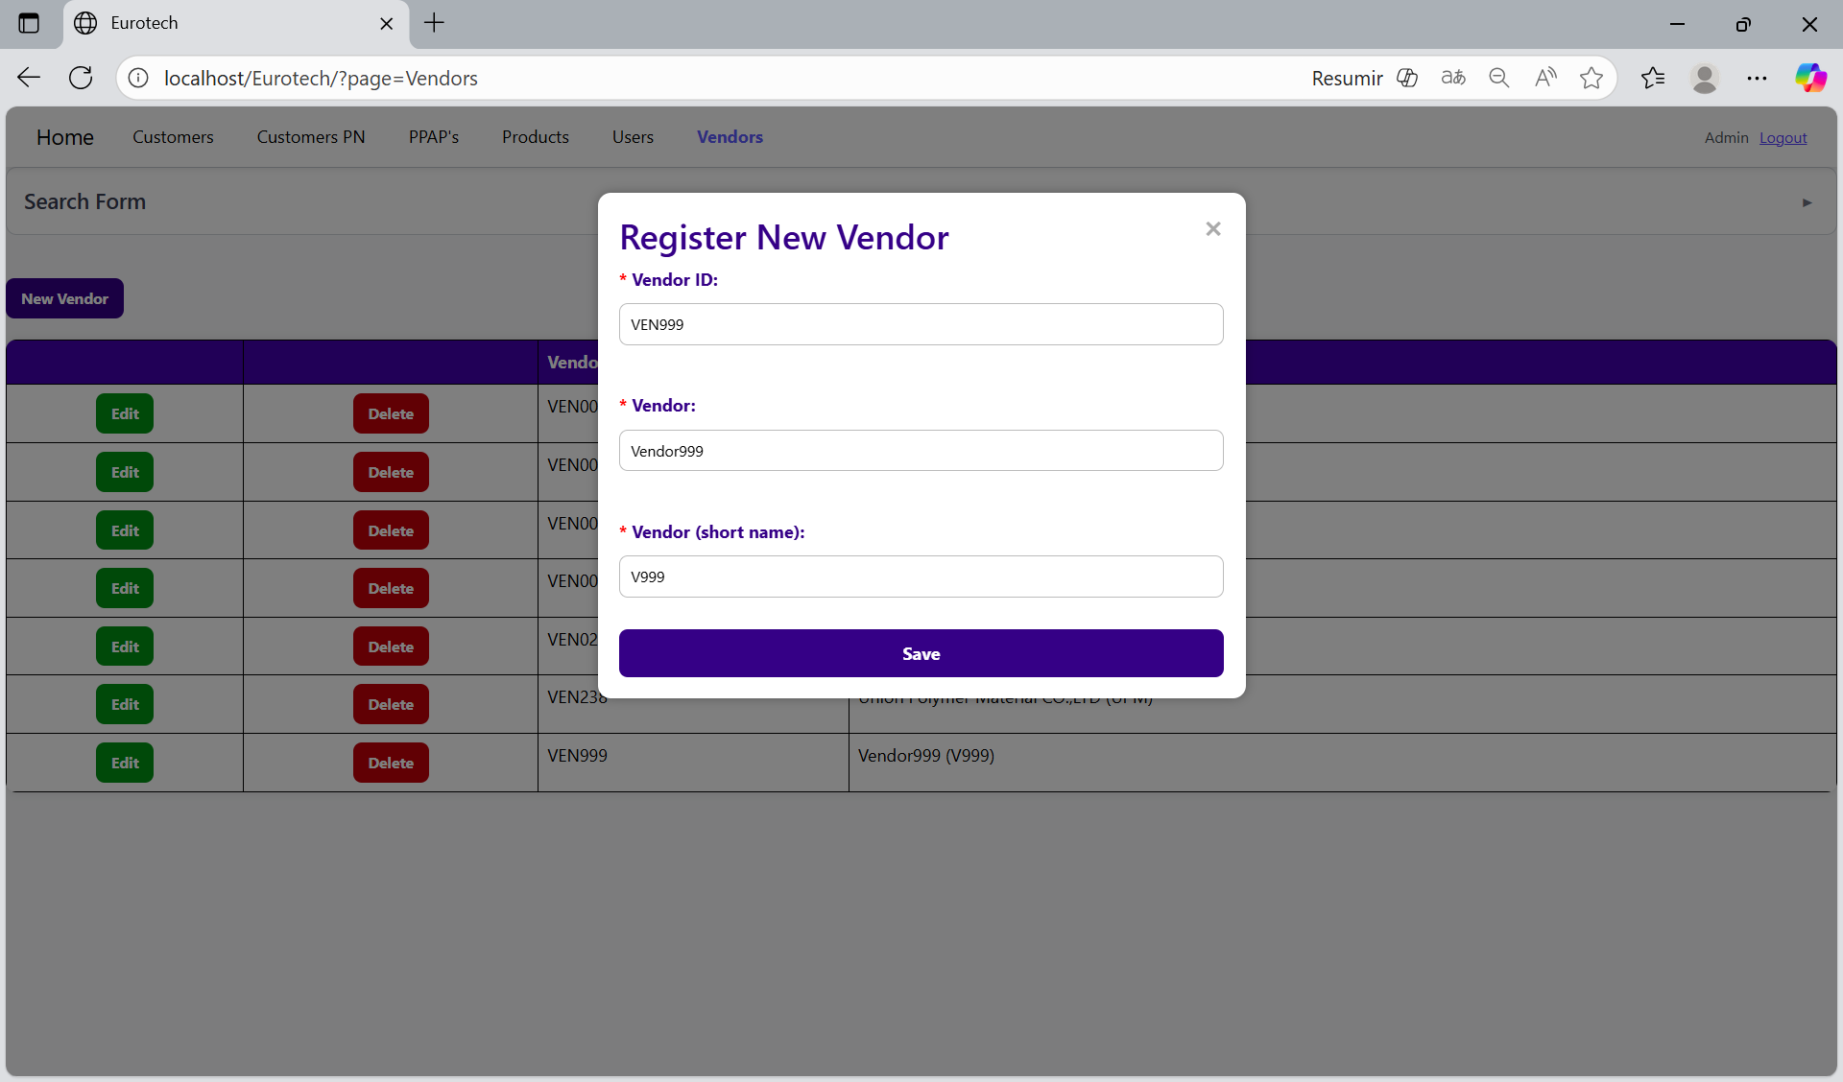

*Edit Vendor.*

In each register from the table, it will be an “Edit” button. If this button is clicked, it will display an update form to edit the information of the selected vendor.

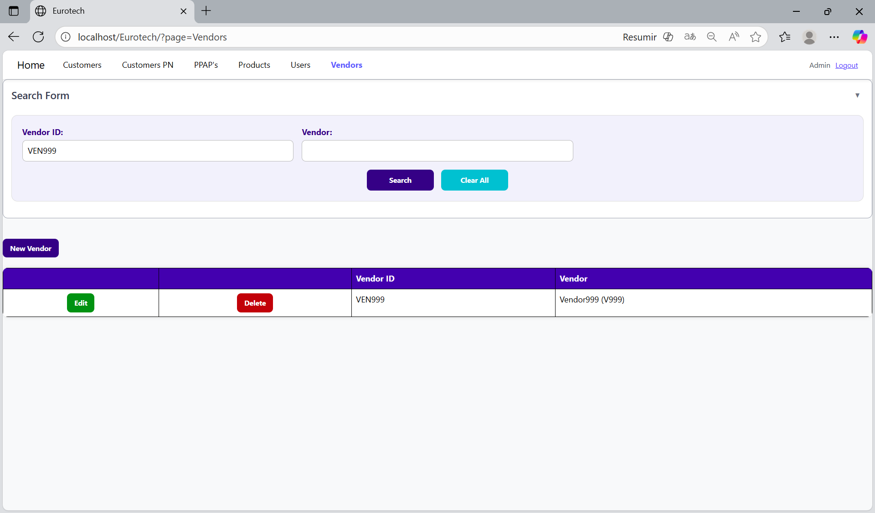

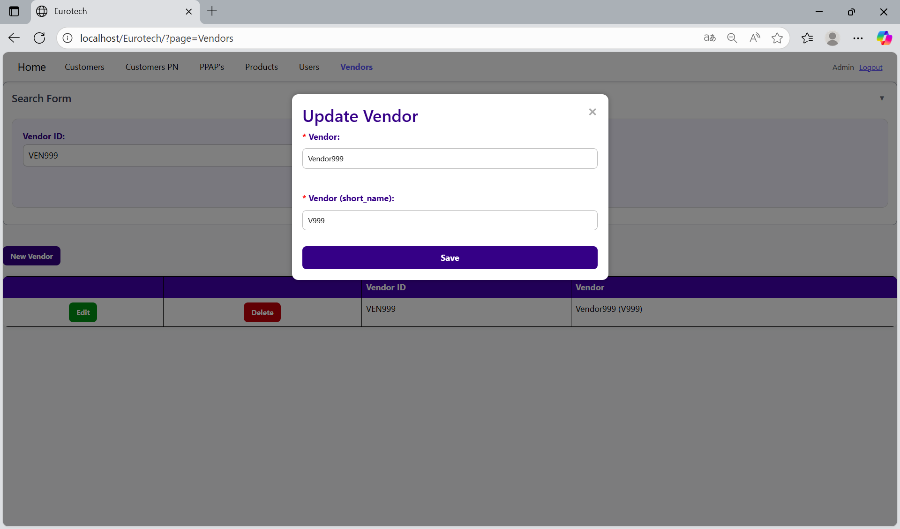

To save the changes, you must click the “Save” button.

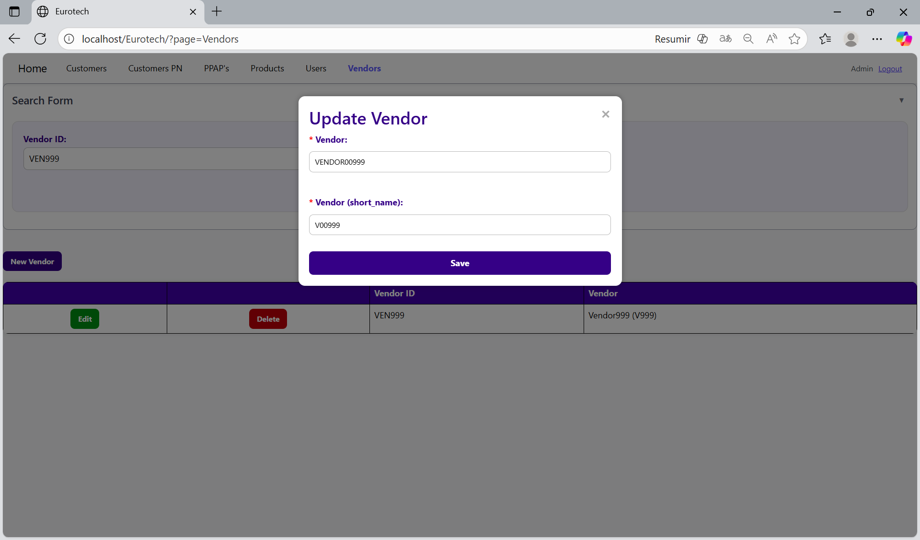

*Delete Vendor.*

In each register from the table, it will be a “Delete” button. If this button is clicked, it will display the information of the selected vendor with a message to confirm the delete action.

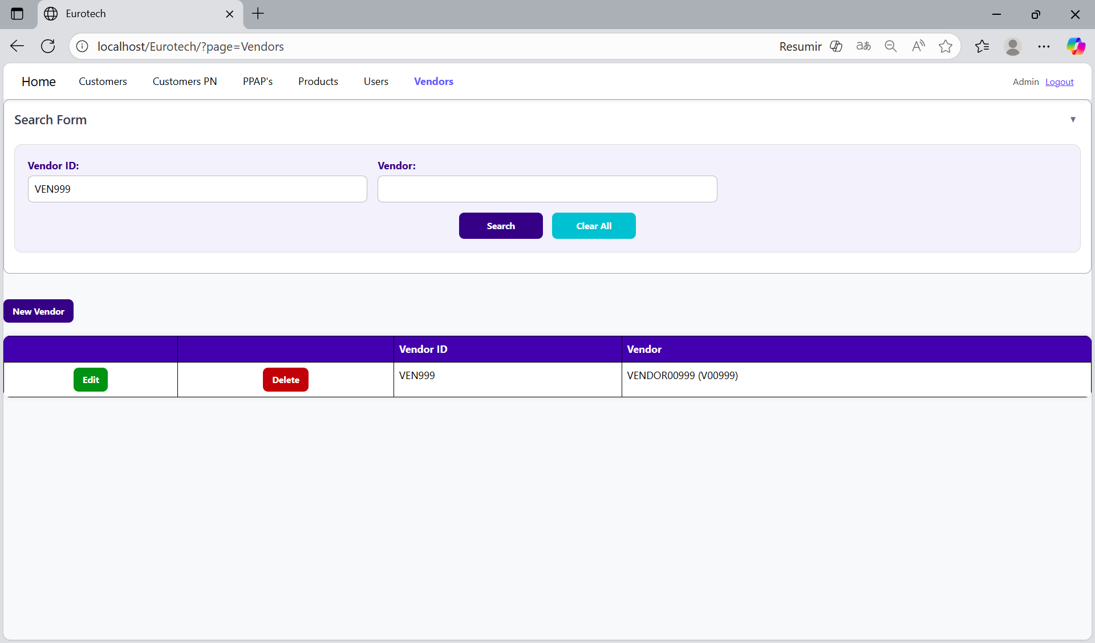

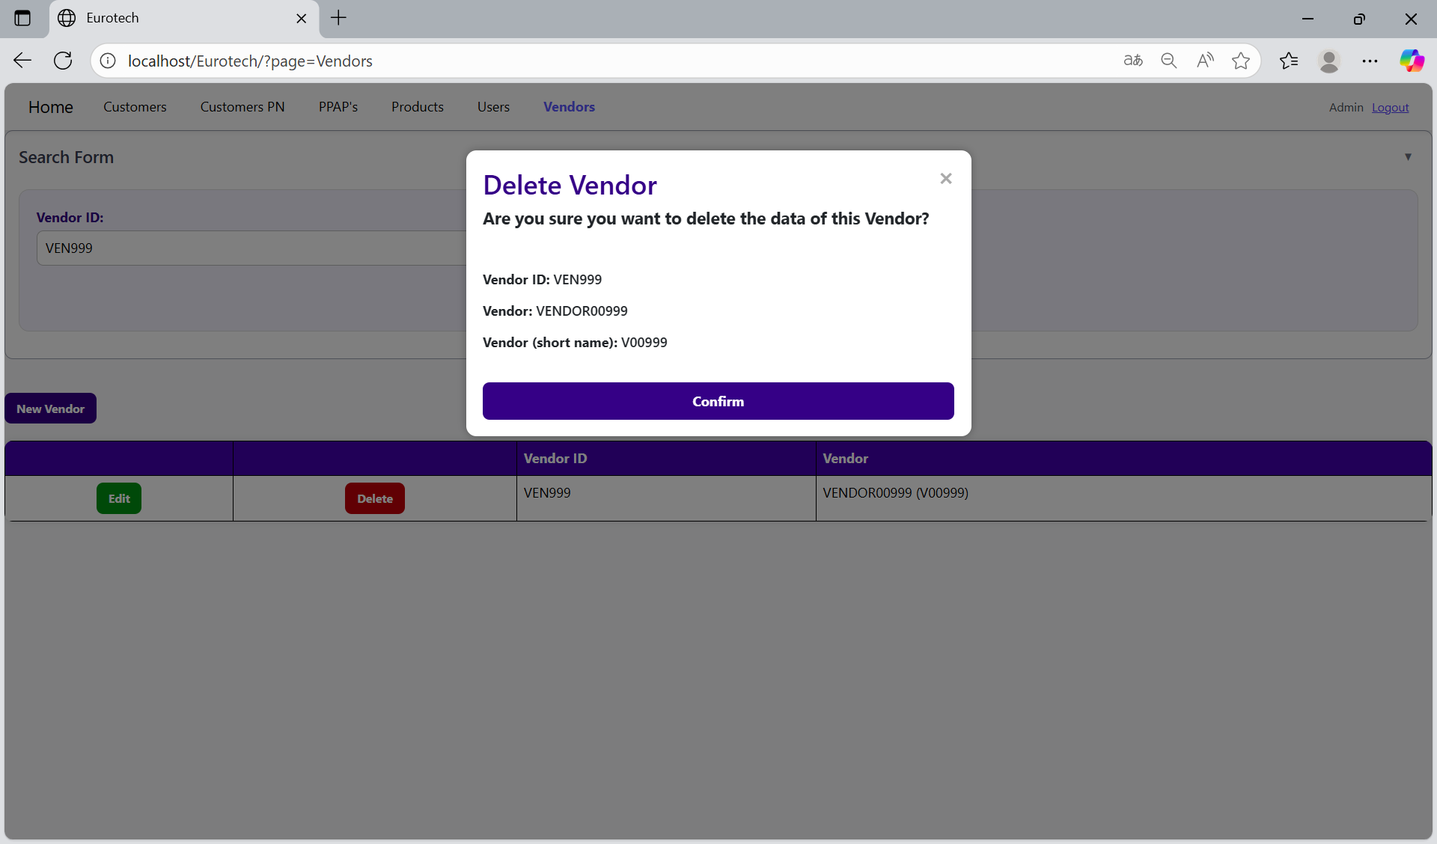

To confirm the delete action, you must click the “Confirm” button.



**Users with the role “User”**